2009 Control System Useful Parts

Jameco

2009 Driver station power supply -
TRANS,WALL,12VDC/1000mA,F2,  2.1mm x 5.5mm,UL/CSA | JAMECO RELIAPRO DDU120100Z7974 | 100870

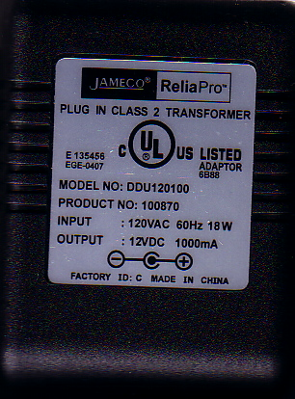

.1” header supplies

For making your own 2 & 3-pin PWM cables, as well as, Driver Station pin connections

Jameco catalog page: http://www.jameco.com/Jameco/catalogs/c291/P64.pdf

50’ 3-color servo wire, 22 gauge
http://www.jameco.com/webapp/wcs/stores/servlet/ProductDisplay?jameco_page=42&langId=-1&productId=396279

2-pin Housing – 100812 (as of 1/14/09)
http://www.jameco.com/webapp/wcs/stores/servlet/ProductDisplay?jameco_page=42&langId=-1&productId=100812
(Note the photo is generic and not for 3-pins)
3-pin Housing – 157383 (as of 1/14/09)
http://www.jameco.com/webapp/wcs/stores/servlet/ProductDisplay?jameco_page=42&langId=-1&productId=157383
(Note the photo is generic and not for 3-pins)
Male pin – 145358 (as of 1/14/09)
http://www.jameco.com/webapp/wcs/stores/servlet/ProductDisplay?jameco_page=42&langId=-1&productId=145358
Female pin – 100766 (as of 1/14/09)
http://www.jameco.com/webapp/wcs/stores/servlet/ProductDisplay?jameco_page=42&langId=-1&productId=100766
Crimper - 159266
http://www.jameco.com/webapp/wcs/stores/servlet/ProductDisplay?jameco_page=42&langId=-1&productId=159266

