Pneumatics Step-by-Step
(For the cRIO Controller)
2013 edition


FIRST Robotics Team 358, Hauppauge, NY

How to Assemble Your Pneumatics
It's a good idea to plan ahead and layout all your parts on a big table or the floor before you begin connecting things, and of course a layout design is always helpful. For help with designing pneumatics circuits see: http://team358.org/files/pneumatic/PneumaticsForNewbies.pdf.
This Step-by-Step goes through all the mechanical connections and pneumatic system testing, before adding in the electronic side that powers it, and finally the computer controls, but we begin right away with running the compressor with a battery to test for air leaks as each circuit stage is completed.

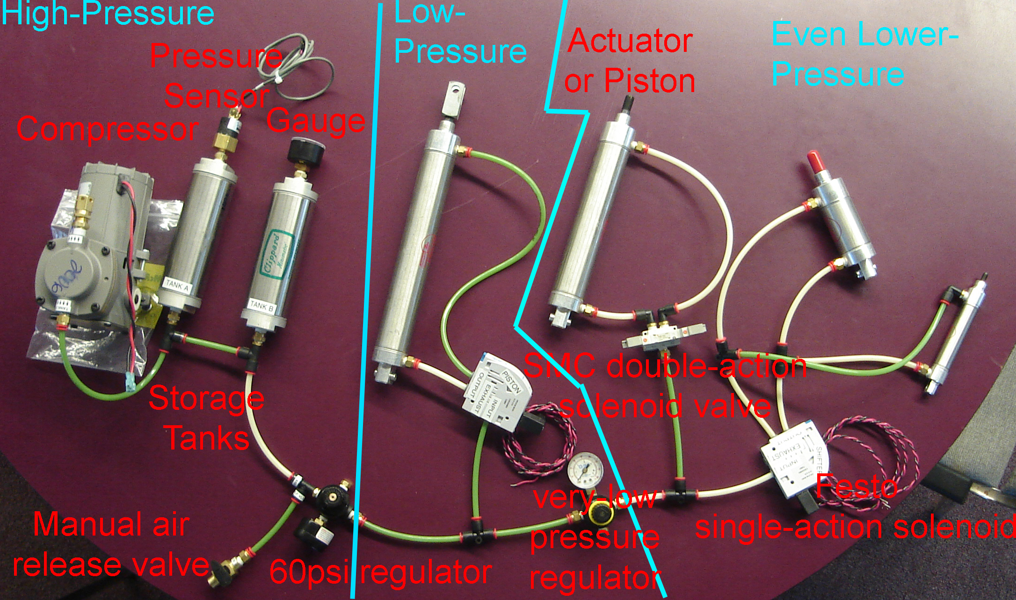
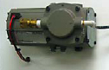

Compressor
Parts needed: compressor, emergency relief valve, (1) push-to-connect tube fitting, Teflon tape
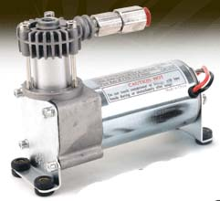
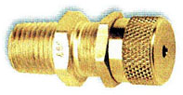
- Attach a push-to-connect fitting if one isn’t pre-installed (use Teflon tape as a seal)
- Attach the pressure safety valve to the compressor if it’s a model with an extra port (use Teflon tape as a seal)
- Mount the compressor using the vibration dampers to avoid rattling everything else on your robot loose.
- Test the compressor by connecting the wires directly to a 12v source briefly

High-Pressure Circuit
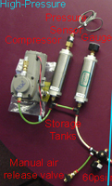
Parts needed: storage tank(s), pressure sensor, manual relief valve, gauge, push-to-connect tube fittings, brass fittings, tubing, Teflon tape.
Most common mistakes: not sealing everything with Teflon tape, not checking for leaks section by section as you go, not making all tubing cuts as square as possible.

- Add fittings to one or more storage tanks using Teflon tape
- Add pressure sensor using Teflon tape
- Add manual relief valve using Teflon tape
- Add pressure gauge using Teflon tape
- Leave tail to add 60psi regulator later, but plug it temporarily, e.g.,
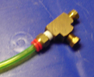 or 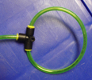
- Connect all tubing
- Test again by connecting the compressor to a 12v source and watch the gauge climb. The sensor is not yet hooked up, so it will not automatically stop yet.
- Check for leaks when you stop the compressor and correct any you find.
- Adjust the pressure safety valve to 125psi. Do so by running the pressure up to 130psi, loosen the lock nut in the center and twist the knob until pressure drops to 125psi, then retighten the lock nut. This valve just bleeds air when pressure gets above the limit setting.

Low-Pressure Circuit
Parts needed: all-black regulator, solenoid(s), cylinder(s), multiple push-to-connect tube fittings, brass fittings, tubing, Teflon tape.
Most common mistakes: incorrect assembly of the regulator by not recognizing the high-pressure port. Not using the correct solenoid ports.
- Assemble the all-black regulator using Teflon tape
  - The low-pressure port indicated by an arrow gets a tube fitting using Teflon tape
  - The port directly opposite the low-pressure outlet is for the high-pressure input. Add a tube fitting for high-pressure air using Teflon tape. All other outputs are low pressure and if unused should be plugged..
  - Add a pressure gauge to either of the remaining two ports using Teflon tape
  - Add the plug packed with the regulator to the final unused port using Teflon tape
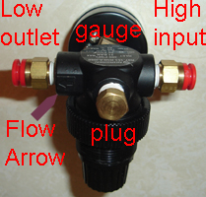
- Add the 60psi (all black) regulator to a tube from the tail-end of the High-Pressure Circuit.
- Assemble solenoids if required, following the manufacturer’s instructions. In general:
  - Check the solenoid to see if it is 24VDC or 12VDC, and be sure you have the right one for the voltage you have chosen to use.
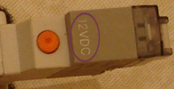
  - If the manifold with the ports comes separately, then add it to the main body being careful to use the rubber seal
  - Add tube fittings to the input and output ports using Teflon tape.
- Connect regulator via tubing to one solenoid at a time, so you can pressure test each new addition
- Add tube fittings to cylinder(s) using Teflon tape
- Connect the solenoid(s) to cylinders with tubing
- If you will have an even lower-pressure circuit, or othe solenoids to come, then leave a tail plugged for testing
- Run the compressor as before to see if the circuit holds air. The solenoids can be tested manually. Adjust the regulator to the low-pressure you want, e.g., 60-30psi.

For additional lower pressure circuits repeat as for the Low-Pressure Circuit above.
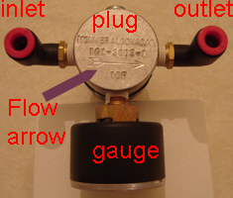

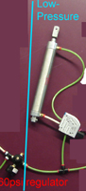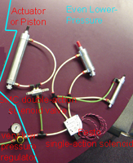

cRIO Wiring
We’ll assume the rest of your cRIO control system is already setup properly. Parts needed: black/red wire, female spade connectors, Power Distribution Panel, a 20a breaker for the compressor's Spike, plus 20a snap-action breaker(s) if optional Spike(s) are used, solenoid module + solenoid Breakout.
Most common mistakes: Not using color coded red/black wire making it easy to mis-wire, and not recognizing the difference between:
- Digital Sidecar General Purpose Inputs/Outputs (GPIO) (used for Pressure Switch & other switches)
- Digital Sidecar Relay Outputs (used for spikes controlling solenoids and the compressor)
- Solenoid Bumper Outputs (used for controlling solenoids instead of Spikes/Relays)
- Digital Sidecar PWM outputs (not used in pneumatics)
- Analog Bumper Inputs (not used in pneumatics)

Compressor
Most common mistake: wiring the compressor backwards (no it will not suck air out, and it won’t break anything).
- Wire the compressor to a Spike using female spade connectors
- Replace the Spike fuse with a 20a snap-action breaker
- Wire the Spike to the Power Distribution Panel using more female spade connectors on the Spike side
- Add another 20a snap-action breaker to the Power Distribution Panel.
- Connect the Spike to a Digital Sidecar Relay with a PWM-style cable
Note: The compressor will run fine in reverse, just inefficiently, so make sure red goes to Spike M+.

Pressure Switch
- Use only signal & ground from a PWM-style cable– the two outside pwm-cable wires, NOT power
- Connects to a Digital Sidecar GPIO Input.
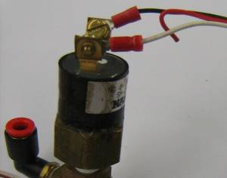

cRIO Solenoid Module Breakout Board
The breakout board on the solenoid module(s) must be wired back to the Power Distribution Panel using a small white wago connector that plugs directly into the breakout board. The other end of this wire at the Power distribution Panel end has two wiring choices (described in more detail on the next page):

- For 12v solenoids, wire the other end to a pair of the mid-sized wago connectors on the Power Distribution Panel with a 20a breaker.
- For 24v solenoids, wire the other end to the special cRIO connector on the Power Distribution Panel. The cRIO connector is labeled V - C - NC - C, but it is actually wired V - C - V - C, meaning +24V - GROUND - +24V - GROUND. Use the spare connection points. NOTE: only one 24v Solenoid Breakout can be used. The 24v solenoid breakout has a wattage limit of 16W for the 8-slot cRIO or 21W for the 4-slot cRIO, but these aren’t a problem with normal solenoids.

You can see a photo of the solenoid breakout board mounted atop a cRIO solenoid module in the picture on the next page.

Optional Solenoid Spikes
For 12v solenoids only, an optional/alternate way to connect and control them is through a Spike. The Spike is controlled by a Relay output on the Digital Sidecar and is wired for power from a regular 12v wago connection on the Power Distribution Panel with a 20a breaker.

Wiring Solenoid Valves
On the cRIO you have two wiring choices mentioned earlier: Solenoid Bumper (simplest) or the less common Spike/Relay. For detailed wiring consult the wiring diagrams:
    - Power (http://team358.org/files/programming/ControlSystem2009-/setup/2011PowerDistributionDiagram.pdf )
    - Control (http://team358.org/files/programming/ControlSystem2009-/setup/2011DataDiagram.pdf )
- To wire the solenoid directly to the Solenoid Bumper:
  - It’s the cRIO module labeled “9472”with the 8 green status LEDs and the associated Breakout that is shorter than the look-alike Analog Breakout.
  - The two solenoid wires (a pair from each end if it’s a double solenoid) need a two-pin female connector, then are plugged into one of the two-pin male outputs on the Breakout.
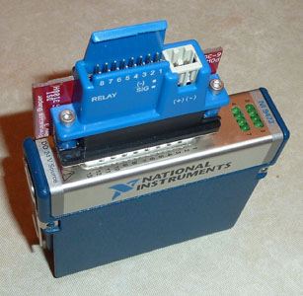
  - A single solenoid uses one Solenoid Bumper output, while a double solenoid must use two Solenoid Bumper outputs. Red wire goes to “+” on the Bumper, and black wire goes to “-“ as marked on the Bumper cover.

- To wire the solenoid to a Spike use female spade connectors.
  - Single-action solenoid just wire black to M- and red to M+
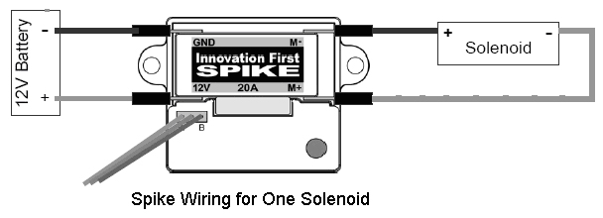
  - Double-action solenoids have two pairs of wires. The two reds go to M+ and M- respectively, while the two blacks join and go to the breaker panel. See the diagram.
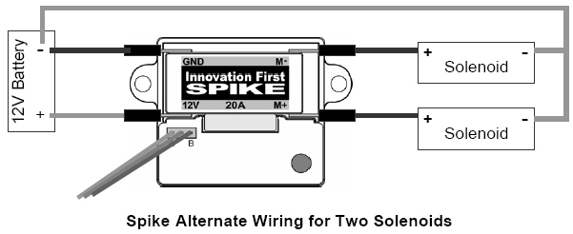
  - Wire the Spike to the Power Distribution Panel just as for the Compressor earlier and connect a PWM cable between the Spike and a Digital Sidecar Relay.
  - Add a 20a snap-action breaker for each solenoid.
- If just your compressor code is ready, the solenoids can be manually tested if you didn’t do so before and you have a basic pneumatics system setup. Flip the on switch and quickly, as the compressor runs, manually test each solenoid. Your cylinders should be moving in and out as you manually operate the solenoids.
  - Festo (pre-2010 version) - moving the blue switch (bottom left in image) in the direction of the arrow will shift the valve manually.
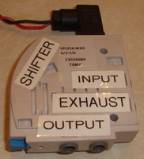
  - Festo (2010-2013 version) – IMPORTANT: This requires 24v power!
Pushing the blue buttons (on the right and left in image) will shift the valve manually.
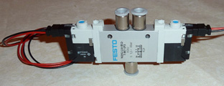
  - SMC solenoids buttons are small, so you may have to use a pen to push them. Note: the single solenoids will revert to the default position when the override button is released, but the double solenoid will stay in position.
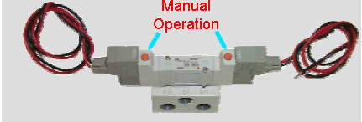

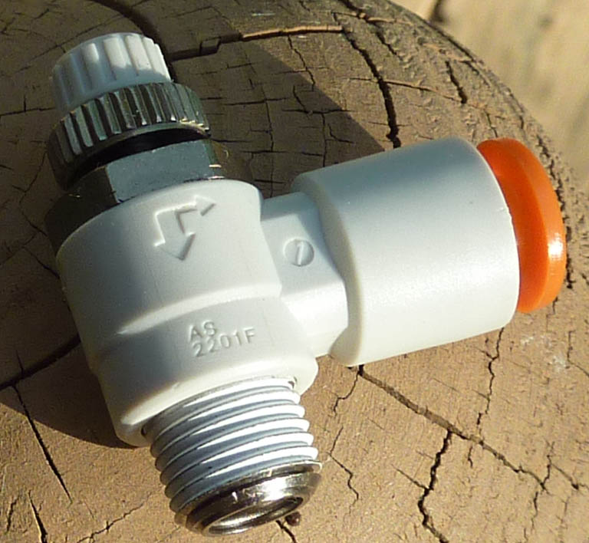
Special Parts

Flow control fittings
The cylinders normally operate as fast as the pressure allows, which can make for very quick and violent slamming. The reaction of a cylinder can be slowed down and softened by special adjustable flow control fittings that screw right into the cylinder ports. These types of fittings usually restrict the air flow in one direction only and are marked on the side with flow arrows (see photo) showing the direction restricted/unrestricted air flow. The large arrow is the unrestricted flow direction while the small arrow is the direction of air flow metered by the adjustable thumb dial. The thumb dial also has a locking nut underneath it to keep the setting from drifting during use.

Actuator magnetic reed switches/Magnetic cylinders:
These reed switches physically mount by clamps directly onto a special magnetic cylinder. They can be positioned anywhere along the cylinder to tell your code when a cylinder is open/closed or three-quarters open, for instance. Usually, a pair of reed switches will come with a magnetic cylinder order.
To hook these switches up to the control system, use just the signal and ground wires for a pwm-style cable. The pwm cable then connects to a Digital Sidecar GPIO Input.
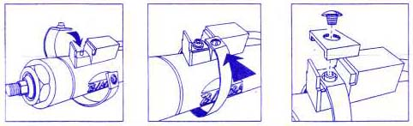

Assembling Regulators (Revisited)
There is a definite right way to assemble these. Some styles have a large arrow on the back. You will note on some types that one port extends out a little bit more than the others. It may have the flow direction arrow on it to denote the low-pressure outlet of the regulator. The opposite port at the tail of the arrow is the high-pressure inlet. All other ports are low-pressure. A pressure gauge may be placed in any of the low-pressure ports. You will have to plug any unused ports with the enclosed hex plug(s). Seal all threads with Teflon tape.

The all-black regulator must be used for stepping down the high-pressure, but the regulator with the yellow ring can be used between your low-pressure circuit and an even lower pressure sub-circuit.

Programming

LabVIEW

Compressor setup
This assumes the Spike to run the compressor is controlled through Digital Sidecar relay 1, and the pressure switch is connected to Digital Sidecar GPIO 1. These can be moved to other I/O/Relays as desired.

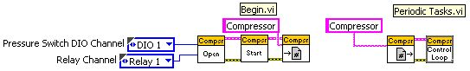

Solenoid connected to Spike/Relay
This is only one way to control a solenoid. This assumes you have connected the solenoid to a Spike controlled by Digital Sidecar relay 2, and uses the trigger on joystick 2 to forward/Reverse the solenoid.

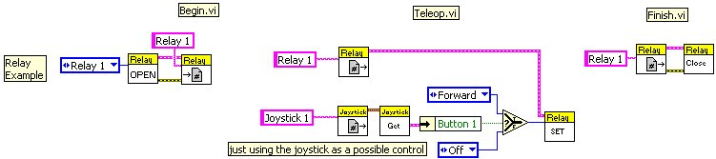

Solenoid connected to the cRIO Solenoid Bumper
This eliminates the need for a Spike and connects the solenoid directly to the cRIO’s Solenoid Bumper using the #1 pins. In these examples the trigger on joystick 2 controls the solenoid. The Bumper also has status lights for each set of output pins that indicate when it is activated.
Single Solenoid example:

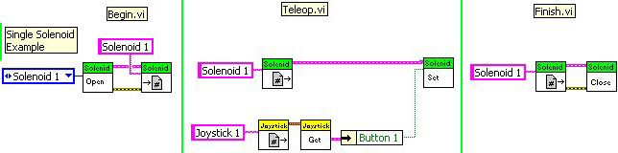
Double Solenoid example:

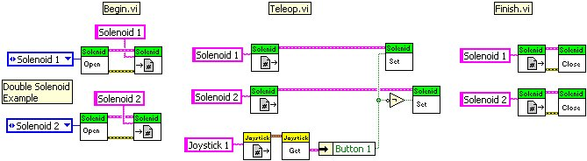
Alternate Double Solenoid example:

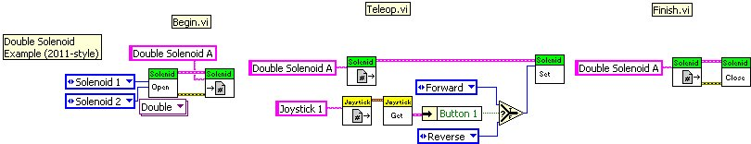

CC++
Compressor Example:

Compressor *c = new Compressor(4, 2);
c->Start();

Solenoid Example:

Solenoid *s[8];
for (int i = 0; i < 8; i++)
s[i] = new Solenoid(i + 1); // allocate the Solenoid objects
for (int i = 0; i < 8; i++)
{
s[i]->Set(true); // turn them all on
}
for (int i = 0; i < 8; i++)
{
s[i]->Set(false); // turn them each off in turn
Wait(1.0);
}
for (int i = 0; i < 8; i++)
{
s[i]->Set(true); // turn them back on in turn
Wait(1.0);
delete s[i]; // delete the objects
}

Relay Example:

Relay *r;
r = new Relay(2,kBothDirections); //allocate a Relay object
r->Set(kForward); // turn the relay to forward
Wait(1.0);
r->Set(kBackward); // turn the relay to backward

Java

Compressor
Constructor Summary:

Compressor(int pressureSwitchSlot, int pressureSwitchChannel, int compresssorRelaySlot, int compressorRelayChannel)

Constructor Details:

public Compressor(int pressureSwitchSlot,
int pressureSwitchChannel,
int compresssorRelaySlot,
int compressorRelayChannel)
Compressor constructor. Given a fully specified relay channel and pressure switch channel, initialize the Compressor object. You MUST start the compressor by calling the Start() method.
Parameters:
pressureSwitchSlot - The module that the pressure switch is attached to.
pressureSwitchChannel - The GPIO channel that the pressure switch is attached to.
compresssorRelaySlot - The module that the compressor relay is attached to.
compressorRelayChannel - The relay channel that the compressor relay is attached to.

Solenoid
Constructor Summary:

Solenoid(int slot, int channel)

Constructor Details:

public Solenoid(int slot,
int channel)
Constructor.
Parameters:
slot - The slot that the 9472 module is plugged into.
channel - The channel on the module to control.

Method:

set(boolean on)
Set the value of a solenoid.

Method Details:

public void set(boolean on)
Set the value of a solenoid.
Parameters:
on - Turn the solenoid output off or on.

Relay
Constructor Summary:

Relay(int slot, int channel, int direction)
Relay constructor given the module and the channel.

Constructor Details:

public Relay(int slot,
int channel,
int direction)
Relay constructor given the module and the channel.
Parameters:
slot - The module slot number this relay is connected to.
channel - The channel number within the module for this relay.
direction - The direction that the Relay object will control.

Method:

set(int value)
Set the relay state.

Method details:

public void set(int value)
Set the relay state. Valid values depend on which directions of the relay are controlled by the object. When set to kBothDirections, the relay can only be one of the three reasonable values, 0v-0v, 0v-12v, or 12v-0v. When set to kForwardOnly or kReverseOnly, you can specify the constant for the direction or you can simply specify kOff and kOn. Using only kOff and kOn is recommended.
Parameters:
value - The state to set the relay.

Troubleshooting
Sort of a checklist to evaluate problems, the key is patient and methodical checkout of the entire system.
- General layout
  - Parts in the wrong place
  - Pistons too large and powerful or too small and under powered.
  - Pressure too high or too low (<30psi). solenoids require 20-30psi to operate.
  - Piston moves too fast. Use flow valves fittings to slow down overly speedy pistons.
- Compressor won't shut off
  - Pressure sensor on the wrong side of the regulator
  - Sensor or compressor controlling pwm-cables not hooked to the correct Digital Input or Relay Output. If the sensor is not connected right, then typically Digital Inputs by default read like the compressor should be running.
  - Test the sensor output with a multi-meter (ohm setting)
- Compressor won't run
  - Compressor not wired to the spike to the breaker panel correctly
  - Missing spike breaker
  - Pressure sensor mis-wired or not connected to the right Digital Input
  - Fuse blown in the compressor spike
  - Sensor or compressor controlling pwm-cables not hooked to the correct Digital Input or Relay Output
- Pressure too high or too low (see testing for air leaks below)
  - Kinked or pinched tubing
  - High-Pressure side
    - An uncommon reason can be the automatic release valve you added to the compressor. It comes pre-set for 125psi and shouldn't be tampered with, but it can be knocked out of adjustment if the wrong piece was twisted by an inexperienced student. It does not let the high pressure get above 125psi no matter how much the compressor runs. It uses a double-nut to keep it secure, so with NO pressure in the system release the thin inner lock nut and tighten the larger, outer cap to increase the release pressure.
  - Low-Pressure side
    - Almost always due to the regulator,
      - Check that the low-pressure output port was used.
      - The regulator may be set to a lower or higher pressure than you want. Adjust the regulator by loosening the locking ring and twisting the base ring while watching the attached gauge change.
- Pistons don't move
  - Solenoid tubed incorrectly
  - Solenoid/spike not wired correctly
  - Spikes are controlled by RC Relay outputs. Make sure the spike pwm-style cable is hooked to a Relay.
  - Software incorrect
  - Test solenoid manual override to see if it's a pressure or an electrical problem.
    - Festo - moving the blue switch in the direction of the arrow will shift the valve
    - SMC solenoids buttons are small, so you may have to use a pen to push them. Note: the single solenoids will revert to the default position when the override button is released, but the double solenoid will stay in position.
    - Bosch-Rexroth - The yellow arm on the opposite side of the valve is the manual override. On this valve you can turn the override on and leave it in that position.
- Pistons moving in the wrong direction
  - Reverse the tubing going into the cylinder ends
- Regulator
  - Confusing the one low-pressure output port with the three high-pressure ports. On each regulator there is ONE port that is the low-pressure output, indicated by a directional arrow. The others are all high-pressure inputs/outputs.
  - Not dialing in the desired low-pressure.
  - Not tightening the adjustment dial lock.
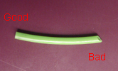
- Air leaks
  - Use a dead-end tube into a plugged brass fitting or a loopback T-fitting to isolate sections that are leaking. Isolate leaking pressure sections one by one, disconnecting later sections so you can concentrate on controlling leaks in one section at a time.
  - Look for the big leaks first by feel. Don't be fooled by air flowing from the Victor or other fans in your robot. When you get it down to tiny leaks then judicious use of soap blowing bubbles, soapy water, Windex can help locate problem joints.
  - Square cut tubing – tubing cut at any sort of angle rather than as square as possible will leak air from the system. The tube end needs to rest very flat inside the fittings to prevent air leaks.
  - Rough/scratched tubing ends also will not seal correctly
  - Failure to use Teflon tape to seal all screw thread fittings
  - Proper use of Teflon tape
    - Any Teflon that's been used once before should be replaced. Always use fresh Teflon and clean off all remnants. This means any on threads that have been screwed in once, then take off again need to have the Teflon replaced before screwing it on again.
    - Stop the Teflon several threads before the end to avoid scraps coming loose and clogging the solenoid valves.
    - Wrap Teflon in the opposite the direction you'll be screwing the threads in (clockwise as you look from the tip), so it pulls tighter rather than bunching up.
    - Make sure the wrap overlaps itself, but wrap it no more than twice around.
  - Cut or nicked tubing
  - Damaged fittings having either damaged threads through general abuse, cross threading, etc., or the seal on the push tube connection can be damaged from rough tubes, debris, or yanking the tube out too many times instead of releasing it properly.
  - Leaky regulator or other parts
  - Leaky solenoids
    - Large leaks could be caused by debris in the valve such as odd bits of Teflon tape or dirt. Try replacing the solenoid.
    - Most solenoid valves seem to suffer from slight leaks that slowly let air out of any system. No real solution to this problem other than for the SMC you can disassemble and rearrange the gaskets between parts. You can test if this is your problem by temporarily blocking or looping-back the exhaust ports.
    - Rarely, a valve can be stuck in an in-between state and you'll feel excess air escaping from one of the open exhaust ports. The valves only operate if they have some minimum air pressure to start with. To reset a stuck valve, force it up to minimum operating pressure by blocking the valve leaking exhaust vent with your finger, you can easily hold in the pressure, and the valve will self-reset at 20-30psi.
- Air used too quickly
  - Oversized actuators. Place your solenoid valves as close to the cylinders as possible to minimize that little bit of volume needed to fill the tubing.
  - Add more storage tanks
  - Too many actuators
  - Actuators used too often
  - Low pressure, 60psi or less, is too high, so too much stored air gets used too quickly.
  - Solenoids will stop operating when the system pressure drops too low (20psi for SMC & Bosch-Roxroth, 30psi for Festo). The running compressor provides .4 cubic foot of air per minute.
- Mis-wiring
  - Sensor PWM-style cable uses only signal and ground, NOT power.
  - Solenoid
  - Sometimes the SMC solenoids come with 24volt coils that must be replaced with 12v coils. Check to see each coil is printed with "12vdc."

Parts is Parts
Parts photos to help you identify what's what are shown in the FIRST Pneumatics Manual: http://www.team358.org/files/pneumatic/2012_FIRST_Robotics_Competition_Pneumatics_Manual.pdf
The pneumatics system is divided into a high pressure circuit where pressure is stored at 120psi, and one or more low-pressure circuits at 60psi or less, known as working pressure.

High Pressure parts
Air compressor
Storage tank(s) - 18.85 cu-in per tank
Pressure release – you must be able to manually dump the pressurized air in your system
Pressure gauge – must read 120psi or less at all times
Pressure sensor – must help the Robot Controller (RC) turn off the compressor at ~120psi (and on at ~95psi)
Primary 60psi Regulator – takes tubing for high-side pressure, low-side exit, a pressure gauge, and a plug for the extra port. Pay particular attention to the flow arrow so you use the special low-pressure outlet.

Low Pressure parts
Pressure gauge – must read 60psi or less
Actuator(s) – pistons that push and pull
Actuator(s) with magnetic reed switches incorporated
Solenoid valve(s) –
- Single action solenoid – has a home position it returns to when power is cut off.
- Double action solenoid – keeps an actuator in whatever position it was last in when power is cut off.
- Assembling SMC solenoid valves
Vacuum system
Secondary <60psi regulator(s) – optional to step pressure down to a second even lower operating pressure. Takes tubing for 60psi side, low-side exit, a pressure gauge, and a plug for the extra port. Pay particular attention to the flow arrow so you use the special low-pressure outlet.

General parts
All Brass fittings – plugs, 3-way,
Brass/plastic hybrids – straight, right angle
All Plastic fittings – 3-way tube,
Tubing

