Home > Products > Compressor Kits > C Model Compressors > 90 Series > 90C 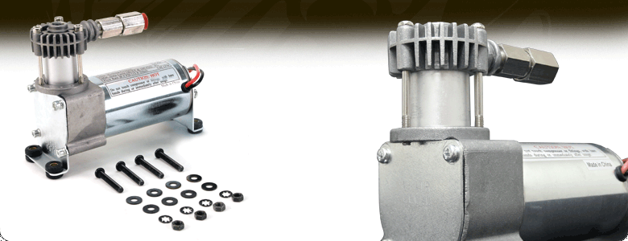


VIAIR 90 Series compressors offer a light duty solution for smaller air requirements and are meant to fill no larger than a 1.0 gallon air tank. Multiple duty cycle, mounting, compressor finish and intake options are available depending on model.
Included Parts
- Installation instructions included
- Mounting hardware included
- Vibration isolators included
- Check valve included Specifications
12-Volt
Permanent Magnetic Motor
Duty Cycle: 9% @ 100 PSI
Max. Working Pressure: 120 PSI
Max. Amp Draw: 10 Amps Tech Links
Dimensional Drawings
Recommended Wiring Diagram
Performance Data
PSI | CFM | A | BAR | LPM | A
0 | 1.03 | 7 | 0 | 29.0 | 7
10 | 0.71 | 8 | 1.0 | 19.0 | 8
20 | 0.67 | 8 | 2.0 | 18.0 | 9
30 | 0.64 | 9 | 3.0 | 16.5 | 9
40 | 0.60 | 9 | 4.0 | 15.0 | 10
50 | 0.57 | 9 | 5.0 | 13.5 | 10
60 | 0.53 | 10 | 6.0 | 12.5 | 10
70 | 0.48 | 10 | 7.0 | 11.0 | 9
80 | 0.45 | 10 | 8.0 | 10.0 | 9
90 | 0.43 | 10
100 | 0.39 | 9
110 | 0.36 | 9
120 | 0.34 | 9 | *Supply Voltage: 13.8 Volts
Fill Rates
0.5 Gallon Tank | Fill Rate
0 To 80 PSI | 48 Sec.
55 To 80 PSI | 16 Sec.
0 To 105 PSI | 1 Min. 08 Sec.
85 To 105 PSI | 14 Sec.
0 to 120 PSI | 1 Min. 23 Sec.
90 to 120 PSI | 25 Sec.
1.0 Gallon Tank | Fill Rate
0 To 80 PSI | 1 Min. 48 Sec.
55 To 80 PSI | 35 Sec.
0 To 105 PSI | 2 Min. 20 Sec.
85 To 105 PSI | 30 Sec.
0 to 120 PSI | 3 Min. 04 Sec.
90 to 120 PSI | 54 Sec.

