Practical Applications
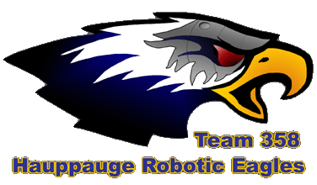
Team 358 Robotic Eagles
June 2008

Rangefinding
Okay, so you have a rangefinder – ultrasonic, IR, whatever – what do you do with it?
Let’s say you already have your rangefinder hooked up and you’re getting readings from it. You can tell something is in front of you and how far away it is to the inch. Now what? Who is your robot going to tell? What can your code do with that?

Variety of sensor choices
There are several methods of range finding readily available on the open market.
- Infra-red (IR) - $12.50
- Ultrasonic - $28
- Laser - $4,000

Now the laser range finder gives really great accuracy, but it’s a little steep for one of our robots. It’s useful to get one of each type to experiment with, because, one type will be better than another under different circumstances. The cheaper ones tell you something is there but not exactly where, while the laser sensor can easily fully map a room.

Choose an Interface
Rangefinders interface with your robot a bunch of different ways.
- Digital - A ping and timed echo initiated and measured by your code
- Analog - Constant feedback where the analog reading means 0=really close and 1024=too far away to see.
- Communication – I2C or Serial data packet of information is requested and is returned to your code

Considerations
Rangefinders have a variety of characteristics emphasizing one thing or another and you need to fit the sensor to the job you have to get done. Here are just a few things to take into account when choosing a model of rangefinder.
- How wide is the cone of detection?
- What is the distance it is optimized for?
- How well does it detect things at odd angles or in a variety of materials?
- Do you need several to accomplish your task?
- If you use multiple rangefinders do you avoid interference?

Here are a series of rangefinders made by MaxBotix that come in a variety of detection patterns. They can be hooked up to your controller three different ways – serial port, analog input, or pulse-width-modulation (pwm). The simplest method to deal with is the analog input, but they can also be free-running (meaning they ping constantly) or triggered (they ping only on command). Triggering the ping is advantageous when there are other ultrasonic sensors in use. In that case these sensors can be easily rigged to avoid interfering with one another by taking turns pinging, trigger one another, so that only one is pinging and listening for the echo at a time.

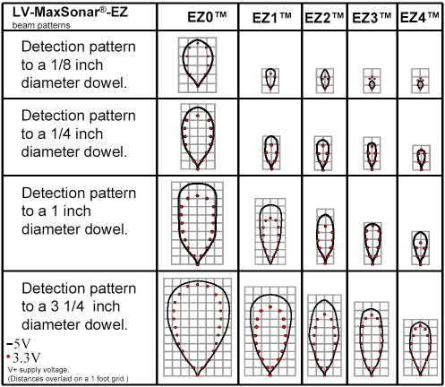

Test in your Environment
The environment you’ll use these sensors in is a major consideration. Angles and materials directly affect your readings or lack thereof. IR rangefinders will pass harmlessly through a clear window and you’ll never know it’s there, but ultrasound will bounce right back. Cloth will dampen and absorb ultrasound where IR will reflect back.

Sample Applications

Tape measure
Just by itself you now have a tape measure, coupled with other sensors that information alone can be pretty useful. Say for instance you want to shoot a ball and just need to pick a shooting angle and throwing power based on the range reading. This would reduce the problem to a simple lookup table or calculation where a range of 1 foot = a pre-calibrated angle and speed.

Example:

unsigned char HitMe (char angle)
{
unsigned int range;

range = Get_Analog_Value(MAXSONAR); //Returned value will be 0 to 1023, a distance

if (range < 120)
{
angle = 10;
}
else if (range < 500)
{
angle = 20;
}
else if (range < 750)
{
angle = 30;
}
else
{
angle = 45;
}
}

Let’s play keep-away
This algorithm is a form of obstacle avoidance that keeps the robot at a constant distance from any detected obstacle be it wall or human legs. If the object gets too close the robot will back away. If the object is too far away the robot will drive forward. When it’s just right the robot will stop and keep watching. It can make it difficult to pickup the robot though…

This example applies power proportional to how far we are from the target distance to temper how fast the robot zooms forward or backward, otherwise, it would tend to overshoot and be constantly shooting forward and then rapidly backing up, never quite settling down. This just causes the robot to slow down as it gets closer to the distance it wants to be.
This example uses:
- An IR rangefinder pointed straight ahead of the robot.
- A potentiometer mounted on the robot so we can dial in a distance the robot is ordered to maintain.

Example:
#define MIN_SPEED 30 //Any slower and the robot wouldn't be moving
#define MAX_SPEED 127 // Our maximum speed (<=127)
#define DISTANCE_TOLERANCE 10 // How close to the right distance is good enough?
#define KP 5/10 // Basic proportional adjustment, higher # gives faster response, but overshoots
#define LOW_IR_VALUE 70 // Minimum value at maximum IR sensor range
#define NEUTRAL 127 //Motors are not moving

void Auto_Distance (void)
{
unsigned int pot, IR_far;
int proportion;
int temp;

// Use a pot mounted on the robot just for the user to dial in a distance rather than hardcode one.
// Map pot input (0-1023) to IR range (616-80) so divide pot by 17 (1023/536~=2)
pot = Get_Analog_Value(POT_INPUT)/2; // User picks the distance we stay away

IR_far = Get_Analog_Value(IR_FARRANGE) - LOW_IR_VALUE; // How far away are we now?

// What's our current distance being returned by the IR rangefinder, a Sharp GP2Y0A02YK
// Useful range for this sensor is 6" to 60" or so (sensor is mounted 1.5" behind bumper)
// Closer than 6" = invalid out-of-range
// 575 = 6" (1st valid IF_far value)
// 350 = 12"
// 230 = 18"
// 205 = 24"
// 125 = 36"
// 105 = 48"
// < = invalid/out-of-range

//******** This distance is just right ********
if ( (IR_far >= pot) && (IR_far <= (pot+DISTANCE_TOLERANCE)) )
{
pwm01 = NEUTRAL; // Sit still
pwm02 = NEUTRAL; // Be still my motors
}

//******** We are too close ********
else if (IR_far > pot)
{
// Make our motor reaction proportional to how far we are from where we want to be
// If we're close then go slowly so we don't overshoot
// If we're farther away then we can go full speed to get where we want to be sooner
proportion = (int)(IR_far - pot) * KP;
if (proportion > MAX_SPEED) proportion = MAX_SPEED;
if (proportion < MIN_SPEED ) proportion = MIN_SPEED;

pwm01 = NEUTRAL + proportion ; // Backward proportional to error (254)
pwm02 = NEUTRAL - proportion; // Backward proportional to error (0)
}

//******** We are too far away ********
else if (IR_far < pot)
{
proportion = (int)(pot - IR_far) * KP;
if (proportion > MAX_SPEED) proportion = MAX_SPEED;
if (proportion < MIN_SPEED) proportion = MIN_SPEED;

pwm01 = NEUTRAL - proportion; // Forward proportional to error (0)
pwm02 = NEUTRAL + proportion; // Forward proportional to error (254)
}
}

