Who’s Who at FIRST

FIRST Leadership 2
Becky Alseth 6
Ken Johnson 7
Anna Maenhout 8
FRC Program Staff 10
September 2008 13
January 2009 18
June 2009 19
September 2009 21
January, 2010 28
June 2010 30
September 2010 32
June 2011 45
September, 2011 47
January, 2012 60
FIRST Newsletter - September, 2012 - New Faces at FIRST 66
New Faces at FIRST 66

FIRST Leadership

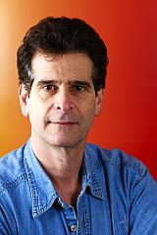
Dean Kamen
Founder, FIRST
President, DEKA Research & Development Corporation
Dean Kamen is an inventor, an entrepreneur, and a tireless advocate for science and technology. His roles as inventor and advocate are intertwined—his own passion for technology and its practical uses has driven his personal determination to spread the word about technology's virtues and by so doing to change the culture of the United States.
As an inventor, he holds more than 440 U.S. and foreign patents, many of them for innovative medical devices that have expanded the frontiers of health care worldwide. While still a college undergraduate, he invented the first wearable infusion pump, which rapidly gained acceptance from such diverse medical specialties as chemotherapy, neonatology, and endocrinology. In 1976, he founded his first medical device company, AutoSyringe, Inc., to manufacture and market the pumps. At age 30, he sold that company to Baxter International Corporation. By then, he had added a number of other infusion devices, including the first wearable insulin pump for diabetics.
Following the sale of AutoSyringe, Inc., he founded DEKA Research & Development Corporation to develop internally generated inventions as well as to provide research and development for major corporate clients. Kamen led DEKA's development of the HomeChoiceTM peritoneal dialysis system for Baxter International, Inc. The HomeChoiceTM system allows patients to be dialyzed in the privacy and comfort of their home and quickly became the worldwide market leader. Kamen also led the development of technology to improve slide preparation for the CYTYC (now Hologic Inc.) ThinPrep® Pap Test. Kamen-led DEKA teams have also developed critical components of the UVARTM XTSTM System, an extracorporeal photophereisis device marketed by Therakos, a unit of Johnson & Johnson, for treatment of T-Cell lymphoma. An advanced prosthetic arm in development for DARPA should advance the quality of life for returning injured soldiers. Other notable developments include the HydroflexTM surgical irrigation pump for C.R. Bard, the CrownTM stent, an improvement to the original Palmaz-Schatz stent, for Johnson & Johnson, the iBOTTM mobility device, and the Segway® Human Transporter.
Kamen has received many awards for his efforts. Notably, Kamen was awarded the National Medal of Technology in 2000. Presented by President Clinton, this award was in recognition for inventions that have advanced medical care worldwide, and for innovative and imaginative leadership in awakening America to the excitement of science and technology. Kamen was also awarded the Lemelson-MIT Prize in 2002, and was inducted into the National Inventors Hall of Fame in May 2005.
In addition to DEKA, one of Kamen’s proudest accomplishments is founding FIRST® (For Inspiration and Recognition of Science and Technology), an organization dedicated to motivating the next generation to understand, use, and enjoy science and technology.
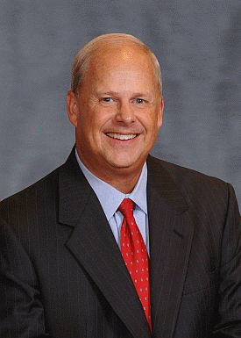
Walt Havenstein
Chairman of the Board, FIRST
CEO, Science Applications and International Corporation (SAIC)
Walter P. Havenstein joined Science Applications International Corporation (SAIC) as chief executive officer on September 21, 2009. He is also a member of SAIC’s board of directors.
He is also chairman of the board of directors of FIRST® (For Inspiration and Recognition of Science and Technology), a not-for-profit organization founded to inspire young people’s interest and participation in science and technology. He serves on the board of advisors for the Whittemore School of Business, University of New Hampshire.
Prior to joining SAIC, Havenstein served as chief operating officer and member of the board of directors for BAE Systems plc, a $34 billion global aerospace and defense company; and as president and chief executive officer of BAE Systems Inc., the company’s wholly owned U.S. subsidiary, which employs 53,000 employees and generates annual sales in excess of $20 billion. Havenstein previously served as president of the Electronics & Integrated Solutions Operating Group within BAE Systems. Before that, he was president of BAE Systems’ Information and Electronic Warfare Systems business unit. Havenstein was president of the Sanders defense electronics business prior to it being acquired by BAE from Lockheed Martin in 2000. Before joining Sanders in 1999, he had been vice president and general manager of the Strategic Systems Division for Raytheon. He began his defense industry career at the ITT Aerospace and Communications Division in business development and program management roles.
Havenstein received a bachelor’s degree in aerospace engineering from the U.S. Naval Academy and a master’s degree in electrical engineering from the Naval Postgraduate School. He served on active duty in the U.S. Marine Corps from 1971 to 1983, specializing in tactical communications and systems acquisition management, and completed his career in the Marine Corps Reserve in 1999 retiring as a colonel.
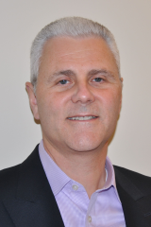Don Bossi, President
Don Bossi joined FIRST as President in May, 2013. Don, who has excelled in a 20-year career with several high technology companies, primarily in the fiber optics field, brings deep technical and management skills to the organization. Starting his career as a research scientist, first at MIT Lincoln Laboratory and then at United Technologies Research Center (UTRC), Don was a part of an advanced project at UTRC which was acquired by JDS Uniphase (JDSU). After a series of promotions at JDSU, he became Vice President and General Manager for JDSU Electro-Optics Products. Don next served as Group President of JDSU Active Components Group, and then as Group President, JDSU Transmission Products Group. In 2005, Don joined Technology Ventures Partners, serving first as CEO of Aegis Lightware, Inc. and then as CEO of Inlet Technologies. Most recently, Don served as the COO of CIDRA Holdings.
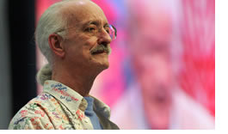
Woodie Flowers
FIRST National Advisor
Dr. Woodie Flowers is the Pappalardo Professor Emeritus of Mechanical Engineering at the Massachusetts Institute of Technology and a Distinguished Partner at Olin College. Dr. Flowers participates in the design of the FIRST Robotics Competition game each year. He has served as a National Advisor to FIRST since the inception of the FIRST Robotics Competition.
Dr. Flowers helped create MIT's renowned course "Introduction to Design." He also received national recognition in his role as host for the PBS television series Scientific American Frontiers from 1990 to 1993 and received a New England EMMY Award for a special PBS program on design. He is a member of the National Academy of Engineering and a Fellow of the American Association for the Advancement of Science and of the American Society of Mechanical Engineers. He recently received The Joel and Ruth Spria Outstanding Design Educator Award from ASME, a Public Service Medal from NASA, and a Doctor Honoris Causa from Andreas Bello University in Chile. He is a MacVicar Faculty Fellow at MIT for extraordinary contributions to undergraduate education. He was also the Inaugural Recipient of the Woodie Flowers Award by FIRST. Currently, Dr. Flowers is a director of three companies. He and his wife Margaret live in Weston, Massachusetts.
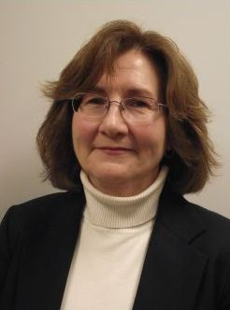
Virginia Szymanowski
Senior Advisor to the President, FIRST
As Senior Advisor to the President, Ginny provides managerial support to all members of Senior Management, as well as having responsibility for business planning and Human Resources. Prior to serving in this role, Ginny was a member of the FIRST Finance Department for four years specializing in Financial Planning and Compliance.
Ginny has worked in financial management and planning in the not-for-profit sector for 20 years, including work for a state-wide historical society, a Federal Health Center, a fine art museum, and a social services agency. Like FIRST, these organizations strive for the betterment of children, which has become Ginny’s life work. Prior to entering the not-for-profit world, Ginny worked in finance for a multi-national manufacturer of optical devices, and as an auditor for a major accounting firm.
Ginny is a CPA and holds a Bachelor’s degree from Boston University, an MBA from Babson College, and a Master of Science in Taxation from Bentley College.
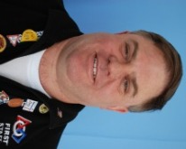
Steve Chism
Vice President, Programs, FIRST
As Vice President of Programs, Steve Chism has overall program responsibility for all FIRST programs including budget, planning, implementation and logistics. At FIRST, Chism has worked tirelessly with each Program Director to oversee the tremendous growth in the FIRST mission through all four programs: FIRST Robotics Competition (FRC), FIRST Tech Challenge (FTC), FIRST LEGO League (FLL) and Junior FIRST LEGO League (Jr. FLL). Chism joined FIRST as the Senior Director of Programs in 2003.
Chism brings more than 23 years of leadership and experience in technical programs for the U. S. Navy in submarines and submarine related systems development and acquisition. While teaching in the Naval Architecture, Ocean and Marine Engineering Department of the U. S. Naval Academy, Chism started and co-mentored the FIRST Robotics Competition (FRC) Team 165, Das Goat, in 1998. Chism then went on to both volunteer and judge as an FRC Judge and Judge Advisor for several years before becoming the Committee Chair of the Chesapeake Regional Planning Committee. It was in September 2003, after the successful inaugural FRC Chesapeake Regional at the U. S. Naval Academy in March 2003, that Chism signed on with FIRST to be the Senior Director of Programs.
He has earned his Bachelor of Science in Electrical Engineering degree at the University of Southern California, a Master of Science in Mechanical Engineering degree and Degree of Mechanical Engineer at the Naval Postgraduate School, and his Master of Science in Engineering degree at The Johns Hopkins University. Chism also holds a level III Program Management certification from the Defense Management Systems College for his work related experiences in submarine industrial shipyards and systems acquisition jobs in the U. S. Navy.
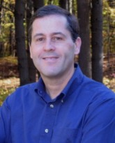
Terry Durkin
Vice President, Finance, FIRST
Terry Durkin is Vice President of Finance at FIRST. Durkin joined FIRST in 1999 as the Director of Finance adding Administration to his duties shortly thereafter. In addition, Durkin has had interim responsibility for Human Resources (2004-2006), Information Technology (2005) and has overseen the management of the FIRST facility since 2003.
Prior to joining FIRST, Durkin held financial positions at several major New Hampshire for-profit corporations including ten years at Sanders Associates (now part of BAE Systems), five years with Freudenberg-NOK as Controller of the Bristol New Hampshire manufacturing plant, and he later joined a manufacturing startup LLC in Maine.
Durkin received his bachelor's degree in business administration from Fairleigh Dickinson University in New Jersey and his MBA from Rivier College in New Hampshire. His volunteer interests include the Lions Club and serving on the board of David's House, a 501(c)(3) whose mission is to provide support and a home-away-from-home for families with children receiving treatment at Children's Hospital at Dartmouth-Hitchcock Medical Center.
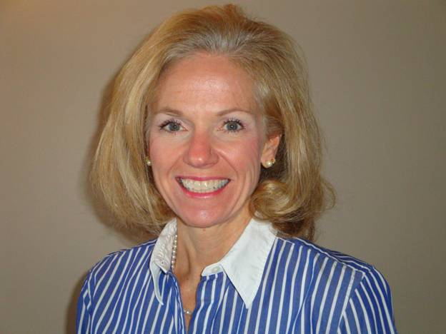
Roseann Stevens
Vice President, Field Operatons, FIRST
Roseann Stevens is Vice President of Field Operations at FIRST. She is responsible for field operations and has principal responsibility for overseeing Regional Directors and Committees, managing a global Volunteer and Mentoring Resources, and organizing and promoting Regional Events and Strategic Partners for FIRST.
Stevens has been affiliated with FIRST for more than 10 years, serving as a Mentor, Judge and Judge Advisor for FIRST events. She has more than 25 years of industrial technology experience in the automotive industry, having worked for Tier-1 suppliers such as Lear, Visteon and Metaldyne. She became the first female vice president at Lear and was instrumental in leading the sales team that won the first-complete interior program. Her specialties include organizing global sales teams and expanding markets.
She began her career with the Ford Motor Company and has twice been listed on “The 100 Leading Women in the North American Auto Industry.” In addition, she has served on the boards of CLARCOR, Inforum, the Automotive Women’s Alliance and the Girl Scouts of Metro Detroit. She holds a bachelors degree and an M.B.A. from the University of Detroit Mercy.

Becky Alseth
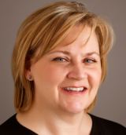
Chief Marketing & Development Officer, FIRST
Becky Alseth is the Chief Marketing & Development Officer for FIRST. Prior to joining FIRST, Alseth spent 9 years leading the U.S. marketing team at the leading car rental company, Avis Budget Group. In that role, Alseth oversaw all marketing efforts including brand strategy, consumer insights, advertising and media, marketing partnerships, CRM, and e-commerce. She started her career working in a series of progressive brand management roles at leading Fortune 500 companies including The Clorox Company, Nestle, and Diageo. Alseth also had the opportunity to join an Internet start-up, move.com, and a medical device company, Therasense. Alseth believes she spent the last two decades learning both the art and science of marketing, so she would be ready to join FIRST and contribute to its important mission.
A native of Montana, Alseth earned her Bachelor of Science in the technical field of Society & Technology from Montana Tech, and her MBA from the University of Washington Foster School of Business in Seattle.

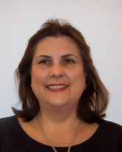
Cheryl Walsh
Senior Director, Marketing, Media Relations and Alliances, FIRST
As Senior Director of Marketing, Media Relations, and Alliances, Walsh is responsible for traditional and emerging communications channels to raise brand awareness of all FIRST programs. Walsh joined FIRST in 2008 with more than two decades marketing and corporate communications experience. Her work for technology, education, and management consulting firms brings a combined corporate, agency, and non-profit perspective to FIRST’s brand management strategy.
Walsh has worked across all global communications disciplines including marketing, branding, corporate communications, Web marketing, and public relations. She has held a number of senior positions for Boston-based public relations agencies including Senior Vice President at Brodeur Worldwide, Vice President at SHIFT Communications, and Senior Counsel at Topaz Partners. Her industry experience includes software and hardware, telecommunications, business-to-business, management consulting, education, defense contracting, and financial services for companies such as BBN, Arthur D. Little, FTP Software, and The Hanover Insurance Group.
Prior to her corporate work, Walsh held educational public affairs positions at the University of Massachusetts (UMASS), Amherst and the WANG Institute of Graduate Studies. A member of the board of directors for the United Nations Association of Greater Boston (UNAGB), she holds a master’s degree in business administration from Suffolk University’s Sawyer School of Management and she earned her bachelor’s degree in journalism and English literature from UMASS, Amherst as well as an international certificate from Wroxton College in Oxfordshire, England.

Ken Johnson
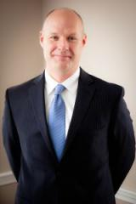
Director, FIRST Tech Challenge, FIRST
Ken Johnson is the Director of FIRST Tech Challenge (FTC), one of two FIRST programs directed toward inspiring grades 9-12 youth towards continued education and careers in science and technology.
Prior to joining FIRST, Johnson was Vice President of Ward Hill Marketing, a technology marketing group that worked with emerging technologies in various markets including alternative energy, semiconductor process equipment, and photonics. He has also served as Vice President for Labsphere, a photonics based organization serving both defense and commercial entities worldwide.
He has also held senior positions in technology companies involved in power systems, avionics, and medical devices.
Johnson has an undergraduate degree in finance from the University of South Florida and earned his MBA at the University of New Hampshire.

Anna Maenhout

Director, FIRST LEGO League and Junior FIRST LEGO League, FIRST
Anna Maenhout has been the Director of the FIRST LEGO League program at FIRST since its inception ten years ago. She also manages Junior FIRST LEGO League, a three-year program she piloted in 2004. Maenhout came to FIRST in 1998 with a broad background in business management, primarily in organizational and corporate communications.
She spent more than 12 years at Digital Equipment Corporation where she held progressive assignments developing and implementing domestic and international communication strategies. Maenhout was recognized by both Digital and numerous Fortune 500 customers for her innovative and rapid response programs. Subsequently, she joined the management team of New Media Solutions, a start-up company consulting with major U.S. corporations on the use of leading edge multimedia technology as sales tools.
Maenhout holds a bachelor’s of science in Psychology from Boston College.

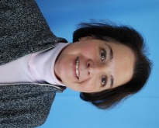
Dia Stolnitz
Director, Strategic Projects, FIRST
Dia Stolnitz is Director of Strategic Projects for FIRST. She has served in a range of roles at FIRST since 1993, joining first as a consultant under a National Science Foundation grant, and then full-time to start FIRST Place, an R&D hands-on science and technology facility in Manchester for students, teachers, community and national groups. She has also served as Director of Development for the organization. As Director of Strategic Projects, she is responsible for FIRST’s key national events, managing FIRST’s research and evaluation efforts and initiatives, direction of FIRST Place to expansion, as well as assisting the President with the FIRST Board, and she is key liaison with the FIRST Executive Advisory Board.
Prior to joining FIRST, Stolnitz was the Founder and Director of The Idia (Intervale, Design, Idea & Art) Center (Intervale, NH), a multidisciplinary art center offering exhibits, performances, special events (1989-1993). Previously she worked at Edwin Schlossberg Incorporated (New York, NY) as a Conceptual Designer of participatory exhibit programs for entertainment and educational sites, at the Museum of American Folk Art (New York, NY) as a Project Director of Special Events, and as a consultant for interactive collaborations with museums and public centers.
Stolnitz is an artist who works in photography, sculpture, and multimedia installation. She received her BA from Reed College and an MFA from Yale University. She has exhibited work nationally and is represented in several museum collections and teaches on faculty at the New Hampshire Institute of Art in Manchester.

FRC Program Staff

Frank Merrick
Director, FIRST Robotics Competition, FIRST
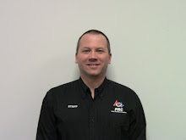
I’ve been working for FIRST since 2008 as Deputy Director of FRC. In my career before FIRST, I worked in organizations including the United States Air Force and Rockwell Automation, and held positions including Engineering Manager, Production Manager, Quality Manager and Procurement Manager. I graduated in 1987 with a bachelor’s of science degree in Electrical Engineering from Rensselaer Polytechnic Institute. Several years later, I received my MBA from the University of New Hampshire. My introduction to FIRST came in 2002 with a call from Dave Kelso of Team 131 in Manchester, who was looking for a new build site. I mentored team 131 for 4 years, and have started two FIRST LEGO League teams, one of which I still coach, and several Jr.FLL teams. In 2011 I coordinated a Jr.FLL Expo at UNH, which was a great deal of fun. In direct on-the-ground support of FRC regional events, I’ve been FTA at the New York City, Philadelphia, and Seattle Regionals.

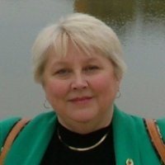 Wendy Trommer Program Coordinator

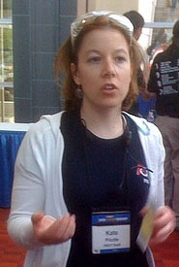Kate Pilotte KOP Manager
Matt Pilotte, Electrical Engineer
Derek Foster, Engineering Project Manager
• Supervision of Engineering Technicians, Field Maintenance, and seasonal employees.
• Yearly design of playing field and transportation cases.
• Ensure that field mechanicals are ordered, manufactured, prepped and packed in time for competition season.
• Support GDC activities by building prototypes of field components and robots.
• Responsible for cost control within the FRC Field budget.
• Worked as a FIRST Technical Advisor at regional competitions. Instruct groups of volunteers in building and teardown of FRC field. Ensure that the competitions meet quality and schedule requirements.
Charlie Jacobs, Engineering Manager
Reports directly to the Director of FRC , and is responsible for managing a team of engineers and technicians that support game design, field fabrication, and test and verification of all components that comprise the field

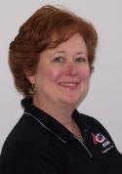
Carla Proulx, International Coordinator, FIRST Robotics Competition (FRC)
This newly created position will provide support to our international contingent as FIRST looks to expand into other countries throughout the globe. In addition, Carla will continue to provide support to FRC Director Bill Miller, engineering management, and the entire FRC HQ team.
In her previous role as VP of Operations for Severn Trent Environmental Services, Carla saw firsthand the void of new engineers entering the environmental field. She shared the concern of her senior colleagues that more needed to be done to attract students to careers in engineering in order to meet the increasing industry demand. She worked on many initiatives with the New England Water Environment Association (NEWEA) and the NH Water Pollution Control Association (NHWPCA) to encourage an interest in the field through exposure and mentorships within the environmental community. High on that list was introducing female students to the many career opportunities available to them and how the industry had evolved over the years.
Leaving big corporate behind, Carla accepted a yearlong contract to help launch New Hampshire’s first middle/high school dedicated to students with an interest in math, science, and engineering. The Academy for Science and Design opened its doors in Merrimack, NH in the fall of 2007 and has doubled its student body in just one short year.
Carla joined FIRST in December of 2007 after hearing so much about the program from Academy students. She’s heard countless stories and sees the difference FIRST programs make in the lives of these students. “I see some great future engineers in these kids and THAT makes me very happy!”

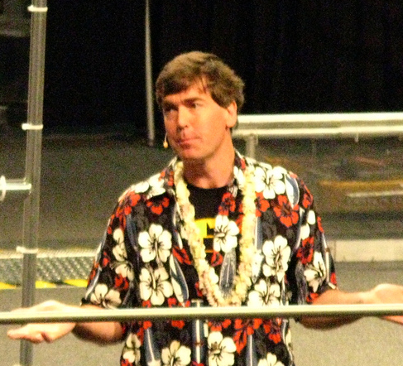
Blair Hundertmark, Production Developer at FIRST

September 2008

New Faces at FIRST
As FIRST continues to grow at a rapid pace, we are pleased to welcome and introduce several new members of the FIRST Community who are helping us implement our programs around the globe and recruiting more young people, volunteers, and sponsors to FIRST.
FIRST Regional Directors… work collaboratively to create and maintain volunteer driven, self-sustaining, and growing FIRST programs in a named geographic area.

Connie Haynes, FIRST Regional Director for Georgia and Tennessee
About ten years ago, I was introduced to FIRST by chance. My husband, daughters, and I had gone to Disney World for a dual purpose – a few days in the parks and to check out this new FIRST organization for possible sponsorship from my husband’s company. Naturally, the girls and I left work to my husband and we headed off to the park for another day of Mickey. When I received a call from my husband saying, “You have got to get over here and see this. You are going to be blown away!” Little did I know that the focus of my volunteer work was about to change. After learning that our current home state, Georgia, was poorly represented, we both vowed to change that. And that is exactly what we have been doing ever since.
Being an educator for many years, I have seen the next best thing in education come and go many times. From the beginning of my involvement with FIRST, I saw something different – something that excites students with real-world application and fosters a ‘can do’ attitude from many who were simply coasting along. Not only does FIRST change attitudes about success in the areas of science and technology, it brings together a group of kids, at every level of FIRST, who develop a peer group that is so important in their educational career. I have been privy to many success stories. That is why I am still with FIRST and feel privileged to have the opportunity to take GeorgiaFIRST to the next level. My home state of Tennessee is poised to be one of the next growth areas for FIRST and I am excited to lead this charge as well.
I look forward to a long, productive relationship with FIRST and commit myself to bringing this program to as many of today’s youth as possible. Our future depends on the scientists, engineers, and leaders we develop today. FIRST’s future depends on us!
Dan Holzmiller, Assistant Regional Director for Wisconsin
Dan will be working with FIRST Regional Director, Susan Lawrence. He brings 10 years of FIRST experience with him and a wealth of knowledge of FIRST in the state of Wisconsin. In addition, he has been a Chemistry teacher which will be a great help in his new role recruiting teams, teacher/mentors, and building FIRST programs.
Stan Toney, FIRST Regional Director for Maryland
Stan has spent his career in high technology and is currently teaching Physics and Chemistry in the state. Stan will be a team member in the "Capital Region" which includes the FRC Regional events at Chesapeake, Washington, DC (new) and NASA VCU, working with Regional Director, Pattie Cook.
FIRST Senior Mentors... "Make Magic Happen” by seeking out, recruiting, and fully supporting Team Mentors and Event Volunteers for FIRST programs and other initiatives in the geographic area in which they reside.
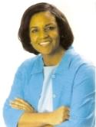
Denise Lewis, Senior Mentor, Washington, DC
Denise is a dedicated educator, consultant, and community volunteer extraordinaire. She holds both a BA degree in Economics and a MS degree in Education. She is a veteran FIRST Coach and Mentor. Currently, she serves as leader of the Robotics Ministry at the Mount Airy Baptist church in DC.

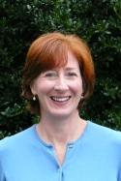
Sally Sylvester, Senior Mentor, Virginia
Sally, a former BCBS Training & Development Professional, has begun her Senior Mentor career in grand style by hosting FLL Coach Orientation & training calls. She is a 4-year veteran FLL Coach and parent volunteer with an FRC Team.


Jane Young, Senior Mentor, SE Texas (no longer)
When she’s isn’t busy running the Legal Services office at the University of Texas, Austin, Jane keeps busy as a FIRST Senior Mentor. After 6 years as a team mentor for the FRC Team 418 “LASA Robotics,” she still continues taking “breaks” by volunteering at FIRST events or running NEMO workshops.

FIRST Americorps*VISTAs… work to create awareness of FIRST in their community, focusing particularly on the needs of the underserved initiative, while seeking sponsors, mentors, and volunteers for FIRST programs.

Clinton Clegg, AmeriCorps*VISTA, Pittsburgh
Indiana University of Pennsylvania grad, a background in Computer Technology, and a talented song writer/musician, Clinton is well equipped to inspire students about FIRST.

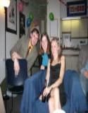
James Conlon, AmeriCorps*VISTA, Philadelphia
Bucknell U. Grad, Roller Hockey – Team Founder & Coach, Boxer, Guitar Instructor, and now a FIRST VISTA. And… he’s just warming up!

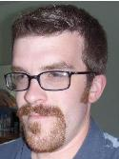
Joshua Dallaire, AmeriCorps*VISTA Leader, New Hampshire
Josh has just completed his inaugural and successful term in Maine as a FIRST AmeriCorps*VISTA. He enters his second season wearing a new hat: “VISTA Leader.” We congratulate Josh on his accomplishments and look forward to a spectacular season with our FIRST VISTAs and Senior Mentors.

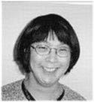
Eileen Phillips, AmeriCorps*VISTA, Massachusetts
Eileen begins her FIRST VISTA service with a tool bag full of degrees, experience, skill, and a deep passion and commitment for helping youth to realize their goals. Look out Massachusetts… Eileen is not shy about having her way…

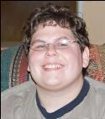
Adrianna Lynn Saar, AmeriCorps*Vista, New Jersey/New York City
Adrianna is a recent graduate from Rutgers University in Business Management. A lady of many talents, she will be guiding the Media and communications support for underserved organizations in New Jersey and NYC. Welcome to FIRST, Adrianna!


Nathan Smith, AmeriCorps*VISTA, Maine
Nate is highly skilled in Computer Technology. Nate has also logged more than 10 years in FIRST beginning as a FRC team member & mentor to a career of providing outstanding service as a Field Support volunteer. Welcome home, Nate!

FIRST International Coordinator… supports our international contingent as FIRST looks to expand into other countries throughout the globe.
Carla Proulx, International Coordinator, FIRST Robotics Competition (FRC)
This newly created position will provide support to our international contingent as FIRST looks to expand into other countries throughout the globe. In addition, Carla will continue to provide support to FRC Director Bill Miller, engineering management, and the entire FRC HQ team.
In her previous role as VP of Operations for Severn Trent Environmental Services, Carla saw firsthand the void of new engineers entering the environmental field. She shared the concern of her senior colleagues that more needed to be done to attract students to careers in engineering in order to meet the increasing industry demand. She worked on many initiatives with the New England Water Environment Association (NEWEA) and the NH Water Pollution Control Association (NHWPCA) to encourage an interest in the field through exposure and mentorships within the environmental community. High on that list was introducing female students to the many career opportunities available to them and how the industry had evolved over the years.
Leaving big corporate behind, Carla accepted a yearlong contract to help launch New Hampshire’s first middle/high school dedicated to students with an interest in math, science, and engineering. The Academy for Science and Design opened its doors in Merrimack, NH in the fall of 2007 and has doubled its student body in just one short year.
Carla joined FIRST in December of 2007 after hearing so much about the program from Academy students. She’s heard countless stories and sees the difference FIRST programs make in the lives of these students. “I see some great future engineers in these kids and THAT makes me very happy!”

January 2009

New Faces at FIRST
Sue Glasspiegel, our new Regional Director for Connecticut.
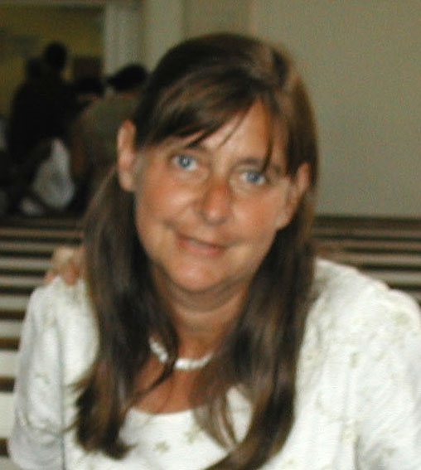
Sue Glasspiegel joined FIRST on September 15 as the new Regional Director for Connecticut. In the four months she has been aboard, she has met with the Connecticut Steering Committee and FIRST Robotics Competition (FRC) Planning Committee and has had some strategic planning meetings with the Executive Advisory Board. She has also accompanied Mike Sperber, Kathie Kentfield, Paul Gudonis, and Rod Miller on some sponsorship visits. Although Sue has led and been part of several health, cultural, and business non-profits, the world of FIRST has been a pleasant, exhilarating eye-opener. She feels particularly grateful for the seasoned, dedicated volunteers who are supporting her in Connecticut.
FIRST Regional Directors work collaboratively to create, maintain, and grow volunteer-driven, self-sustaining FIRST programs in a named geographic area.

June 2009

New Faces at FIRST
Dennis Garrigan, Marketing Communications Programs Manager
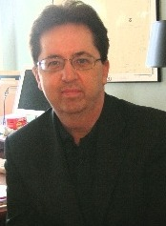
Dennis Garrigan has joined FIRST as Marketing Communications Program Manager and is responsible for developing and executing marketing support for FIRST programs, specifically FIRST Tech Challenge and Volunteer Mentors as well as Alliances and will be setting the direction for program-specific marketing communications strategy and planning to build awareness of FIRST and its key initiatives and emerging markets.
Dennis has more than 25 years of combined media, marketing communications, and public relations experience, serving in roles as an agency consultant to industrial technology companies and non-profits, and previously, as a broadcast news anchor and director. In addition to serving as a consultant to technology agencies such as Davies Murphy Group, Eric Mower and Associates, and Brodeur Worldwide, he was chief marketing officer at Ohio Northern University, an institution dedicated to promoting engineering programs and, in particular, women in engineering. With a B.A. in journalism from Creighton University, Dennis authored the public relations chapters of Guerrilla Marketing for Dummies. His work has been recognized by the Associated Press and the Business Marketing Association (BMA).
Naomi Mancuso, Operations Coordinator

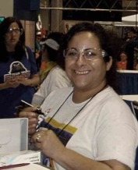
Naomi Mancuso attended and graduated from Franklin Pierce College here in our very own Rindge, New Hampshire. She went on to work for the Empire Development Corporation (government for the State of New York), where she was a Project Manager for the 42nd Street Development Project. In this role, Naomi was a part of a team that helped to restore, restructure, and rebuild 42nd Street between Broadway and the Port Authority in New York City. She then came to New Hampshire to study in law school, becoming a paralegal for an immigration law firm. Naomi says she found her way to FIRST after hearing what a great impact it had on students, and thought it would be great to be a part of this talented and extraordinary group.

Roy Temper, Vice President of Development (left January 2011)
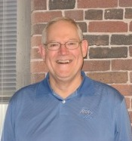
Roy Temper has joined FIRST as Vice President of Development, responsible for fundraising strategies; relationships with major sponsors and individual donors; proposals and grant management; and the scholarship program.
Roy brings significant non-profit fundraising experience to FIRST as well as a passion for education and youth programs. He began his professional life as a middle-school teacher and then spent 15 years with the YMCA, where he served as CEO in several communities and as director of the Management Resource Center in Rochester, NY for the National Y. After leaving the Y, Roy served as Fundraising Counsel for three national/international firms for 29 years – President of J. Donovan Associates, Executive VP of Ketchum, Inc., and Senior Strategist for Changing Our World, Inc. (Omnicom Group). Roy has provided fundraising counsel to 1,100 national and international organizations, raising over $1 billion. His areas of expertise include annual giving, capital/endowment campaigns, corporate support, foundations, major individual giving, and planned giving. Roy is a resident of Campton, New Hampshire, and he and his wife have 2 adult children and 3 grandchildren.

September 2009
New Faces at FIRST
FIRST Headquarters Staff ...

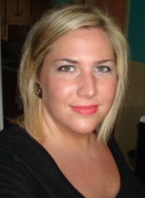
Dana Chism, Program Manager, Junior FIRST LEGO League (Jr.FLL)
Dana Chism has joined FIRST as Program Manager for Junior FIRST LEGO League (Jr.FLL). No stranger to FIRST, Dana has worked as an event assistant manager at FRC Regionals in both Maryland and Pennsylvania, and most recently has worked under contract in FIRST Place as an Education Coordinator. Prior to working for FIRST, Dana was a Title 1 Math Specialist and Classroom Teacher for Prince George’s County Public Schools in Maryland. Dana earned her BS in Elementary Education at the University of Maryland and has an Elementary Education Teacher Certification for New Hampshire and Maryland. Dana comes as a teaching professional with experience both in the classroom and working in an administrative role helping to set up new school programs, as well as having hands-on experience working at FIRST. Dana is looking forward to expanding the Jr.FLL Program globally and helping to spread the mission of FIRST to many more young eager scientists!
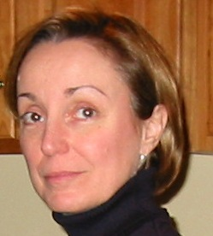
Lee Doucette, Partner Services Manager, FIRST LEGO League (FLL)
Lee Doucette has joined FIRST as FLL Partner Services Manager for the East Coast (US & Canada). Lee spent eight years as the director of a non-profit childcare center that included three sites, offering care to children ages 6 weeks to 6 years including a special needs program; 6 years as the Headmaster’s Assistant at Kimball Union Academy, a private school in NH; 5 years as a legal assistant; worked as Executive Director’s Assistant/Operations Manager at Conflict Management Group, a non-profit conflict negotiation training and consulting organization; and, most recently, co-owned a for-profit business where she was involved primarily in graphic design and customer service. Lee attended the University of New Hampshire.

Haley Dunn, Operations Coordinator
Haley Dunn graduated from the University of New Hampshire in May of 2009, receiving her Bachelor's in Communications. During her college career, she participated in the Honors in Major program and completed her thesis which focused on identity representation within online venues. She presented her findings at UNH's annual Undergraduate Research Conference in April of 2009. Before joining FIRST, Haley interned at New Hampshire Public Television as a Communications and Promotions assistant. It was during her fantastic experience with NHPTV that Haley discovered she very much enjoyed working for a non-profit organization; a realization that—at least in part—sparked her interest in working for FIRST. Haley is excited and honored to be a new member of the FIRST team, and is looking forward to working with this wonderfully talented and devoted group of people.
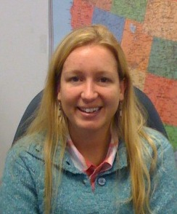
Amy Mitchell-Hartson, Program Manager, FIRST LEGO League (FLL)
Amy Mitchell-Hartson joined the FIRST team in July as the FLL Program Manager. Amy earned her BA in Environmental Science from Franklin Pierce College in Rindge, NH and her Master’s Certificate in Organizational Leadership from Kansas State University.
Amy brings over 10 years of non-profit leadership to FIRST. Prior to joining FIRST, Amy was a Program Director for NFI North in Concord, NH where she managed contracts between NFI North and the NH Department of Health and Human Services. Amy worked for the Society of the Protection of NH Forests as the Rocks Estate Assistant Manager and North Country Education Coordinator. In her current role at Program Managerat FIRST, Amy is responsible for the production of the FLL field setup kit and mat, as well as the team FLL registration system.
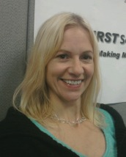
Jael Roberge, Senior Mentor and AmeriCorps VISTA Programs Manager
Jael Roberge’s first FIRST experience was as a volunteer within the Volunteer Resources Department. Soon after, it became apparent that the vision behind FIRST rang true within her own personal quest. Jael has professional experience both in the classroom setting, and working in various administrative roles including the medical and mental health fields. Having worked with children and young adults in community-based capacities, she is thrilled and honored to be part of FIRST as the Senior Mentor and AmeriCorps VISTA Programs Administrator.
“Science and technology revolutionize our lives, but memory, tradition and myth frame our response.” Arthur M. Schlesinger
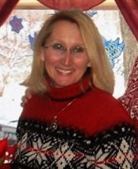
Lorrie Russell, Partner Services Manager, FIRST Tech Challenge (FTC)
In her role as Partner Services Manager for FTC, Lorrie Russell will provide support for the Affiliate Partners in the North and West regions. Lorrie has spent the past two decades creating both technical and artistic digital artwork. Her illustrations have been used on book covers, in magazines, marketing collateral and music CD covers. Before joining FIRST, Lorrie worked as a technical illustrator for Brooks Automation in Chelmsford MA, where she created detailed photorealistic renderings used as graphical instructions for the assembly of robotic equipment. Under the pseudonym Lorrieann Russell, she has written the novels My Brother's Keeper and In the Wake of Ashes, both published by Writers Club Press of New York. By Right of Will marks her first novel with Lachesis Publishing. She was a contributing author and artist to The Writers Post Journal for three years.
FIRST Regional Directors ... work collaboratively to create and maintain volunteer driven, self-sustaining, and growing FIRST programs in a named geographic area.

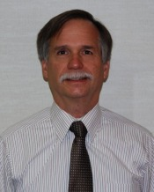
Bill Hodrinsky, Regional Director, Long Island, NY (no longer)
In his capacity as Regional Director for FIRST, Bill Hodrinsky will be in charge of coordinating the FRC, FTC, FLL, and Junior Jr.FLL programs in the Long Island, New York area, which currently has more than 100 FIRST teams. He previously served as the District Director of Information Technology at Connetquot Central School district in Bohemia, and as a District Coordinator of Technology at Central Islip Public Schools. Hodrinsky has been a School-Business Partnerships of Long Island (SBPLI) Board member for the past 10 months.

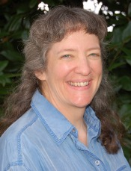
Marie Hopper, Regional Director, North Carolina
Marie Hopper initially became involved with FIRST in 2001 when she signed on as an FLL coach for her son’s team. Since then, she has coached an FRC team and 20 FLL teams, in addition to coaching FIRST Tech Challenge for a year. A small business owner for more than 20 years, Hopper expects to significantly expand the presence of FIRST in the North Carolina region. The region currently supports more than 225 FIRST teams.

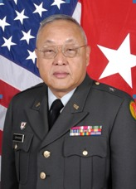
Gary Ishikawa, Regional Director, Hawaii
As Deputy Adjutant General for the State of Hawaii, Brigadier General Ishikawa is also Deputy Director of the Hawaii National Guard’s Youth Programs ─ which include a residential mentorship program called the Youth Challenge Academy and “Operation About Face” for at-risk youth. It was through the Academy that General Ishikawa initially became involved with robotics. Today, the state supports more than 200 FIRST teams.

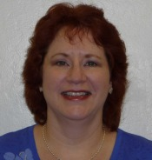
Carol Popovich, Regional Director, Arizona
Carol Popovich is the Principal Investigator for the Science Foundation Arizona (SFAz) and Stardust Foundation grant, known as the "FIRST Arizona Educational Infrastructure Initiative.” In this role, she performs fundraising, team recruitment and retention, and promotes FIRST in Arizona. Popovich also serves as FIRST Community Relations Representative for Microchip Technology Inc., and she co-chairs the Arizona FIRST Planning Committee. During her 14-year career with Microchip, Popovich has served as Business Analyst and Coordinator of the Company’s Academic Program, where she interfaced with K-12 educators and encouraged them to incorporate Microchip’s products into their curriculum.
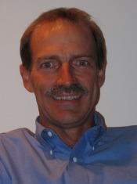
Ned Smith, Regional Director, Erie, PA
Ned Smith is a technology specialist previously employed by the Catholic Schools of the Erie Diocese and the Girard and Iroquois School Districts. He has coached FIRST LEGO League teams participate from middle schools with a regional competition and was helpful in establishing programs in the Erie City School District when he served as a member of its Board of Directors. With a grant from the GE Foundation and a partnership with the national 4-H clubs, Smith’s emphasis this year will be to develop the FIRST Tech Challenge in the area.

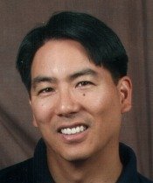
Richard Yasui, Regional Director, Canada
A founding mentor of FRC Team 1310, Runnymede Robotics, Richard Yasui went shopping for classroom robots in 2003, but found FIRST instead. Since then, he has been the Main Coordinator, as well as the programming and electrical mentor for the team. He has a degree in Electrical Engineering and for the past 18 years, and has been teaching Math, Science, and Computer Technology courses at Runnymede Collegiate Institute in Toronto. In addition, for the past two years Yasui has been involved with Howard Public School’s FLL team. Canada currently supports approximately 550 FIRST teams.

FIRST Senior Mentors ... "Make Magic Happen” by seeking out, recruiting, and fully supporting Team Mentors and Event Volunteers for FIRST programs and other initiatives in the geographic area in which they reside.
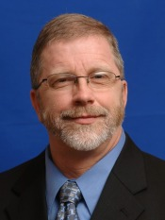
Ron Borden, Senior Mentor, Finger Lakes, NY
Ron has served as the Chairman for the Finger Lakes Regional Planning Committee from its origin in 2003. Over the last seven years, Ron has been working with FIRST teams in various capacities and currently mentors five regional FRC teams.

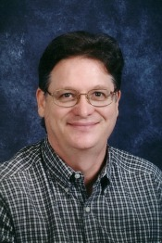
Mike Henry, Senior Mentor, Texas
In 1999, Mike achieved a lifetime goal when he received a Master of Science in Space Studies from the University of North Dakota. He also holds a Bachelor of Science in Mathematics Education from Baylor University. Mike’s 25 years of experience as an educator has included developing and implementing many space education projects including the design, construction, and operation of a classroom space flight simulator and a mission control simulator for students in which “space flights” were conducted.
For the past nine years of his teaching career, Mike was the faculty advisor for a high school FRC Robotics team that was a two-time FIRST Regional winner during that nine year period. Currently Mike is working as a consultant and mentor for a STEM Academy robotics program. Mike is a GTE GIFT Fellow, and was awarded the 2000-2001 Christa McAuliffe Fellowship award by the Texas Education Agency.
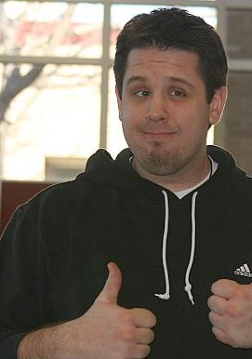
Nathan Knauss, Senior Mentor, New Jersey
Nathan is a product of FIRST. A 2002 graduate of FRC Team #87, he pursued a career in Technology Education at The College of New Jersey. Through his experience with FIRST, he recognized the need for youth to become more technologically literate as the demand of developments in technology accelerates over time.
Nathan is currently a Technology Education teacher at Cherokee High School in the Lenape Regional High School District where he teaches courses related to electronics, design and problem solving, and communication technologies. He holds professional affiliations with the New Jersey Technology Education Association and the International Technology Education Association.

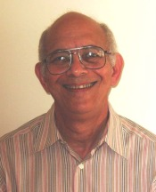
Richard Levey, Senior Mentor, Illinois
Rich has over 40 years of experience programming large IBM Mainframe computers specializing in the operating system itself. Rich’s involvement with FIRST began as a coach for his daughter’s FLL Team Volcanic Panic in 2000. He continued on organizing FLL teams in the school for three more years before moving on to become a Regional Tournament Coordinator.

FIRST AmeriCorps VISTAs… work to create awareness of FIRST in their community, focusing particularly on the needs of the underserved initiative, while seeking sponsors, mentors, and volunteers for FIRST programs.

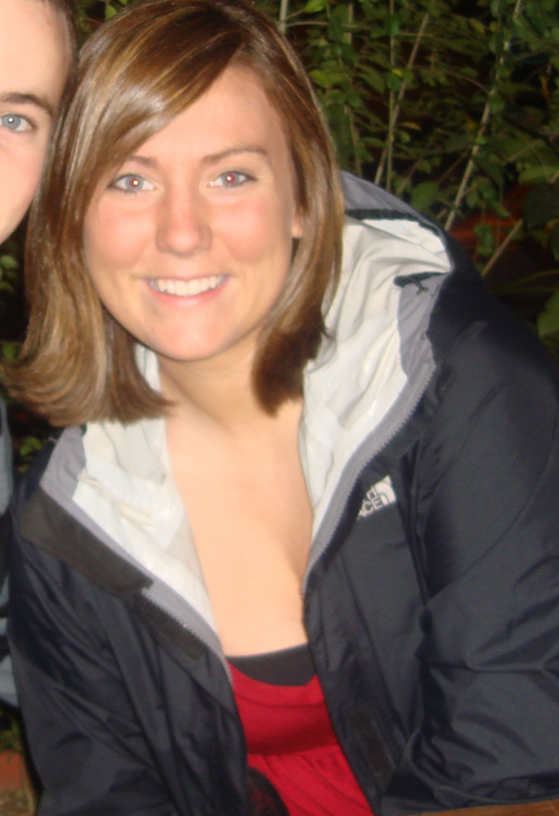
Cynthia Brenner, FIRST AmeriCorps VISTA, Boston, MA
Cindy is a recent graduate from the University of Notre Dame where she majored in Theology and Public Policy. The Notre Dame community fostered her sense of service through numerous volunteer opportunities. Cindy became involved in a local Catholic grade school where she served in numerous capacities from art teacher to the 8th grade girls’ basketball coach.
Most recently, Cindy worked on an Indiana Congressman’s campaign where she was staffed as the Volunteer Coordinator. In this capacity, she was tasked with building and maintaining volunteer lists, creating recruitment strategies and certainly walking in countless parades. Cindy was drawn to the FIRST program because of its creative and unique approach to opening up the world of science and technology by fostering a community of active learning.
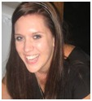
Ashley Carlson, FIRST AmeriCorps VISTA, Boston, MA
Ashley Carlson, a true California girl, attended Cal Poly San Luis Obispo and Kingston University, UK internationally and recently graduated with a BS degree in International Business. While attending college, Ashley became involved in various community service projects. One included supervising at a homeless shelter. As the supervisor, she helped people with their chores, tutored children, and made their stay as comfortable as possible. Other community activities included service trips to Mexico, local fundraising events, and volunteering services to aid blind adults. Ashley is excited and eager to begin her VISTA Service in Boston with FIRST.
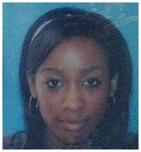
Kimolee Tiffany Cowell, FIRST AmeriCorps VISTA, Hartford, CT
Kimolee Cowell joined AmeriCorps and FIRST from the Urban League of Greater Hartford. As a volunteer with the Urban League organization she became interested and alerted to the Urban League’s FTC program and of an opportunity to serve as an AmeriCorps VISTA in the FIRST Programs. Kimolee is well familiar with the struggles and lack of opportunities of inner-city kids, and her mission and objective is to educate and encourage the students and community to the opportunities available in math, science, technology and engineering through FIRST programs.

William Duncan, FIRST AmeriCorps VISTA, Baltimore, MD
Bill brings more than 25 years of experience in telecommunications and marketing to his role as VISTA member for FIRST in Maryland. After retiring as Vice President of Marketing Communications for Spirent Communications, (a global telecom equipment company), Bill has been an at-home dad and part-time marketing consultant. Looking to re-enter the workforce and responding to President Obama's call to service for America, Bill checked the VISTA database and found the FIRST opening in Maryland. Drawn to FIRST's mission to promote science and technology to students, his background in marketing and high technology seems to be an excellent fit with FIRST's needs. Bill is eager to begin his year of service to promote FIRST activities in underserved school districts and help strengthen FIRST's organizational infrastructure in Maryland.
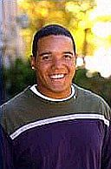
Earl Hart, FIRST AmeriCorps VISTA, Washington DC
Earl has recently completed a dual-Bachelor’s degree program at Purdue University in West Lafayette, Indiana in Mechanical Engineering Technology and Industrial Management. While attending Purdue University, he was an executive board member of the National Society of Black Engineers Chapter, as well as a Senior Advisor to the Society of Minority Managers. Earl already has very impressive work experience with companies such as Caterpillar, Inc., Delphi Electronics & Safety, and NASCAR Research and Development (as a power-train engineer). Originally from the state of West Virginia, he currently resides in Baltimore, Maryland. Earl is very excited to put the knowledge and skills he has obtained during undergraduate studies to good use with FIRST.

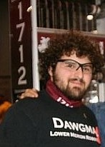
Philip Ross, FIRST AmeriCorps VISTA, Philadelphia, PA
Phil has spent the past three years working in different positions in the FIRST community. He has spent time as a team member, a team captain for Team 1712, “Dawgma”, based in Ardmore Pennsylvania, and a volunteer for all four FIRST programs. Phil recently graduated from Lower Merion High School in Ardmore, Pennsylvania. He decided to take a year off prior to his planned enrollment at the University of Maryland in the fall of 2010. During this year as a VISTA, he is looking forward to working with all members of the FIRST community and to spreading the message of FIRST over as much distance as possible.

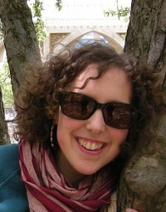
Danya Shneyer, FIRST AmeriCorps VISTA, New York City, NY
Danya recently received a BA degree from Hampshire College in Urban Planning & Development. As a student at Hampshire College, Danya annually coordinated a day of science workshops for middle school aged girls. She also taught neuroscience to third graders at an after- school program in Portland, Oregon. In addition, Danya has supervised and mentored teens at a summer camp for several summers.
She recently completed PSO training and is now an AmeriCorps VISTA member, dedicating a year of service to FIRST in New York City. Danya is amazing at doodling and is passionate about marching bands. She also is skilled at television production having written, produced, and directed programming for Hampshire college public access television broadcasts.

January, 2010

New Faces at FIRST
FIRST is pleased to welcome the following new members of the FIRST Community:
FIRST Headquarters Staff ...
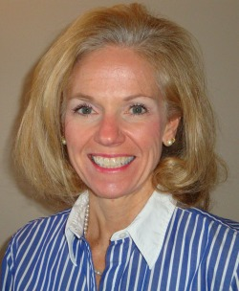
Roseann Stevens, Vice President - Field Operations & Planning
Roseann Stevens has joined FIRST as Vice President of Field Operations. Roseann will take over from Bruce Linton, who has been a member of the senior leadership team of FIRST for the past 3-1/2 years; Bruce will move into the Development organization with responsibility for major corporate sponsors and foundations.
As Vice President of Field Operations, Roseann will be responsible for overseeing the Regional Directors; working with volunteer committees to recruit teams, raise funds, and organize FIRST Robotics Competition (FRC) events; and interface with FIRST LEGO League (FLL) and FIRST Tech Challenge (FTC) partners across the country. Also reporting to her will be Dennis Howland, Volunteer Resources Manager, along with his team and Senior Mentors in the field.
Roseann is no stranger to FIRST, having served for 10 years as Mentor, Judge, and Judge Advisor for regional competitions and at the FIRST Championship. She has had a distinguished career in the automotive and manufacturing industries, including managing national/global sales forces for billion-dollar companies such as Visteon (automotive supplier formerly part of Ford Motor Co.), and Lear Corp. She began her career with the Ford Motor Company and has twice been listed on "The 100 Leading Women in the North American Auto Industry." In addition, she has served on the boards of CLARCOR, Inforum, the Automotive Women’s Alliance and the Girl Scouts of Metro Detroit. She holds a bachelors degree and an M.B.A. from the University of Detroit Mercy.
Tim 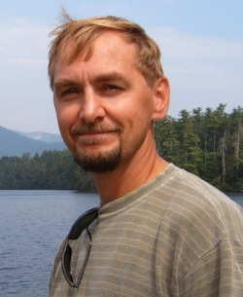Maxton, Manager of Major Gifts and Individual Giving
Tim Maxton joined FIRST in November, bringing with him 15 years of fundraising experience from both higher education (Boston University and Northeastern University) and healthcare (Tufts Medical Center and Hallmark Health System). While at Hallmark Health, he oversaw development for two community hospitals, a cancer center, hospice, visiting nurse association, and a school of nursing.
Fascinated by science, Tim is enthusiastic about working for an organization that nurtures an active interest in STEM and instills teamwork and self-confidence in children as young as six years of age. He has worked as a stage manager and set designer, holds a black belt in Kempo Karate, and enjoys the outdoors-rock-climbing, hiking, and cross-country skiing. Tim earned a BA in History, magna cum laude, from Boston University.
Charlie Jacobs, FIRST Robotics Competition Engineering Manager
Robert Mitchell-Hartson, FIRST Robotics Competition Engineering Tech
Josh White, FIRST Tech Challenge Engineer
FIRST Regional Directors ... work collaboratively to create and maintain volunteer driven, self-sustaining, and growing FIRST programs in a named geographic area.
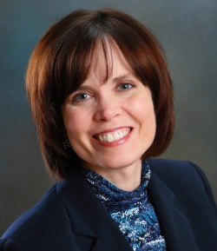Patricia DePra, Ph.D., Regional Director, Western Pennsylvania
Patricia DePra was born and raised in southwestern Pennsylvania and received a Ph.D. in chemistry from Northwestern University (1989). Her experience includes industrial chemical research, human resources/communications, management, teaching at the college and university level, and collaborative science education grants. Patricia has served as chair of two local sections of the American Chemical Society, and has enjoyed leading and working with volun¬teers from industry and academia at numerous events. As Regional Director, Patricia will work collaboratively to create and maintain volunteer driven, self-sustaining, and growing FIRST programs in western Pennsylvania.
"I'd been seeking a position in which I can truly integrate my creativity, my enthusiasm, my experience in education and management, my computer skills, and my knowledge in science in a way that is fresh, energizing, and helps to improve lives. Working with FIRST provides tremendous opportunities to do this. I feel doubly fortunate for this opportunity with FIRST located right here in Pittsburgh."
Julie Booth, Regional Director, Utah
Ken Mitchell, Assistant Regional Director, Northern California
David Price, Regional Director, New Hampshire

June 2010
New Faces at FIRST
FIRST Headquarters Staff ...
Kathleen Kennedy, FIRST LEGO League Partner Services Manager
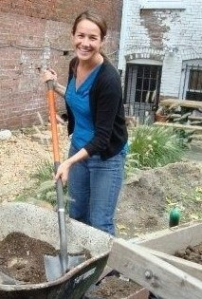
Kathleen Kennedy joined FIRST as the FLL Partner Services Manager for the North Central Region of the United States and Canada in February. Drawn to FIRST by the mission and passionate volunteer base, she is happy to be part of the dynamic organization that she first experienced in high school.
Prior to joining FIRST, Kathleen worked at Southern New Hampshire University as the Assistant Director for the School of Community Economic Development, which focuses on social and economic justice. During her educational path, she studied Travel and Tourism Development and specialized in sustainable tourism. She also has a Master’s of Science in Organizational Leadership and most recently completed her Graduate Certificate in Leadership of Nonprofit Organizations.
Kathleen is a lifelong resident of Manchester NH and is active in the local community. As an avid volunteer, she participates on various committees with a variety of nonprofits that surround issues from animal welfare to neighborhood revitalization to recreation development. Her 11 year old dog, Foozball is glad she lives in close proximity to FIRST HQ so she can visit him during lunch!
Jen O’Callaghan, FIRST LEGO League Partner Services Manager
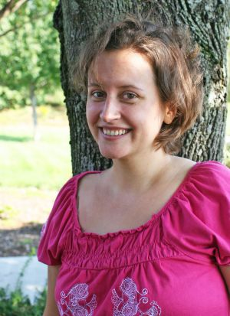
Jen O’Callaghan is excited to join FIRST LEGO League as the Partner Services Manager for Zone 2 (Southern U.S., Mexico, Puerto Rico, and Hawaii). Prior to coming to FIRST, she worked in the marketing department of a SaaS company that specialized in tools and websites for independent schools. Her first love was community journalism, and she spent eight years in newsrooms in New Hampshire, serving as the arts editor for first Foster’s Daily Democrat (Dover) and then The Telegraph (Nashua). Despite her unforgivable affinity for bad puns, the New England Press Association named her Humor Columnist of the Year in 2004. She is an occasional contributor to NH Magazine and has been editor of Destination NH since 2008.
No stranger to the non-profit world, she has worked in the offices of the NH Spinal Cord Injury Association, Pennsylvania Youth Theatre and the parent organization of Pennsylvania’s annual Celtic Classic Highland Games and Festival. She earned her BA in Russian studies from the College of Wooster in Ohio. She is thrilled to be a part of FIRST because of its incredible impact on so many children’s lives and because robots are pretty darn cool.
Katy Reno, FIRST LEGO League International Program Manager
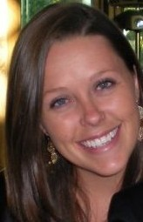
Katy Reno joined FIRST in mid-May and will serve as the International Program Manager for FIRST LEGO League. Prior to joining FLL, Katy worked for Southern New Hampshire University in partnership with the State of New Hampshire in the International Trade Resource Center (ITRC). The ITRC is an agency that assists New Hampshire companies that export their products internationally. Katy served at the International Training Manager from June of 2008 until her departure for FIRST, and was responsible for developing, marketing, and implementing 35 seminars a year on all aspects of international trade.
Katy is a 2008 graduate from the University of New Hampshire, where she double majored in International Affairs, Political Science, and received a minor in Spanish. Katy enjoys reading, traveling and is excited to join FIRST community.

FIRST Regional Directors... work collaboratively to create and maintain volunteer driven, self-sustaining, and growing FIRST programs in a named geographic area.
Patricia Daly, Regional Director, New York City
Patrick Felty, Regional Director, San Antonio
LJ Robinson, Regional Director, Tennessee

September 2010
New Faces at FIRST
FIRST Headquarters Staff
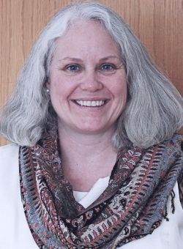
Terry Allen, National Grants Writer/Manager
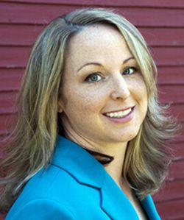
Terry Allen joins FIRST as its new National Grants Writer/Manager. She feels fortunate to have a career that combines her love of writing with her desire to help others. As the former director of Corporate, Foundation, and Government Relations at Merrimack College, Terry brings several years of experience writing STEM grants in higher education. Terry has also served as the grant writer at Easter Seals New Hampshire, the manager of public relations at the Currier Museum of Art, and as the senior writer at Public Service of New Hampshire. Terry earned her master’s degree in 19th Century American Literature from the University of New Hampshire and she continues to have a strong interest in this field. In her free time, Terry enjoys traveling, painting, and writing her own fiction. She lives with her husband David in Milford, New Hampshire.
Shana Benzinane, Marketing Communications Program Manager
Shana Benzinane joined FIRST in August as Marketing Communications Program Manager. Prior to FIRST, Shana worked in various creative positions at Scholastic Book Fairs, Giga Information Group, Toysmart.com, and Little, Brown & Company. Having dedicated most of her career to making educational content fun for kids, Shana was immediately drawn to the FIRST mission to make science, technology, and math enticing for young people.
"With kids, it's all in the pitch. If you call it a science experiment, it doesn’t sound fun," Shana said. "But if you call it an icky-sticky, ooey-gooey (only-do-this-when-your-mother’s-not-looking) experiment, you’ll definitely turn some heads!”
Shana is the author of six children's books published by Scholastic including World Series of Math, two books about the rainforest, and a science experiment book called Grow Your Own Monsters. When she’s not busy consignment shopping or messing around in Photoshop, she can often be found on the floor of her New Hampshire home giving horsey-back rides to her toddler or listening intently to her 6-year-old’s enthusiastic read-aloud of yet another Captain Underpants book.

Bonnie Bourret, Accounts Payable Specialist
Bonnie Bourret joined FIRST in August as Accounts Payable Specialist. A Massachusetts native, Bonnie moved to New Hampshire before heading south to Florida where she lived and attended Florida Metropolitan University for Accounting. In Southern Florida, she held several accounts payable positions before moving back to Manchester.
Outside of accounting, Bonnie has enjoyed professional pursuits as house-painter, interior decorator, seamstress, and hair dresser. But her true calling is in the finance field, where she feels her niche is in accounts receivable.

“I am thrilled to be supporting the FIRST mission while continuing my career in finance, which I most enjoy,” Bonnie said.

Eoin Clarke, IT Network Engineer
Eoin Clarke (pronounced like Owen) started at FIRST in August as IT Network Engineer. Born and raised in New Hampshire, Eoin earned a bachelor’s degree from Plymouth State University. Before joining FIRST, Eoin recently held various positions at Keene State College and Monadnock Family Services and brings 14 years of IT and customer service experience to the position. Although he is the first in his family not to be born in Ireland, Eoin spent six years living and working in Cork, Ireland (where everyone already knew how to pronounce his name) and traveling to various places in Europe.
Eoin was drawn to FIRST because of its mission to inspire young people with real-world science and engineering programs, something he feels his school system lacked growing up.
“When I was a kid, I used to love taking apart the clocks in the house and trying to put them back together. But at school, there were no programs to support this kind of thing.” Eoin said. “I am delighted to be a part of an organization that encourages kids this way. It’s brilliant!”
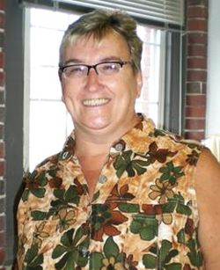
When Eoin is not busy driving around his BatJeep, he enjoys movies, reading, camping, fishing, hiking, walking, breathing, laughing, and yes—even working (hmm, likely story). Eoin lives right up the street from FIRST in Manchester with his cat Squeaker.
Martha Dickey, Operations Grant Manager
Martha Dickey joined FIRST in September as Operations Grant Manager. Martha comes to FIRST with eight years of experience working in the non-profit world, including time spent at Concord Hospital and at the NH Local Government Center. Most recently, she worked as a program assistant for the New Hampshire Charitable Foundation in Concord where she administered the Neil & Louise Tillotson fund grant program. As an adult student, Martha graduated from Franklin Pierce University in 2008 after earning a bachelor’s degree in business management.

“I was attracted to FIRST after seeing its impact firsthand through my son’s involvement with Jr.FLL and I thought it would be fun to become part of such an interesting and talented group of people,” Martha said.
Martha lives in Boscawen and enjoys spending time with her husband, children, and grand-children and exploring her adopted state of New Hampshire.
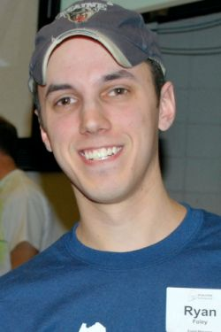
Ryan Foley, Software Engineer - FIRST Robotics Competition
Ryan Foley joined the FIRST team in August as the FRC Software Engineer. Ryan graduated in May of 2010 from the University of Maine with a bachelor’s degree in Mechanical Engineering and a minor in Digital Systems. Prior to FIRST, he worked as a student engineer at the UMaine Advanced Manufacturing Center where he was responsible for mechanical and controls design as well as software development for a variety of projects. Ryan’s first FIRST experience was with an FLL team for the 1999 challenge: FIRST Contact. In high school, he joined FRC Team 350 “Timberlane Robotics” for the 2001-2004 seasons. While in college, Ryan volunteered at more than 20 FIRST events, and served as a mentor on FRC Team 1995 “Fatal Error.” Ryan is thrilled and honored to be “on the inside” as a member of the FIRST staff.

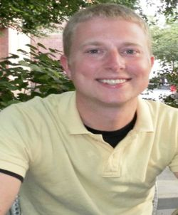
Collin Fultz, Kit of Parts Engineer- FIRST Robotics Competition
Collin Fultz has been involved with FIRST since 2001 and is excited to join the FIRST staff as FRC Kit of Parts Engineer. From 2001-2004, he was a member of FRC Team 234 “Cyber Blue” from Indianapolis, IN. Since 2005, he has volunteered as a Game Announcer and Master of Ceremonies at Regionals and the FRC Championship. In 2006, he was a college mentor for Team 1747 “HBR.” In 2008, Collin rejoined Team 234 as an engineering mentor. He has a BS in Mechanical Engineering from Purdue University and was a co-op for Rolls-Royce Corporation through college. He worked full-time at Rolls-Royce after graduating for two years before accepting this position at FIRST.

When Collin is not doing FIRST, he enjoys travelling with his wife, Jenny, camping with his family, wakeboarding, and spending time with friends. Having never lived outside of Indiana, Jenny and Collin are excited about the opportunity to explore a different part of the country.
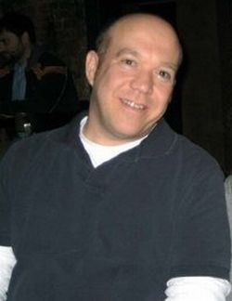
Dan Maggio, FIRST LEGO League Partner Development Manager
Daniel Maggio joined FIRST in August as the FLL Partner Development Manager. He was drawn to working for FIRST because of his 11-year role as one of Michigan’s FLL partners, his 13 years as a FRC mentor and supporter, and his desire to make a positive impact on today’s youth.
Dan was born and raised in Erie, Pennsylvania. He attended the University of Detroit where he received his B.S and M.A. in mathematics. After graduating, he worked for his alma mater for the next 20 years as an Adjunct Professor in the Math and Computer Science Department and as the Director of Pre-College Programs in the College of Engineering and Science. During this time, he helped develop and deliver STEM-based programs to the K-12 community in and around the City of Detroit, which impacted more than 5,000 students annually.
Dan is an avid curler in the winter and a member of the Detroit Curling Club. He is a long-time panelist on the University of Detroit Mercy’s Ask The Professor radio show. He also enjoys biking, gardening, and chess.


Brian Packard, FIRST Tech Challenge Engineer
Brian Packard joined FIRST in September as FTC Engineer. An alumnus of Merrimack High School’s FIRST team and a 2009-10 FIRST mentor, Brian brings a breadth of experience to FIRST. He is a 2008 graduate of University of Alaska with a Bachelor of Science degree in mechanical engineering. Brian also worked in the research department at BAE Systems in Merrimack and as a mechanical engineer for MKS Instruments in Andover, MA. In addition to working at FIRST, Brian is an active community service volunteer who is “excited to work for and help develop such a great organization.” When asked what about his expectations for his new role, Brian said, “It is my hope that someday all of the world’s youth will have a chance to work with and learn about robotics, as my experience has been.” Brian currently lives in Manchester.

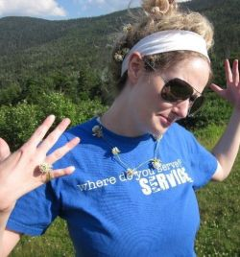
Allison Smith, Mentor/Coach Program Services Coordinator
Allison Smith joined FIRST as the Mentor/Coach Program Service Coordinator in the Volunteer Resources Department. Prior to joining FIRST, Allison served two years in AmeriCorps at the Mass Mentoring Partnership in Boston, MA, the umbrella organization for mentoring programs across Massachusetts. As a senior corps member of the Highland Street Corps Ambassadors of mentoring, she focused on event planning, social media, and public awareness campaigns to recruit mentors.

During her off time, Allison volunteers as the Membership Coordinator and Leadership Camp Facilitator with the New Hampshire Chapter of the International Order of Rainbow for Girls, a girls youth leadership nonprofit.
Allison is a 2007 graduate of Franklin Pierce College in Rindge, NH. She has her graduate certificate in Non Profit Leadership Development from Cambridge College and is pursuing a master’s degree in Organizational Leadership.

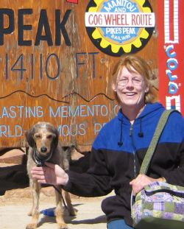
Lisa Yesse, Programmer/Analyst
Lisa Yesse started at FIRST in August as Programmer/Analyst in the IT Department. She is a 28-year-veteran of Digital Equipment Corp./Compaq/Hewlett Packard, mostly in storage engineering.
“Having come off several months of unemployment, I feel like I’ve landed my dream job at FIRST!” Lisa said. “Not only is it a good match technically (as a programmer/analyst in IT), but it’s also wonderful to be a part of programs that benefit and positively impact students.”
A native New Englander, Lisa has also lived and explored Utah and Colorado. She currently lives in New Hampshire where she is an active community member, volunteering at Friends of Goffstown Rail Trail and formerly at the Bedford Animal Rescue League. Lisa likes hiking, skiing, and outdoor activities that include her two dogs.
“The people at FIRST are great, and I’m really looking forward to seeing the local competitions.” Lisa said. “Someday, I also hope to try out a Segway!”

In the Field
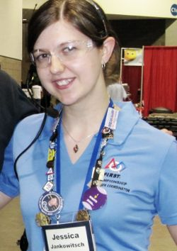
Jess Jankowitsch, Assistant Regional Director, Southern Texas
Jess Jankowitsch became active in FIRST in 2001 as a student member, and later as president of the 2003 Championship Chairman's Award-winning Cybersonics Technology Team 103 from Kintnersville, PA. Upon moving to Pittsburgh in 2005 to begin her undergraduate education at Carnegie Mellon University, she dedicated herself to aiding local teams and the regional, eventually taking on the roles of Volunteer and Judges Coordinator and local FIRST Senior Mentor. In 2009, she was awarded the Pittsburgh Regional Outstanding Volunteer of the Year Award.

This past season, Jess completed her third year as a Volunteer Coordinator at both the Pittsburgh Regional and FIRST Championship in Atlanta, Georgia. Jess has also served as an FRC, FTC, and FLL team mentor and Regional and Championship Volunteer. Jess is currently working toward a master’s and doctorate degree in Developmental Psychology at the University of Texas at Austin. She is thrilled to assist the new Alamo Regional in San Antonio as its Assistant Regional Director.
FIRST Americorps*VISTAs… work to create awareness of FIRST in their community, focusing particularly on the needs of the underserved initiative, while seeking sponsors, mentors, and volunteers for FIRST programs.
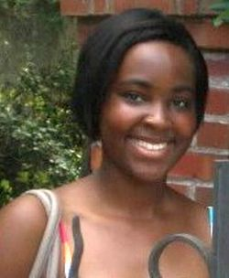
Nakia Beasley, FIRST AmeriCorps*VISTA, Pittsburgh, PA
Nakia has extensive experience in public relations, community outreach, and volunteer coordination. While she has served at a wide variety of organizations, including government agencies and small businesses, her passion lies in the world of nonprofits.
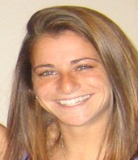
Laura Bitterman, FIRST AmeriCorps*VISTA, Massachusetts/New Hampshire
Laura is a recent graduate of the University of Wisconsin-Madison. She received a bachelor’s degree with honors in biology and plans to attend graduate school to become a public health nurse. Laura is passionate about health and has headed teams that raised over a thousand dollars for the American Heart Association Heart Walks and the Juvenile Diabetes Foundation Walk.
As a volunteer with the University of Wisconsin’s Biocore Outreach Ambassadors for three years, Laura taught science to students aged 9-15 in rural schools. In this program, Laura worked closely with the teachers to develop a curriculum that they can deliver in future years. Her senior year, Laura created and led an after school science club for an under-served elementary school students in Madison, WI. Team sports—Ultimate Frisbee and Soccer—are also an important part of her life. Through coaching and teaching youth, Laura enjoys being a role model for kids and encouraging them to become the people they want to be.

Sharlene Brown, FIRST AmeriCorps*VISTA, Baltimore, MD
Sharlene is a former FIRST team member from the Techno Warriors at Woodlawn High School in Baltimore. She graduated from Ursinus College with a Bachelor of Science in neuroscience and biology and is pursuing a doctorate degree in biomedical sciences at West Virginia University. Having volunteered off-and-on for such organizations as the American Cancer Society, Youth AIDS, and the National Multiple Sclerosis Society, Sharlene was ready for a greater challenge. For this reason, Sharlene is taking a year off from her graduate studies to commit to a year of service as a VISTA Volunteer to give back to FIRST in Maryland, an organization that had a pivotal role in shaping her passion for the sciences and gave her the confidence to succeed.
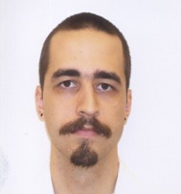
Carl Schreep, FIRST AmeriCorps*VISTA, Eastern Pennsylvania
Carl graduated from Duke University in 2009 with an M.A. in ancient Jewish history and literature. He has been actively involved in his communities by leading student organizations, volunteering, and tutoring at-risk children. Most recently he worked at the Chester County Historical Society where he helped develop programs for children and continuing education programs for adults and educators.

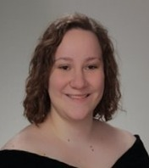
Mary C. Samot FIRST AmeriCorps*VISTA, Sag Harbor, NY
Mary has extensive work experience with non-profit organizations. As President of Alpha Phi Omega, a national co-ed community service fraternity, Mary has been dedicated to enriching the lives of others through leadership, friendship, and service. As a student leader, Mary has developed leadership skills, acted as a change agent, role model, team builder, and a creative problem solver.

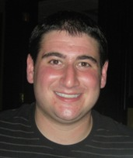
Scott Statman, FIRST AmeriCorps*VISTA, NYC
Scott graduated from Washington University in St. Louis in May 2010 with a bachelor’s degree in neuroscience. During his time there, Scott gained extensive volunteer experience as a member of the Campus YMCA. He was responsible for coordinating an after-school science and math education program called Catalyst. On a weekly basis, Scott and his co-leaders brought Washington University volunteers to St. Louis public middle schools to perform fun, hands-on experiments with the kids. Scott gained additional exposure in the nonprofit community during the summer he spent as a fellow in the St. Louis Science Center’s Youth Exploring Science program. Scott was responsible for designing a five-week science education curriculum, which he used to mentor a group of ten at-risk St. Louis public high school students. Scott is excited to continue pursuing his passion for science education as an Americorps VISTA member serving FIRST in New York City.
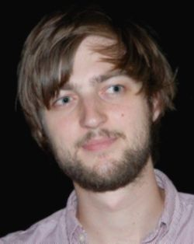
Benjamin Weber, FIRST AmeriCorps*VISTA, Boston, MA
Benjamin Weber graduated from Brown University in May 2010 with a bachelor’s degree in anthropology. He has worked with a variety of nonprofits, including The League of Young Voters in NYC, the Institute for Cultural Diplomacy in Berlin and the International Organization for Migration in Timor Leste. These opportunities have helped him gather experience about many different aspects of community development and non-profit work, and he is looking forward to using this knowledge to help FIRST in Boston. Benjamin is excited about the opportunity to serve as an AmeriCorps VISTA with FIRST in Boston and is looking forward to an exciting and fulfilling year.
FIRST Senior Mentors..."Make Magic Happen” by seeking out, recruiting, and fully supporting Team Mentors and Event Volunteers for FIRST programs and other initiatives in the geographic area in which they reside.
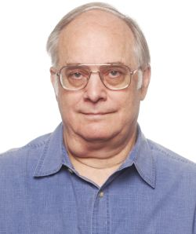
Don Brobst, FIRST Senior Mentor, Washington DC/Virginia
Don has 30 years of experience in software and systems engineering in defining requirements and project management. Don graduated with a BS from the University of Maryland and is a certified PMP, and a retired Naval Reservist. Don is active in the Falls Church community and currently serves as the Chair of the City’s Housing Commission. Don has been involved with FIRST for more than seven years, and is a mentor to Team 1418, going on four years now. Don has a daughter who is a junior in college.

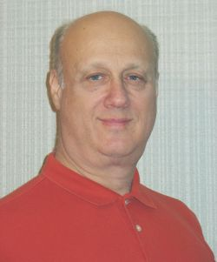
Mike Siegel, FIRST Senior Mentor, New York City
While still in engineering school, Mike worked in aerospace. After graduation, he took a position at a college television studio where he worked as an Assistant Chief Engineer. It was also at this time that he started to work with the Ferrari North American Racing team as an engineer. After a few years, he made a move to the ABC Television Network. This position took him literally all over the world, working in Video Tape Technical support, RF Engineering, and as a Post Production Engineer/Editor. After 21 years at the television network and having won 21 Emmy Awards and a Peabody Award, he decided to take an early retirement.

Soon after, he was contacted by the Staten Island Technical High School inquiring if he was available to teach engineering subjects. Over the years that followed he taught: strength of materials, technical drawing, electronics, and started a robotics curriculum, and within a month was introduced to an FRC team: Team #375. Under his leadership the team excelled; each year improving more and more, building better robots, and winning highly coveted awards. Mike has also been a long-time member of the regional FLL Steering committee, and an event coordinator for regional FLL tournaments. Mike’s involvement has spanned over 10 years of being affiliated with FIRST, and after being nominated to ‘Who’s Who in America three times (in two different industries) he has finally decided to retire—sort of—and has been a senior mentor with FIRST now since July, 2010.
January 2011
New Faces at FIRST
FIRST Headquarters Staff
Danielle DeCaro
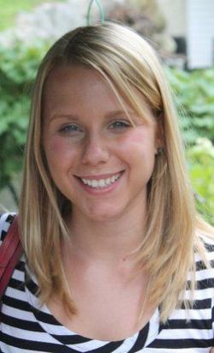
Having joined FIRST in November as a staff accountant, Danielle feels fortunate to be given the opportunity to work with a dynamic group of people supporting a mission about which she feels strongly. Her previous experience was as Audit Senior at Baker Newman Noyes, a public accounting firm in Manchester. Danielle graduated from the University of New Hampshire in 2008 with a master’s degree in accounting.
In her free time, Danielle enjoys gardening, reading, and hiking. She lives in Nashua with her husband and two cats.

Jack Endyke, Purchasing Agent
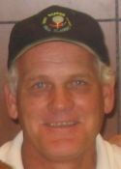
With an extensive purchasing career behind him, Jack Endyke joins the Procurement department at FIRST as Purchasing Agent. Jack enjoys the services he performs in helping individuals as well as helping the company to attain its goals. He also appreciates the challenge of negotiating with suppliers for cost savings and delivery schedules. Jack is looking forward to experiencing the competition season at FIRST and helping to make it enjoyable for its Volunteers and participants.
An enthusiastic fan of Boston sports teams, Jack enjoys many outside-of-work activities with his large family, such as skiing in the winter and golfing during the warmer months.

Derek Mullen, Shipper/Receiver
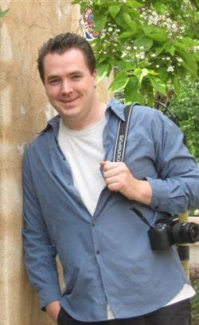
Raised in New Hampshire, Derek graduated from Pinkerton Academy for High School where he pursued an interest in theater and art. He continued his education at UCONN with two BFA’s as an individualized art major with a specialized degree in puppetry/theater. Being able to animate things into a new view for people has been Derek’s greatest thrill in his work.
“FIRST is a company all about changing one’s view on science and technology; and the mission is one I can relate to very well,” Derek said, adding, “I am happy to join the FIRST staff in making that vision become a reality.”
To enhance his education and learn new things, Derek has started ballroom dancing, stilt walking, western sword training, and graduate classes that continue with his majors. He also enjoys the outdoors whenever possible as a pastime. Derek currently lives in Chester, New Hampshire.
Robin Pullo, Human Resources Generalist
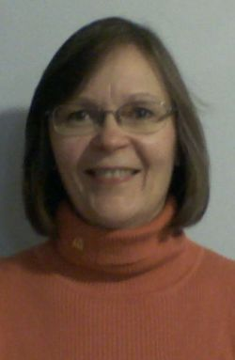
Robin Pullo is thrilled to be part of the FIRST team. Her HR career started with a company called Softdesk, which was later acquired by Autodesk (a FIRST Championship Sponsor). From there, she had the opportunity to be part of the Microsoft Business Solutions (MBS) Division, surviving through two acquisitions (RealWorld Corporation and Great Plains). After Microsoft centralized and closed the Manchester office, Robin went on to work for a law firm and then a non-profit. “The non-profit experience at Granite State Independent Living was very rewarding”, said Robin. “You feel you are truly making a difference in people’s lives.” She had a brief stint with a public company but saw it close its doors in April 2010. The impact on people’s lives was devastating. Her desire to again work for a non-profit was renewed and then fulfilled when she joined FIRST.
Robin’s husband, Chris, is Head Coach of the Seacoast Fencing Club located in Manchester and Rochester, NH. Her daughter, Juliet, is a freshman at Washington University in St. Louis. She plans to volunteer for the FIRST Championship in April and cheer on her brother, Marcus, and his FIRST Robotics Competition (FRC) Team 1922, “Oz-Ram.”
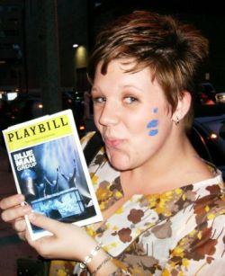
Erin Robie, Operations Coordinator
Raised in Hillsboro, New Hampshire, Erin Robie earned a degree in business administration and economics at Plymouth State University. Having been familiar with FIRST since 2008, when she attended a Regional competition with a friend who mentored a local Manchester team, Erin is impressed with the organization’s ability to influence people of all ages to become involved with science and technology. With a charismatic personality, and always looking for innovative ways to think outside the box, Erin feels she is a natural fit for FIRST.
“I thought with my educational background and desire to be around fun and outgoing people – FIRST was a great fit for me,” Erin said. “I couldn’t stop smiling when I found out I was accepted to come on board.”
Erin is thoroughly enjoying herself as she settles into her role in the Operations department as Operations Coordinator, but she is anxious to meet other employees and to attend FIRST events to witness the effect of the FIRST mission, which has inspired so many students, Mentors, parents, and communities over the years. In her spare time, Erin practices her hobby as a voice and piano musician. She has lived in many places throughout New Hampshire and currently resides in New Ipswich.
Gwen Silva, Senior Executive Assistant
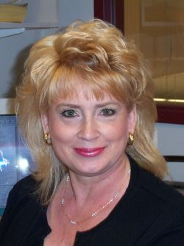
Gwen Silva joins FIRST as Senior Executive Assistant reporting to Jon Dudas. Her career as an executive assistant includes companies such as Symmetrix, World Conference Holdings, Epsilon Data Management, and Whitehead Institute/MIT Center for Genome Research. For the last seven years, Gwen worked for the CEO at Newmarket International, a software company for the hospitality industry, located in Portsmouth, New Hampshire.
“I was drawn to FIRST because of its commitment to encourage creativity and teamwork in our youth,” Gwen said, adding, “I’m excited to be a part of the FIRST family.”
Raised in North Carolina, Gwen moved to the Northeast many years ago and is still trying to get used to the long, cold winters. During her off-time, Gwen enjoys traveling and spending time with her two grown sons and their families in Nashua – especially her ten grandchildren. Gwen resides in Maine with her fiancé.

Nicholas Skripsky, FIRST Place Resources Coordinator
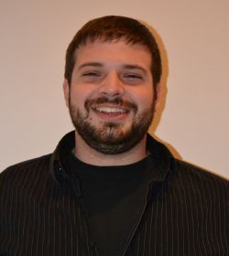
Nicholas Skripsky earned a bachelor’s degree in mechanical engineering from Iowa State University mostly due to a life-long obsession with breaking things. He loved trying to figure things out, but wasn’t always graceful during disassembly. He transitioned quickly from tearing apart everything he owned to the world of LEGO, and his parents were never happier than the day that they invested in his first LEGO kit.
During college, Nicholas volunteered at a FIRST LEGO League (FLL) event in Ames, Iowa. He was a judge’s assistant for an entire day and fell in love with his judges, the teams, and the planning team at Iowa State. After writing the planning team a “middle school love letter” asking how he could help, they offered him a spot on the team! Nicholas had the opportunity to work as an operations chair at ISU, and was lucky enough to go to FLL World Festival for three seasons.
Four years later, Nicholas left Iowa State in pursuit of a “real job” and was welcomed with open arms into the FIRST family as FIRST Place Resources Coordinator.
“I cannot express how excited I am to be HERE, in Manchester, and I cannot express how excited I am to be working for FIRST,” Nicholas said.
In his free time, Nicholas loves to create with LEGO, play video games, dance, skate, cook, watch movies, and hang out with friends. Almost all of them still live in Iowa, so Nicholas is looking forward to making new friends in Manchester.
Kim Wierman, FIRST LEGO League Program Manager
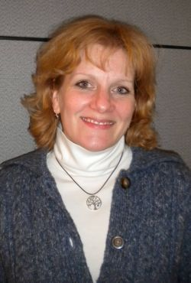
Kim joined FIRST in November as FLL Program Manager. Prior to FIRST, she was co-owner of Waves of Gratitude, an online community and retailer of TouchStone Jewelry. She has held various marketing communications positions for both non-profit and for-profit companies, with an emphasis on writing and public relations. Kim feels fortunate to have been a stay-at-home mom of three great boys for 12 years and to have worked as a freelance writer during that time. She has ghost-written more than 10 books on everything from lowering your blood pressure without drugs to planning the perfect baby shower to researching your family tree. She has had her own work published in the Chicken Soup for the Soul: Power Moms edition. Kim is a graduate of Brigham Young University and enjoys attending her boys’ sporting events, reading, baking, and going to the movies.

In the Field
Mark Breadner, FIRST Regional Director, Canada
Mark has been a strong supporter of FIRST robotics since 1998. A member of the FIRST Executive Advisory Board and a Woodie Flowers Award recipient, Mark co-founded FIRST Robotics Canada with FIRST Board member, Gordon Homer, and brought FIRST to Canada. Under his leadership, the number of FIRST teams rose quickly and the Toronto District School Board created a fully funded robotics administrator position that incorporates the regional director role. Mark was a Regional Director for three years before returning as Vice-Principal within the Toronto District School Board. During that time he served on many FIRST committees, including Game Design Strategy, World Festival site selection, and Regional Director’s meetings. He has a bachelor’s degree in mathematics from the University of Waterloo and a bachelor of education from the University of Toronto.
Michael Campbell, FIRST Regional Director, Washington
Mike brings to FIRST more than 30 years of experience in marketing, event production, advertising, public relations, sales, broadcasting, and finance. A skilled business leader and manager, Mike is president of the Northwest Marine Trade Association and former president of the Greater Seattle Chamber of Commerce. Active in civic affairs in the Seattle community, including the Washington State Tourism Commission and the Seafair Foundation, Mike holds a B.A. in sociology from the University of Washington.
Maggie Peterman, Regional Director, Wisconsin
Maggie has been a newspaper reporter for more than 29 years for The Saginaw (Michigan) News. As a member of the Dane County YMCA Board of Directors, Maggie has served as Chair of the Board of Development, and as a member of the Financial Development and Marketing Committees. Active in the Madison, Wisconsin, community, Maggie has raised more than $1 million as Chairman of the Dane County YMCA Strong Kids Campaign.
Paul Borchardt, FIRST Assistant Regional Director, Kansas City, Missouri
An experienced video and live events producer/director, Paul is a program development and educational consultant who helps organizations in the education and not-for-profit sectors achieve their communications, organizational, and leadership goals. A former Assistant Regional Director for FIRST, Paul helped to initiate the greater Kansas City Regional, developed the Kansas City Regional Planning Committee for FIRST, recruited FIRST teams and Mentors, and cultivated Sponsors, oversaw grants administration, and established business and higher education sponsorships. Founder of the Alexandrea Corporation, Paul is a successful educator, trainer, and director.
David Berggren, FIRST Assistant Regional Director, California
David has served as a Senior Mentor for FIRST teams in southern California, is engineering instructor department chair for High Tech High in San Diego, Calif., and has championed the concept of engineering in the high school curriculum through real-world community work. Owner and engineer of Blue Chip Machine and Fabrication, he holds a B.S. in marine science technology from California State University’s Maritime Academy in Vallejo, Calif.
Eunice Brown, FIRST Assistant Regional Director, Kansas City, Missouri
Eunice has several years of experience with FIRST, having served as Mentor, Sponsor, Volunteer, and as a parent of FIRST teams. She has recruited teams of 175 Volunteers in support of FIRST events and activities. A successful entrepreneur, business owner and manager, Eunice earned a bachelor’s of science degree in business administration from Central Missouri State University.
Joan B. Rogers, FIRST AmeriCorps*VISTA Volunteer, Connecticut
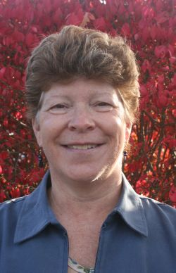
Joan has extensive experience in non-profit organizations in capacity building, advocacy, and fundraising and development roles. Joan served for four years as the Community Coordinator of the Granby Early Childhood Council in Granby, one of 54 Connecticut community coalitions working to build strong connections between the early childhood environment and public elementary education. In this role, Joan was actively engaged in ongoing community organizing and capacity building, which enabled community members the opportunity to be effective advocates for children and families.

Rick Sisk, FIRST Senior Mentor, Southern California
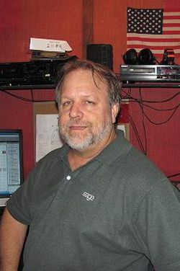
Rick found the magic of FIRST when he helped his wife Dona start a rookie FRC Team in 2008. Since then, he has helped start and mentor several rookie teams, as well as acted as a judge at the Los Angeles and Phoenix regionals and the Championship in Atlanta. Rick served in the Air Force at Langley AFB in VA. This is where he learned about computer programming, which led to his current position at Sage Software in Irvine; designing applications that run many small and medium-sized businesses around the world.

June 2011
New Faces at FIRST
FIRST Headquarters Staff
Christina D’Auria, Operations Coordinator

Three days after joining FIRST, Operations Coordinator Christina D’Auria hit the ground running at the FIRST Championship in St. Louis. Christina graduated from Endicott College in 2009 with a Bachelor of Science in Communication and Contemporary Journalism. She is currently attending Southern New Hampshire University, where she is working toward her Master’s Degree in Secondary English Education.
Christina enjoys working at FIRST where she is inspired every day by our future engineering and technology leaders.
Andrea Jennings, Software Systems Analyst

Originally from northeast England, Andrea Jennings traveled to the U.S. at 19 years old and has been here ever since. Andrea was a competitive gymnast and swimmer growing up and competed internationally. She aspired at one time to become an attorney and has a Criminal Justice degree, graduating with Summa Cum Laude honors. She turned to Sales and Marketing, but always seemed to become involved in the way business flowed, the processes of business, streamlining and investigating, and determining how to do things more efficiently, eventually leading to her current career path.
Andrea was recently hired as Software Systems Analyst for FIRST. She is proud to be part of the IT Department and feels fortunate to work with people who are friendly, kind, hardworking, and passionate about what they do.
Amanda Maloney, Human Resources Assistant

Drawn to FIRST by her desire to work in the HR department of an interesting company, Amanda Maloney joined the organization in May, 2011 as the HR Assistant. Amanda was born in Canaan, New Hampshire and attended Plymouth State University, graduating in 2010 with a Bachelor’s degree in Communications studies, paired with an Associate’s degree in Graphics. After graduating college, she worked for Verizon Wireless as a customer care representative. During this time, Amanda realized how much she loved working with others, and how much she wanted to expand upon her knowledge of Human Resource management.
In her spare time, Amanda enjoys watching movies, going to the beach, creating artwork, and playing poker. Amanda is also an avid movie and panda collector.
Jennifer McManus, A/P Specialist

Jennifer joined FIRST in March as an Accounts Payable Specialist in the Finance department. Jennifer previously worked at Daniels Equipment Company in Auburn, NH handling all aspects of accounts payable, as well as some duties in purchasing, customer service, and shipping & receiving. Prior to that, she was a Department Manager and Sales Floor Rep for Target. Her love of numbers prompted her to work towards a Bachelor’s degree in Accounting, which she expects to complete in October, 2011.
“I like working in the positive atmosphere that FIRST offers,” said Jennifer. “It feels as if everyone who works here loves what they do.”
In her free time, Jennifer enjoys reading, hiking, movies and helping her parents on their small farm when needed.

September, 2011

New Faces at FIRST
FIRST is pleased to welcome the following new members of the FIRST Community:
FIRST Headquarters Staff
Nancy Boyer, Evaluations Manager
Nancy Boyer joined FIRST in July, 2011, as the Evaluation Manager for Development. Nancy is very excited to take this next step in her non-profit career. Before coming to FIRST, Nancy spent nine years at The Children’s Place and Parent Education Center. She served on their Board of Directors for several years, later becoming their Director of Program Development. Nancy also teaches students in the School of Social Work at Boston University. She has a Masters in Social Work from the University of Pennsylvania, as well as a Ph.D. in Sociology and Social Work from Boston University.
Nancy enjoys spending her free time with her two children and her husband, Brian. She loves to run, and especially enjoys participating in road races from 5Ks to half marathons. Nancy volunteers her time coordinating the Pan Mass Challenge Kids Ride where children ages 2 to 12 ride their bikes to raise funds for the Jimmy Fund and Dana Farber Cancer Institute.
John Grabowski, Network Engineer
John Grabowski became a member of the IT team at FIRST in August 2011 after working as a contracted employee since April. John enjoys the great working environment at FIRST, and working with enthusiastic people who are dedicated to bringing science and technology to young people. He is looking forward to the challenge of improving the data infrastructure at FIRST.
John has had a variety of careers: machinist, toolmaker, NC programmer, tool and product designer, and of course, all around computer geek. As a mechanically minded individual, working for an organization that promotes science and technology is very exciting for John. Over the past few years, he owned and operated Cadmetrix and worked support and implementation for VantiCore, an IT services vendor.
When not at work, John spends his time with his wife, Debra, at their home in Raymond, New Hampshire. Debra and John enjoy grilling and entertaining for their family and friends at home.
Timm Huffman, FIRST Tech Challenge Program Coordinator
Timm Huffman joined FIRST in August 2011, as the new FTC Program Coordinator. Timm was drawn to FIRST because of his desire to help others, and because of his belief in the mission of the organization.
Timm attended the University of New Hampshire Manchester and graduated in 2009 with a Bachelor’s degree in Communication Arts. He also holds an Associate’s degree in Communication Science from the Community College of the Air Force.
Timm is a Technical Sergeant in the Air Force Reserve and drills out of Westover Air Reserve Base, Massachusetts one weekend a month. In his military capacity, Timm works as a public affairs specialist. Prior to coming to FIRST, Timm spent six years working in various capacities at the Easter Seals New Hampshire youth residence and schools in Manchester, New Hampshire.
In his off time, Timm enjoys long-distance running and hiking. He also has a passion for film making and photography.
Michelle Long, Administrative Assistant, Field Operations
Michelle Long joined FIRST in August 2011 as the new Assistant for Field Operations and Volunteer Resources. Michelle was drawn to working at FIRST because of her love of education and passion for getting young adults involved in technology. Michelle graduated from Hillsdale College in 2007 with a Bachelor’s degree in technical theater with a specialization in lighting design and programming. After graduating college, Michelle ventured into the non-profit world at North Shore Music Theater, where she was the in-house lighting programmer and operator. After leaving North Shore, she worked in higher education administration before realizing that FIRST could combine both of her passions!
In her spare time, Michelle enjoys spending time with her husband, playing video games, and reading.
Amy Lyle, Operations Coordinator
Amy Lyle joined FIRST in August of 2011 as an Operations Coordinator. She was intrigued by the mission and values of the organization.
Amy was born and raised in Contoocook, New Hampshire. She graduated from the University of New Hampshire Durham with her Bachelor’s degree in Sociology. She aspires to return to UNH to earn her Master’s degree someday.
Prior to her arrival at FIRST, Amy worked for the New Hampshire Charitable Foundation. She has always had an interest in working in the non-profit sector.
In her spare time, Amy enjoys reading, painting, kayaking, and hiking.
Kristen MacCulloch, Junior FIRST LEGO League Program Coordinator
Kristen MacCulloch joined FIRST in August 2011 as a Junior FIRST LEGO League Program Coordinator. She is excited to join such a great team and looks forward to the challenge of this new position. A New Hampshire native, Kristen received her BA in Communication Arts from the University of New Hampshire in 2006 and recently achieved her Six Sigma Yellow belt certification.
After graduating college, Kristen worked as a Customer Service Rep for Jetboil Inc., then as a Customer Relationship Specialist for Velcro USA.
In her free time, Kristen enjoys hiking, playing softball, and spending as much time as possible with her husband, Drew, and son, Bennett.

Kevin O’Connor, FIRST Robotics Competition Engineer
Kevin O'Connor joined FIRST in September 2011 as an FRC Engineer. Kevin was attracted to working at FIRST due to his long history with the organization as a participant and Volunteer. Kevin was born in Portland, Maine.
Kevin attended the University of Minnesota - Twin Cities and graduated in 2010 with a Bachelor’s degree in Electrical Engineering. After graduating college, Kevin worked for GeckoSystems Intl. Corp. as an EE Roboticist. This position solidified Kevin's interest in the field of robotics.
In his spare time, Kevin enjoys watching and playing sports, hiking, and movies.
Ashley Sleath, Operations Coordinator
Ashle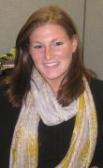y Sleath graduated from Plymouth State University in 2010 with a Bachelor’s degree in English and recently joined FIRST as an Operations Coordinator.
She was selected to be a part of Reebok International’s Post-graduate Apprenticeship program for one year, working with the Design team as well as Operations team.
In her free time she enjoys reading, outdoor activities, going to Broadway shows, antiquing, movies, and volunteer work.
Lisa Vincent, Senior Grants Writer
Lisa Vincent joined FIRST in August, 2011 as the senior grants writer. Prior to working at FIRST, Lisa was the Development Director for New Generation, Inc., a small homeless shelter for pregnant women and their babies. Lisa began her fundraising career as a Major & Planned Giving Assistant at New Hampshire Public Television.
Lisa graduated magna cum laude from Southern New Hampshire University in 2004 with a degree in Communications. She currently resides in Newmarket, NH with her husband, Ray, and four of her five children.

New Faces in the Field…
Regional Directors… work collaboratively to create and maintain Volunteer driven, self-sustaining, and growing FIRST programs in a named geographic area.
Rhonda Christen, Assistant Regional Director - Louisiana
Rhonda Christen joined the Field Operations team in July as the Assistant Regional Director for Louisiana. Rhonda has been involved with FIRST in the Bayou region since 2008, through her work at ITT Technical Institute. Rhonda holds degrees in Drafting and Design from ITT Technical Institute and Health Vocation/Medical Technician from Eastern College in Louisiana.
Sandra Contreras, Assistant Regional Director - Southern Florida
Sandra Contreras joined the Field Operations team in July as the Assistant Regional Director for the Southern Florida area. Sandra holds a BS Industrial and Systems Engineering from Instituto Tecnologico y de Estudios Superiores de Monterrey, in Mexico and an MBA from the MIT Sloan School of Management. Sandra became involved with FIRST as a Mentor/Coach in the Junior FIRST LEGO League. She brings with her a diverse background in business and technology. Currently Sandra serves as the Director of Business Development for Mass Hispanic Marketing in Miami.
Dan Green, Regional Director - Illinois
Dan Green joined the Field Operations team in July as the Regional Director for Illinois. Dan has been involved with Illinois FIRST since 1996, serving as a team leader and Mentor. He received the National Woodie Flowers Award in 2007 and also serves on the Board of Directors for the Mid-West Regional. Dan holds his BS in Computer Engineering from the University of Illinois and his MBA from the University of Chicago. He has long worked in the telecommunications industry with Motorola Inc., and is the Chief Operating Officer and Acting Chief Technology Officer of The Learning Guide Network, Inc. (an online directory of Learning Providers and Learning Events).
Meredith Novak, Assistant Regional Director - Arkansas
Meredith Novak has been a FIRST fanatic, Volunteer, and true believer since attending an FLL tournament 10 years ago. She is an FRC Hall of Fame Team 16 Mentor, the FLL Operational Partner, and FTC Affiliate Partner for Arkansas. She has served as an FRC and FLL competition judge and Volunteer and FLL Coach. She is a member of the 2012 FLL Challenge Advisory Team.
An Arkansas native and graduate of Hendrix College, Meredith was a Hendrix Merit Award Recipient and earned a Bachelor of Arts Degree with Distinction in Economics and Business. Her professional experience includes technical writing and editing, financial and utility analysis and consulting, as well as non-profit and tax accounting.
Meredith lives in Mountain Home, Arkansas with her family. Her children are all FIRST students/Alumni and her husband, John Novak, is a 17-year FIRST Volunteer and the 2009 Championship Woodie Flowers Award winner.
Theresa (Terri) Willingham, Assistant Regional Director - Central Florida
Teri W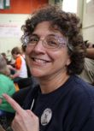illingham joined the Field Operations team in July as the Assistant Regional Director for the Central Florida area. Terri has been involved with FIRST through the FIRST Tech Challenge since 2008. She is a professional writer by trade and is also the President and Founder of Learning is For Everyone, Inc. (a non–profit education resource organization). Terri holds a degree in English and Journalism from Florida International University and is a member of The Author’s Guild.
Senior Mentors… work on the ground in a hands-on environment in support of the family of FIRST programs; recruiting, supporting, and sustaining teams, Mentors, Coaches, and Volunteers in their region.
Teri Benart-Abrahamzon, Senior Mentor - California
Teri Benart has 20+ years of experience in the Information Technology field. She has performed both hardware and software requirements, architecture, design, engineering, and project management. She has managed large global projects and budgets as part of her role in IT. Teri was introduced to FIRST three years ago by her son and has been mentoring Team 2085 from Vacaville, California since then. She has also participated in FIRST as a judge for both FLL and FRC in the northern California Region and at Championships for FRC this year. She serves on the Regional Planning Committee for the Sacramento Regional and is the Regional Planning Committee Chair for 2012.
Tara Bowen-Biggs, Senior Mentor - Oregon
Tara Bowen-Biggs has been a communications professional for local government for six years as well as a preschool teacher and parent. She has been a Coach and Volunteer for FLL, FTC, and FRC teams and events as well as coordinator for Benson Polytechnic High School’s robotics club. As a “govie,” she has been involved in community building and economic development as well as projects encouraging youth to become involved in their local communities. Tara helped develop and implement Multnomah County, Oregon’s social media policy and programs and has received recognition for innovative communications strategies utilizing Facebook, Twitter, and video. She loves the challenge of breaking down complicated issues and programs and explaining them in interesting and engaging ways. She is committed to encouraging all young people to pursue their interests with passion and zeal and is committed to introducing the potential in business, education, and community leadership to motivated youth.
Vicki Coaty, Senior Mentor - Minnesota
Vicki Coaty has a tremendous amount of organizational and leadership skills gained from her past professional career in advertising and her vast Volunteer experiences in her community and schools. As a Senior Traffic Manager at Colle & McVoy Marketing Communications, Vicki was often responsible for more than 75 projects at a time, ensuring that all projects were completed accurately and in a timely manner.
For the past 14 years she has served her community and schools, taking on a multitude of leadership roles. These roles have included president/chairperson, fundraising coordinator, volunteer director, and program coordinator. She has served on a number of committees for the Robbinsdale Area School District as well as individual schools. Vicki also has extensive experience in FIRST LEGO League, volunteering and supporting the Minnesota Chapter for over a decade as a Coach, Mentor, tournament director, referee, and judge.
Steve Florence, Senior Mentor - Indiana
Steve Florence has been a technology teacher for 36 years and is currently employed by the West Lafayette Community School Corporation. He has been involved with FIRST for 12 years as a Lead Mentor for Team 461 “Westside Boiler Invasion,” and he is also involved with FLL and FTC. In addition, he is a charter member for the Boilermaker Regional Planning Committee. With his leadership and dedication he has helped develop a college-based student Mentor program at Purdue University; Purdue FIRST Programs. Over the past 10 years, Steve has developed and presented at numerous FLL, FTC, and FRC workshops designed to help educators, parents, students, and professionals participate in all FIRST programs. He has been honored throughout his teaching career for excellence in teaching and his awards include Indiana Technology Teacher of the Year and a Regional Woodie Flowers Award in 2006.
Dana Henry, Senor Mentor - Massachusetts
Dana Henry has worked for United Technologies business unit, Hamilton Sundstrand/Space Systems for 29 years, building various life support systems for NASA and the U.S. Navy, including the EMU (extravehicular mobility unit, “the space suit”), oxygen generation, life support, cooling and gas management systems for the NASA Space Shuttle, International Space Station and U.S. Navy submarines. In 2002, Dana co-founded FRC Team 839 “Rosie Robotics,” and in 2005 co-founded FTC Team 839 with the late John Burns. Since then, Dana has expanded FIRST to all schools in all grade levels in Agawam, Massachusetts, founded the Agawam Robotics Education Association, Inc. a 501(c)(3) and currently serves as President. He has organized FLL state Qualifying Tournaments for three years and has been a FRC Championship Inspector for seven years. Henry has also presented various training modules at Kickoff in Manchester, on rookie FRC/FTC/FLL team formulation, veteran team sustainability, and how to shape local politics for the support of FIRST.
Michael Klanica, Senior Mentor - Pittsburgh
Michael Klanica was introduced to FIRST in 2005, and became a FRC team Mentor in 2007. After transferring schools to be closer to home for the birth and adoption of his son, Brady, in 2008, Michael introduced competitive robotics to his new school and formed FRC Team 3062, “Spartan Robotics.” This team went on to capture the Highest Rookie Seed and Rookie All-Star awards that season, and even earned a spot at the Championship event in Atlanta. He continued the FIRST mission for two more years before leaving the teaching profession after the 2010/2011 school year to return to computer programming.
Michael’s pre-FIRST experiences consisted of two tours of duty with IUP, resulting in Bachelor’s degrees in Applied Mathematics/Applied Computer Science and Secondary Mathematics Education.
Heidi Lovett, Senior Mentor - Washington
Heidi Lovett has worked extensively with students as a homeschooling parent, scout leader, Coach, and Mentor. Heidi is passionate about FIRST and has witnessed firsthand the positive impact it has on students, Mentors, parents, schools, and professionals. She has more than five years of experience with three of the FIRST programs – two years as Coach for FLL, three years as lead Mentor for FTC, and one season with FRC. In addition she has worked with a Jr.FLL team and a collegiate team.
Joshua Mauro, Senior Mentor - Nevada
Joshua Mauro has extensive experience with FIRST. Being a part of FRC Team 987 “The High Rollers” in Las Vegas, he knows the ins and outs of the FRC competition from the build season to the Championship. He served as president of Team 987 for two years and was a member for three years. The High Rollers also host an annual FLL competition, where Joshua serves as a referee. Mauro also has experience with FTC. Being recommended to serve as a FIRST Senior Mentor by the Nevada FIRST Regional Director, Jean Hoppert, has been a great honor for him and he is very excited to get back into the FIRST family.
Tim Rich, Senior Mentor - Tennessee
Tim Rich initially became involved with FIRST in the autumn of 2008 when his daughter joined her high-school FRC team. This was the team’s second season, and Tim has been involved in helping them grow over the past three years. Tim has served as a parent Mentor, helping kids with a wide variety of activities, including fundraising, marketing, interpretation of rules, web site development, developing team facilities, picking up the kits, build season, practice field mock-ups, pit structures, attending multiple competitions, Chairman’s Award submission, travel, food (and eating), and the like. Tim’s professional background includes over four years in business process project management (which is primarily related to Information Technology), as well as 17+ years in Human Resources, which entails leadership development, training, union issues, corrective action, recruiting, and hiring.
Mary Roberts, Senior Mentor - Georgia
Since being introduced to FLL by a friend in 2002, Mary Roberts has coached both FLL and FTC teams, participated as an FTC Pilot program Coach, and taken two teams to the Championship. Recently, Mary has mentored both FLL and FTC teams, organized FLL regional qualifiers, served as FTC Judge Advisor, and volunteered for many FIRST events. Before discovering FIRST, she was very involved in the Boy Scouts of America as Den Leader and Cub Scout Day Camp Coordinator. After graduating from Georgia Tech with a Mechanical Engineering degree, Mary worked as a computer programmer before staying at home with her children. While coaching FLL teams, she and her co-Coach were asked repeatedly to teach other children the skills learned by their team. As a result, they began a business to teach Science, Technology, Engineering, and Mathematics (STEM) classes to students, leading to the formation of many FLL and FTC teams.
Javier Saenz, Senior Mentor - Texas
Javier Saenz is an engineering physics student at the University of Texas at Brownsville, where he also works as a developmental math tutor. Javier has been involved with FIRST for three years, mentoring Team 2833 for the FRC Lone Star Regional and as a Volunteer for a FTC event held this year in Brownsville. Javier is looking forward to the opportunities that come with being a Senior Mentor, especially within the Brownsville area where there is much uncharted territory for FIRST.
Lia Schwinghammer, Senior Mentor - North Carolina
As a young person, Lia Schwinghammer started her working life teaching children in the family business (preschool-daycare center), transitioned to the business world for years, and is again working with young people. After college and graduate school, Lia worked in business becoming experienced in international trade. Her experience includes operations at a Foreign Trade Zone, managing international sales and distribution for a medical manufacturer, and cross cultural communication trainings for Fortune 500 firms.
After having children and wanting to be involved in their activities, she began volunteering with youth organizations such as Girl Scouts, Boy Scouts, and FIRST. Her growing involvement in FIRST fostered her desire to encourage young people to pursue science and technology careers.
Tom Settle, Senior Mentor - North Carolina
Tom Settle has extensive experience as a Technology Leader and Trainer. As a Network Engineer for 11 years with Cisco, Tom was responsible for supporting and training Cisco customers and employees worldwide on LAN and Data Center Switching Technology. During that time, Tom also served as Content Manger for the coveted CCIE Storage Networking certification. Tom’s foundation in technology education has helped him to successfully volunteer as a Coach and Mentor for many FIRST teams since 2006.
Dennis Skurulsky, Senior Mentor - Wisconsin
Dennis Skurulsky has been involved in education for over 30 years. He has worked as a teacher, curriculum writer, coordinator, grant writer, and department chair. He co-authored and piloted the state curriculum for High School Engineering. He has also been a lead Mentor for an FRC team in Wisconsin for five years. Dennis is student-centered, has a strong work ethic, possesses a great sense of humor, welcomes challenges, and has a proven ability to motivate others.
Rose Young, Senior Mentor - Maryland
Rose Young, a science teacher, began her involvement with FIRST in 2006 when she was asked to mentor the new high-school FRC team her oldest son joined as a freshman. At the same time, her youngest son joined the new FLL team at the local middle school. Since then she has continued to mentor the FRC team which “adopted” three FLL teams from the middle school, and several elementary school FLL teams as well. Rose represents the FRC team as part of the Baltimore Area Alliance of FRC Teams, and has served as Assistant Volunteer Coordinator at the Chesapeake Regional. Her FRC team has run annual FLL Qualifiers in Maryland since they began, and Young has also helped co-host the Battle o’ Baltimore off-season FRC event each year for the past five summers. In 2011, Young began working to help enable the formation of a non-profit corporation to support regional robotics and STEM programs, which will support existing FRC and FLL teams as well as a new FTC team in the Carroll County, Maryland area.
AmeriCorps VISTAs… work to create a broader awareness of FIRST in their community, focusing particularly on the needs of the underserved while seeking support from Sponsors to help meet the needs and challenges of teams, Mentors, Coaches, and Volunteers for all FIRST programs.
Tripat Kaberwal, NYC
Tripat Kaberwal comes to FIRST after working as a Donor Relations and Office Assistant for A.J. Muste Memorial Institute in New York, New York. Prior to her work at A.J. Muste, she was a Reader for the Record Campaign & Development AmeriCorps VISTA through Jumpstart for Young Children. During her service at Jumpstart, she was responsible for event planning, event logistics, and development administration. Tripat’s foundation in the non-profit sector was developed while she was a Development Intern for SAYA! (or the South Asian Youth Action) in Elmhurst, NY. Her role as a Development Intern consisted of grant research, database development, and community event planning. She holds a B.A. in Global Studies from the University of California, Santa Barbara.
Eric Leifermann, Washington, DC
Eric Leifermann recently graduated from Michigan Technological University with a Bachelor’s degree in mechanical engineering. He has been involved in FIRST for the past 11 years as both a student and Mentor. He has aspirations of volunteering in the Peace Corps with his wife when his time as a VISTA comes to an end. From his beginnings in FIRST to his involvement in Mu Beta Psi National Honorary Musical Fraternity, Eric has always been dedicated to community service and volunteering. Being able to merge his love for FIRST and community service is a dream-come-true for Eric.
Jesse Moskowitz, Massachusetts
Jesse Moskowitz graduated from Emory University in 2007 with highest honors. As a student, and since then, he has volunteered extensively for literacy organizations. With experience in New England non-profit organizations, as well as international business supply chain management, Jesse is eager to bring his experience to FIRST.
Jaron Newton, New Hampshire
Jaron Newton graduated from Indiana University with a degree in Geographic Information Systems. While attending college, Newton was an intern for a children’s science museum called WonderLab Museum of Health, Science and Technology in Bloomington, Indiana. As an intern he was responsible for recruiting, training, managing, and mentoring many volunteers who served the museum. Also during his undergraduate years, Newton was a summer intern for Science Applications International Corporation. Through SAIC, he worked closely with radio frequency engineers on signal jamming technologies intended for military use. Newton hopes to use his experiences to be able to help students across the country realize their academic and professional goals.

January, 2012

New Faces at FIRST
FIRST is pleased to welcome the following new members of the FIRST Community:
FIRST Headquarters Staff
Scott Comeau, Junior Network Engineer
Scott joined the FIRST IT department as a Junior Network Engineering in December, 2011. Scott attended college in South Carolina and subsequently continued his computer training, gaining multiple computer certifications as well as becoming a certified A+ hardware technician. He has worked in the IT field for over ten years, including for such companies as Hewlett-Packard, Ecollege, and Dartmouth College.
After moving around the U.S., he has recently settled back into the Northeast, where he grew up on the lakes of the coast of Maine. In his spare time, Scott enjoys staying active by working out and progressing in Reiki and other trainings. Scott is always touching up his computer skills by working towards the next certification. Scott also enjoys playing computer games and getting out into nature to explore and observe wildlife.
Rebecca Falkenburg, Team Grants Coordinator
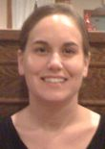Rebecca Falkenburg joined FIRST in November, 2011 as Team Grants Coordinator. Her passion for non-profits and desire to help children discover science and technology are what drew Rebecca to the organization.
Rebecca grew up in Dover, New Hampshire. She went to college in Boston where she earned a bachelor's degree in English at Northeastern University. After graduating, she returned to Dover and earned her master's degree in Public Administration from the University of New Hampshire. Rebecca completed an internship at the HUB Family Resource Center in Dover, which confirmed her desire to help others and work in a non-profit environment. In her free time, she enjoys volunteering, dancing, and spending time with her family.
Stephanie Ford, Business Analyst in Operations Support
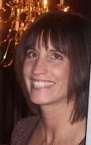Stephanie Ford brings a wide breadth of IT and business experience to the position of Business Analyst for FIRST. Stephanie has an associate’s degree from Hesser College in Computer Science and a bachelor’s degree in Business Management from Leslie College. Prior to FIRST, she worked at Digital Equipment as a computer operator and programmer analyst; at Sun Microsystems as a software engineer and systems business analyst, where she earned several professional awards; and at biotech company Whatman-Balston as North American IT Director. In 2005, Stephanie became an independent IT Consultant where she held positions at Axis Computers, Parker Hannifin, and Watts Water Technologies in a variety of roles such as computer programmer, project manager, IT team manager, business analyst, technical writer, and quality assurance.
In her spare time, Stephanie enjoys being with her family. Stephanie has been married for 15 years and has three children – a 10-year-old daughter and 8-year-old girl/boy twins. The girls are cheer leaders so a lot of time is spent at games and competitions. Stephanie loves the beach and spending time at their lake/ski house in the Sunday River area of Maine. Stephanie enjoys working out, staying healthy, and reading.
Mark Foynes, Manager of Individual Giving/Corporate Relations
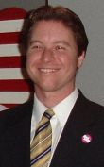Mark Foynes joined FIRST as a consultant in May, 2011 and assumed the duties of Manager of Individual Giving/Institutional & Corporate Relations in December. A tireless advocate of the transformative power of education, Mark has been involved with outreach-based nonprofits since 1996.
A lifelong Granite Stater, Mark earned degrees in history from St. Anselm College and University of New Hampshire. After earning his master’s degree, Mark became the Director of Education at the New Hampshire Historical Society, where he devoted himself to inspiring a love of history among youth through curriculum-based school programs. Under Mark’s direction, these programs would grow to serve 20,000 children each year. In 2007, Mark became the Executive Director of the Wright Museum of WWII History in Wolfeboro, New Hampshire, where he provided overall organizational leadership and served as the institution’s leading fundraiser and public spokesman.
Mark and his wife, Sarah, have two young children and live in New Durham in an antique farmhouse that is a fusion of Mark’s two abiding interests: history and America’s proud heritage of innovation. Mark and Sarah are Mentors to Junior FIRST LEGO League Team “USAFox.”
Maria Gagnon, Institutional Relations Manager
Maria Gagnon joined FIRST in October, 2011 as the Institutional Relations Manager. A New Hampshire native, Maria has devoted her professional career to ensuring the well-being of children and their families by providing them with access to quality services and opportunities to grow and succeed. Maria has demonstrated success in non-profit agency operations, program development and evaluation, fundraising, strategic planning, and board development. She is considered an expert in the area of adolescent substance abuse treatment and has worked for private counseling agencies, the NH District Court System, and New Futures. Most recently, Maria served as Executive Director for the Child Advocacy Center of Hillsborough County, serving child victims of crime.
Maria received her master's degree in Social Work from the University of New Hampshire. In her free time, she enjoys outdoor activities such as hiking, kayaking, biking, and enjoying the state’s seacoast. A quiet night at home will include take out, a good movie, and sharing space on the couch with her husband and two dogs.
Mary Lee, FIRST Tech Challenge Partner Services Manager
Mary Lee joined FIRST in October, 2011 as the FIRST Tech Challenge (FTC) Partner Services Manager. She was attracted to FIRST because she wants to “make a difference” in the lives of youth, especially the next generation.
Mary is currently a Board Member at New Hampshire TechFest, a program designed to encourage students to pursue careers in the STEM areas of study. Prior to FIRST, she was a Marketing Manager at Digital Equipment and a Finance Manager at BAE Systems. She earned her MBA in Marketing from Rivier College and a bachelor’s degree in Finance from Boston University.
Mary and her husband, Steve, love to cook and make intriguing dishes – so many recipes, so little time! Their two children keep them quite busy and they enjoy every moment with them.
Dennis Mitchell, FIRST Robotics Competition (FRC) Field Maintenance
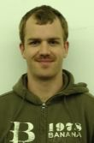Initially with FIRST as a temporary carpenter for the FIRST Robotics Competition, Dennis Mitchell now works fulltime as Field Maintenance. He enjoys being a part of a program that inspires so many youth to follow careers in science and technology.
Prior to FIRST, Dennis worked for two years as both a ski technician and a mountain bike technician in Virginia, followed by five years in Vermont as a sub-contractor building homes, custom woodworking, and fine cabinetry.
Dennis enjoys several outdoor activities such as hiking, mountain biking, rock climbing, skiing, and snowboarding. He also enjoys watching movies and reading.
Beth Murphy, Director of Finance
Beth Murphy joined FIRST in January, 2011 as its new Director of Finance. She has worked in the not-for-profit sector for 15 years – most recently with Camp Fire USA and United Way of King County, both in Seattle, Washington – and was inspired to join FIRST by our mission and values. Beth grew up in Long Island, New York and graduated from Long Island University with a bachelor of science in Accounting. She enjoys family and friends, music, art, movies, and books.
Kathryn Myers, FIRST Robotics Competition Program Coordinator
Kathryn Myers joined FIRST in September, 2011 as the new FIRST Robotics Competition (FRC) Program Coordinator. Kathryn holds a bachelor’s degree with a major in Psychology and Law and a minor in Sociology/Anthropology from Plymouth State University; a master’s degree in Public Administration from the University of New Hampshire (UNH); and a Supervisor’s Certificate and a Train-the-Trainer Certificate, both from UNH. She plans to continue her education and professional development as she loves learning!
Prior to FIRST, Kathryn was Program Manager at the UNH Technology Transfer Center, where she managed a training program and other services offered to local highway departments in the state. The “workforce development” aspect of that job helped Kathryn realize her passion for working in projects that introduce kids and teenagers to science and engineering career fields.
Kathryn was born in Astoria, Oregon and has lived in New Hampshire since age 6. When she is not at work, she enjoys reading, watching movies, playing poker and pool, and spending time with her family. She is excited about her new career with FIRST, which she knows will be both challenging and rewarding.
Jenna Skinner, Accounting Generalist
Jenna Skinner made the jump to FIRST in order to work in accounting and because she wanted to do something good for the community. Jenna graduated from Syracuse University with dual bachelor’s degree in Communications/Theatre with a minor in Radio/TV and concentration in Interpersonal Communication. She worked in Radio doing writing and production, then Retail Management. She furthered her education with an associate’s degree in Accounting.
In her spare time, Jenna volunteers for Greyhound Pets of America, travels, kayaks, renovates her fixer-upper home, makes jewelry, walks her dogs, and searches for the perfect margarita recipe.
Sarah Stray, Volunteer Coordinator
Sarah Stray joined FIRST as Volunteer Coordinator in November, 2011. Drawn to FIRST because of its integral Volunteer base and mission, she’s thrilled to be a part of the expanding Volunteer Resources Department.
Prior to joining FIRST, Sarah lived in Chicago for 13 years where she worked for Hoopla Communications, Inc., a conference and event planning company committed to working with not-for-profit clients who focus on social justice, economic, and community development, working with disenfranchised people, and women’s issues. Sarah was responsible for project managing large-scale events; silent auction and fundraising development; and recruiting, training, and managing event Volunteers. Through her work with not-for-profit organizations and as an animal shelter Volunteer, Sarah became fascinated by how volunteerism affects positive change within communities.
Sarah holds a bachelor of arts degree in English Literature from Wheaton College in Massachusetts. She is an avid knitter, gardener, reader, theatre aficionado, and spins her own yarn. Sarah is happy to be back in her native New England with her husband, two daughters, and rescue dog Comet.
Natalie Turcotte, Volunteer Coordinator
Natalie joined the FIRST Volunteer Services Department in October, 2011 as the Volunteer Mentor/Coach Program Coordinator. FIRST is an exciting place for Natalie to be because of the wonderful contribution it makes to the world.
Natalie is a graduate of the University of New Hampshire with a bachelor of arts degree in Sociology. Over the past several years, she has held positions in both social services and technology. She was born and raised in Manchester. In her free time, she enjoys volunteering, jogging, snowshoeing, and travel.
Kathy Vachon, FIRST LEGO League Partner Services Zone Manager
Kathy started at FIRST in September, 2011 as FIRST LEGO League (FLL) Partner Services Zone Manager covering the west coast of U.S. and British Columbia and Alberta, Canada. Kathy has a degree in Psychology and Criminal Justice and has worked with abused and neglected children for over 20 years. For the past 12 years, she has worked for CASA (Court Appointed Special Advocate), initially as a Guardian ad Litem Supervisor recruiting, training, and supervising the cases and CASA Volunteers in the Manchester Court System. Three years ago, Kathy transitioned to CASA’s Director of Development. In that role, she oversaw all aspects of fundraising including grant submissions, corporate and civic donations, individual gifts, and special events.
Kathy is excited to begin her new career path at FIRST, an organization that values children and encourages their potential.

September, 2012 –

New Faces at FIRST
FIRST is pleased to welcome the following new members of the FIRST Community:
FIRST Headquarters Staff
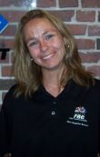Kim Asmega, Shipper/Receiver and Inventory Clerk
Prior to joining FIRST as Shipper/Receiver and Inventory Clerk, Kim Asmega held various administrative and data entry positions in Florida including Assistant Manager for Global Prospects in Port Charlotte.

Michelle Gagnon, Payroll and Benefits Specialist
Michelle Gagnon joined FIRST in July, 2012 as Payroll/Benefits Specialist. Michelle earned her Associate’s degree in Business from Hesser College and is currently working toward her Bachelor’s degree at Granite State College. She also holds a professional certification in Human Resources.
Over the last 14 years, Michelle has held positions at several companies, including both for-profit and non-profit, gaining experience in both Human Resources and Payroll. Her most recent position was with the New Hampshire Institute of Art as the Payroll/Benefits Manager, where she managed the bi-weekly processing of payroll along with administering the employee benefit plans.
Michelle and her husband, John have been married for 28 years, raised two daughters, and have been lifelong residents of New Hampshire. In their spare time, they enjoy hiking, biking, snow shoeing, cross country skiing, and anything else that will keep them outdoors and close to nature.
Gabrielle Muller, Executive Administrative Assistant for Field Operations
Gabrielle Muller initially started at FIRST as a Volunteer in the Volunteer Resource Department in February, 2012. After doing extensive research into non-profit organizations located in the Southern New Hampshire area, she became very interested in working for FIRST and joined the organization full time in July, 2012 as the Executive Administrative Assistant for Field Operations.
Gabrielle was born in Southampton, New York and has lived all over the country, with the most time spent in New England. She graduated from Arizona State University with a Bachelor’s degree in Business Administration and a minor in Finance.
Gabrielle is an avid reader, loves to ski, snowboard, go to the beach, and skydive. She has traveled extensively and particularly enjoys the Caribbean, where she has visited most of the islands.
Kimberley Prygocki-Jeakins, Development Donor Data Coordinator
Kimberley Prygocki-Jeakins joined FIRST in July, 2012 as the new Development Donor Data Coordinator. Kimberley’s experience as a member of two FIRST teams in high school and her desire to work for a nonprofit organization drew her to the position.
Kimberley attended Boston College, graduating in 2000 with a Bachelor’s degree in Psychology and a minor in Computer Science, then completed her Master’s degree in Computer Resources and Information Management at Webster University’s campus in London, England.
After completing her degrees, Kimberley worked as an administrator in the pensions department for Unilever UK for almost five years, where her role focused on pensioner welfare and the database systems to support that work. After relocating from the UK back to her native New Hampshire, Kimberley worked for Member Benefits, Inc., a small company specializing in a program called MemberCard, primarily used by nonprofit public broadcasting stations to boost membership and individual giving.
In her spare time, Kimberley enjoys running, volunteering at the Manchester Animal Shelter, and spending time with her husband and two dogs.
Kerry Wentworth , FRC International Coordinator/Administrative Assistant
Kerry Wentworth joined FIRST in August, 2012 as a FRC International Coordinator. Kerry admires the FIRST commitment to inspire today's youth, which she believes will result in an exciting scientific future. She is very excited to become a member of the team at FIRST.
Kerry graduated from Endicott College in Beverly, Massachusetts with a degree in Marketing/Advertising. She has spent the last 11 years working for non-profits in the local area.
In her spare time, Kerry enjoys relaxing at the ocean and also golfing with her family. She is married with two children.

New Faces in the Field…
Regional Directors… work collaboratively to create and maintain Volunteer driven, self-sustaining, and growing FIRST programs in a named geographic area.
Carolyn Arthurs, Regional Director – Louisiana
Carolyn Arthurs, a New Orleans native, has been involved with FIRST since the 2001 season. A graduate of Archbishop Chapelle High School, she attended college at Southeastern University and the University of New Orleans, with focuses in vocal performance and entrepreneurial business. As one of the Show Ready Events Regional Event Managers, Carolyn has managed over 40 FRC regional events across the country in the last 12 years. In addition to Regional events, Carolyn has also held various managing positions during the FIRST Championship since 2003. Carolyn is the owner of All About Events, LLC, an award winning local event design and management company that focuses on social events and destination New Orleans weddings. She has been in the event and entertainment industry as a manager and performer for over 20 years.
Blair Gallant, Regional Director – Alberta, Canada
As an entrepreneur who started his first business at age 12, Blair Gallant is the founder of chain stores and a land development company. Following his retirement, he started the AO Shirley Foundation to follow his passions, arts organizations, community events, festivals and community spaces, and now FIRST.
Blair was born in Lethbridge, Alberta, a fifth generation member of the Gallant family. He is married and has two children. His oldest son is a member of FIRST Robotics Competition Team 4334 “Alberta Tech Alliance,” an Archimedes Division Winner at the 2012 FIRST Championship.
Senior Mentors… work on the ground in a hands-on environment in support of the family of FIRST programs; recruiting, supporting, and sustaining teams, Mentors, Coaches, and Volunteers in their region.
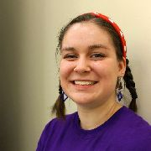Renee Becker, Senior Mentor - Minnesota
Renee is an alumnus of FRC Team 1675 from Milwaukee, Wisconsin. She earned a Bachelor of Science in Scientific and Technical Communications at the University of Minnesota – Twin Cities. During her freshman year she founded a FIRST Alumni Organization, called GO FIRST, to help support the Twin Cities FIRST Community. Throughout her college career, Renee mentored eight FRC teams; helping them with presentations, award submissions, and strategic planning. Renee is a member of the Non-Engineering Mentor Organization (NEMO), facilitator of Roundtable meetings at regionals and off-season events in the Midwest, co-founder of Assisting Creative Energy (ACE), and has presented at: the FIRST Championship Conferences, Minnesota Splash, and other FRC workshops.

Eileen Kahn, Senior Mentor - California
Eileen Kahn has a background in Public Relations and Marketing. She became involved in education in 1999, by working with after school programs. She got involved with FIRST when her oldest child was in 9th grade (in 2004) as the team mom. When the program needed a teacher she earned her teaching credentials and went to work officially as a teacher with the ROP Program at Beverly Hills High School. She started a robotics entrepreneurship program at BHHS and runs her classes and program using a corporate model. Eileen maintains three classes at BHHS and her team, 1515, which usually has 80-100 members each year. She has successfully mentored 12 teams including 3 internationally. Eileen has served as a Google On Air Education Presenter for robotics. She speaks five languages fluently and loves working with motivated students.

Rachel Riquelme, Senior Mentor - Kentucky
Rachel is the Children’s Minister at High Street Baptist Church in Somerset, KY and the Co-Founder of Project 58:10 a non- profit organization that provides weekend backpacks of food for ~500 students who have little access to food when they are away from school. Rachel is very involved in her community and in her local school system where she mentors a local FIRST robotics team, leads science and STEM related camps, teaches leadership in various programs, and volunteers in classrooms throughout the school year.

Roger Riquelme, Senior Mentor - Kentucky
Roger has been involved in FIRST since 2001; first as a student team member and then as a mentor. While in high school, he was part of team 312 (Heatwave) in St. Petersburg, Florida. After graduating, he attended the University of South Florida in Tampa, where he earned a degree in Mechanical Engineering. While in college, he was one of the founding mentors of team 1369 (Minotaur), which he mentored from 2004-2008. After graduating in 2008, he had the opportunity to serve as a technical mentor for team 461 (West Side Boiler Invasion). Roger currently teaches PLTW Pre-Engineering courses at Southwestern High School and coaches team 3259 (The Thoroughbots), which he helped establish in 2010.
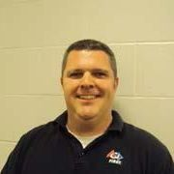
Mark Snodgrass, Senior Mentor - Indiana
Mark has worked with FIRST for 8 years. His primary focus has been working with middle school students who participate in FIRST Lego League. Mark has helped create 2 FLL teams at Center Grove Middle School North. During his time as the coach of those teams, he also volunteered to be the coordinating director for the Indy South FIRST Lego League Qualifying Tournament. He has also helped FRC team 1741, Red Alert Robotics, create outreach activities for their Chairman’s Award such as Community Tech Night. Team 1741 helped bring Mark’s desire to educate the community about internet safety in the digital world through that Community Tech Night. Students pre-K through 5th grade are educated by hands-on-science lessons, while their parents have the option to attend free technology training. Mark teaches Computer Applications at Center Grove Middle School North in Greenwood, Indiana. He received his Bachelors of Science in Elementary Education from the University of Indianapolis in 2000 and just this summer completed his Master’s degree in Education with a focus in Technology from Indiana University/Purdue University Indianapolis.
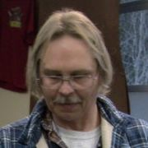
Eric VanBuren, Senior Mentor - Washington
Eric has been involved with FIRST for four years starting when his son joined a FRC team. It wasn’t long until he became hooked on FIRST and switched his focus from the design and fabrication of the robot to being the lead mentor focusing on strengthening the teams Outreach, Marketing, Media, and Web performance. Eric has a background as a small business owner, auto and truck mechanic, Landlord, remodeling, and sales.
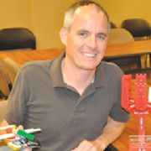
Martin Willie, Senior Mentor - Oregon
Marty has 12 years of experience working in public education and in IT. He is the Program Director for Oregon StRUT (Students Recycling Used Technology) and is employed with Mid-Columbia Council of Governments and is taking on the FIRST role along side his current position. Marty is passionate about FIRST robotics programs, STEM Education, and has trained students, educators, and mentors in preparation for Jr. FIRST LEGO League, FIRST LEGO League, and FIRST Tech Challenge. He recently received the 2012 Award of Excellence from LEGO Education for his service to students in Oregon and SW Washington. In addition to providing training, Marty enjoys calling robotics matches and has emceed several Oregon Intel FIRST LEGO League Qualifying Tournaments, and was the Game Announcer in training at this year’s Oregon Autodesk FIRST Robotics Competition event held at the Memorial Coliseum.
AmeriCorps VISTAs… work to create a broader awareness of FIRST in their community, focusing particularly on the needs of the underserved while seeking support from Sponsors to help meet the needs and challenges of teams, Mentors, Coaches, and Volunteers for all FIRST programs.
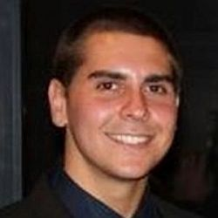
Robert Holup, VISTA - Washington, DC
Robert recently graduated from Florida State University with his B.S. in both Finance and Economics. Originally from Linden, NJ, Robert lived in Cape Coral, FL before attending Florida State University in Tallahassee. During his college career, Robert was highly engaged on campus in a variety of activities giving him a very diverse background; including his leadership roles within The F.S.U. Marching Chiefs and Phi Iota Alpha Fraternity Inc. During his senior year at Florida State, Robert was a co-founder for a new mentoring organization to target ESOL students within the Tallahassee area and served as a counselor for the C.A.R.E. Summer Bridge Program at Florida State University. Robert will be enrolling in law school Fall 2013 pursing his J.D./M.A. in Economics. He hopes to work within public policy either domestically or abroad.
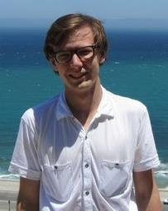
Michael Kaurich, VISTA - Maryland
Mike is a recent graduate from Grand Valley State University with a degree in History and Political Science. While at Grand Valley, Mike worked with the Office of Student Life on a number of different volunteer programs ranging from week-long service trips to weekday service outings. Mike was also a member of FIRST Team 33 out of Pontiac Michigan while in high school and volunteered as a Mentor for a FIRST LEGO League team. Outside of volunteering, Mike really enjoys cities, live music, and loves his record player dearly. He is really excited to get to work inspiring kids to the wonders of science and math.
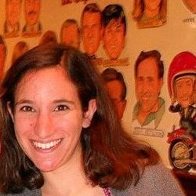
Rachel LaBattaglia, VISTA - New Hampshire
Rachael graduated from Towson University in 2011 with a B.S. in Earth-Space Science and a secondary education certificate. She also minored in Spanish and Astronomy. She participated in a variety of service organizations and held leadership roles throughout high school and college. She has worked extensively with children through being a camp counselor, student teaching, and teaching a year of high school Spanish in Maryland. Rachael is really looking forward to getting students and communities excited about robotics and STEM initiatives.
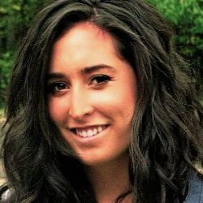
Riley McCall, VISTA - Massachusetts
Riley graduated from Duquesne University with a dual major in International Business and Marketing. While at Duquesne, she studied abroad in Rome, Italy and was involved with campus service groups that have travelled to New Orleans, Louisiana, Appalachia, and West Virginia. Riley has been a strong advocate of volunteering, especially through service-learning. After graduating, she served as a Peace Corps volunteer specializing in Agribusiness in Cameroon. Prior to graduating, Riley interned at the Pennsylvania State Government and Amizade Global Service-learning Programs. Riley is excited to work for FIRST because she loves to see the youth inspired by science and technology in special and extraordinary ways.

Lindsey Wright, VISTA - Maine
Lindsey is a recent graduate of the University of New Hampshire. In December, Lindsey was one of the first students to graduate from UNH's new Sustainable Agriculture & Food Systems program. She has a strong background in research and conducted grant-funded independent research for an honors senior thesis in agroecology during 2011. Lindsey has held several positions with non-profit and service-oriented organizations and she most recently served with the U.S. Navy's Morale, Welfare, and Recreation division. Lindsey's interest in science comes from a fascination with the ways humans interact with their environment. In her future work, she hopes to help others awaken their own curiosity about the world and encourage others to work toward new discoveries.

FIRST Newsletter - June, 2013 - New Faces at FIRST

FIRST Headquarters Staff
Kelly Ashton, Operations Coordinator
Kelly Ashton joined FIRST in June, 2013 as an Operations Coordinator. Prior to joining FIRST, Kelly provided administrative and customer support for diverse industries, from medical offices to high tech companies – most recently Concord Hospital and Regan Technologies Corporation. She also owns a floral design business called Sorella Floral Design. Kelly has a Bachelor of Arts in Humanities from the University of New Hampshire, and she spent a semester abroad at the National University of Ireland in Maynooth.
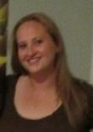
Emily Rose Bainton, AmeriCorps*VISTA Programs Coordinator
Emily Rose Bainton joined FIRST in May, 2013 as the new AmeriCorps*VISTA Programs Coordinator. Emily Rose, or Rosey as she also likes to be called, previously worked for Lutheran Social Services and Wediko Childrens’ Services. Prior to that, she was an AmeriCorps*VISTA member for PlusTime NH, and was a Peace Corps Volunteer in Malawi, Southern Africa. Emily Rose has a Bachelor of Arts in Criminal Justice, Social Work Specialization, and a Master of Science in Business Management and Strategic Leadership, both degrees from New England College in Henniker, New Hampshire.

Don Bossi, President
Don Bossi joined FIRST as President in May, 2013. Don, who has excelled in a 20-year career with several high technology companies, primarily in the fiber optics field, brings deep technical and management skills to the organization. Starting his career as a research scientist, first at MIT Lincoln Laboratory and then at United Technologies Research Center (UTRC), Don was a part of an advanced project at UTRC which was acquired by JDS Uniphase (JDSU). After a series of promotions at JDSU, he became Vice President and General Manager for JDSU Electro-Optics Products. Don next served as Group President of JDSU Active Components Group, and then as Group President, JDSU Transmission Products Group. In 2005, Don joined Technology Ventures Partners, serving first as CEO of Aegis Lightware, Inc. and then as CEO of Inlet Technologies. Most recently, Don served as the COO of CIDRA Holdings.
Daniela Dimova, FIRST Robotics Competition International Program Coordinator
Daniela Dimova joined FIRST in May, 2013 as the FRC International Program Coordinator. She oversees various aspects of the FRC international events and provides administrative and logistical support to the participating teams.
Prior to joining FIRST, Daniela worked in operations and customer support, as well as global travel assistance for companies including Graphic Packaging, Unitil Corp. and On Call International. She has experience in coordinating international medical evacuations and repatriations, and providing support to exchange students abroad.
Daniela graduated from Southwestern University in Bulgaria with a Bachelor of Arts degree in Philosophy. She speaks fluent Bulgarian (naturally), and can also converse in French and Russian.
Kristin Foss, Operations Coordinator
Kristin Foss joined FIRST in April, 2013 as an Operations Coordinator. Kristin was drawn to FIRST because of the organization’s mission and the prospect of a positive and fast-paced work environment.
Kristin attended Roger Williams University in Bristol, Rhode Island where she received her Bachelors of Science Degree in Historic Preservation. However, she learned that she liked to solve problems, work with an array of people, and focus on helping organizations run more efficiently. Kristin took it upon herself to make that her long-term career goal, so she decided to go back and get her Masters of Business Administration. Kristin graduated in 2011 from Southern New Hampshire University, where she received her MBA, concentrated in Operations Management.
Kristin previously worked for L-3 Communications as Financial Analyst and the Timken Company as an Account Analyst. In her spare time, Kristin enjoys the lake, running, and spending time with her husband, Andrew, and Golden Retriever, Zoey.
Cara Galli, Marketing Assistant
Cara Galli joined FIRST in June, 2013 as Marketing Assistant. For the last few months, Cara has been working with us through Wilson Employment Network as a supplemental assistant – first in Development, followed by Marketing.
Cara previously held various marketing and technical roles with local companies such as Apple Inc., MarketReach, PC Connection, i2 Technologies and STMicroelectronics. She has a B.S. in Business Administration from Emmanuel College in Boston, MA.
Mark Giordono, Vice President, Development
Mark Giordono joined FIRST in 2013 as the Vice President of Development. Drawn to working at FIRST because of his passion for the mission, Mark leads national strategy and implementation for sponsor stewardship, new sponsor development, grant writing, annual funds, and fundraising.
Prior to joining FIRST, Mark worked for technology startups in Vermont and New Jersey, served as a Peace Corps Volunteer in Mali, and did economic development via technology commercialization at MIT. Most recently at Hewlett-Packard, he started partner-driven new businesses for the company’s printer division.
Mark attended Dartmouth College and graduated cum laude in 1994 with degrees in Geography and History. In 2002, he received his master’s degree in Business Administration from MIT’s Sloan School of Management where he was a Siebel Scholar.
Mark coaches youth soccer and hopes via FIRST to have a positive impact on his own and all children’s futures.
Kathy Levine, FIRST LEGO League Partner Development Manager
Joining FIRST in April, 2013 as FLL Partner Development Manager, Kathy Levine has more than eighteen years of experience in the field of education, from classroom teaching to curriculum development to the statewide management of programs that provide STEM enrichment opportunities to students of all ages and grade levels. Most recently she served as the Ohio operational partner for the FIRST LEGO League and Junior FIRST LEGO League programs from 2004 until 2013.
Kathy earned a bachelor’s degree in education from The Ohio State University and a master’s degree in education from the University of Dayton.
Jillian Mordarski, Junior FIRST LEGO League/FIRST LEGO League Volunteer Program Coordinator
Jillian Mordarski joined FIRST as the new Jr.FLL/FLL Volunteer Program Coordinator in February, 2013. Jillian previously served for more than seven years as a direct service youth worker. Her work with youth ranges from curriculum development to case management. Her recent position of five years at Girls Incorporated of Lynn included empowering youth through STEM based learning. Prior to that, Jillian studied Human Services and Youth Work at the University of Massachusetts Boston. Jillian continues her work at Girls Inc. as a Volunteer and Mentor.
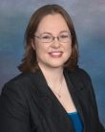Kathy Morgan, FIRST LEGO League Partner Services Manager
Currently a FIRST LEGO League Operational Partner and Project Manager for 4-H through the University of Nebraska, Kathy Morgan joined FIRST as FLL Partner Services Manager in May, 2013.
Previously, Kathy was a Program & Outreach Coordinator for Girl Scouts of New Mexico and spent many summers as an Assistant Camp Director at the Rancho Del Chaparral Girl Scout Camp. Kathy has a Bachelor of Arts in Math and Physics from Colorado College, and is currently working on her Master of Applied Science in Leadership Education from the University of Nebraska. Her thesis is on “Educational Robotics as Leadership Development for Youth”.
Jamie Rich, Development Coordinator
Jamie Rich joined our Development team in April, 2013 as our new Development Coordinator. Jamie served as the Assistant Director of Client Services at Member Benefits LLC for several years, helping public media stations across the country increase their revenue, retention, and renewal rates.
Prior to that, Jamie worked in various departments for the University of South Florida. Some of her roles include; Resident Assistant, Andros Desk Manager, and Assistant of Academic Initiatives. Jamie earned her bachelor's degree in Social Work as well as a minor in Public Health from the University of South Florida in Tampa. She enjoys volunteering, running, and spending time with family and friends.
Susannah Smith, FIRST LEGO League Program Coordinator
Susannah Smith joined FIRST as a Program Coordinator for FIRST LEGO League in February, 2013. In this role, she oversees the Global Innovation Award competition, and helps promote the awareness and growth of the FLL program through various projects. Prior to working at FIRST, Susannah held marketing positions with companies such as M/A-COM, Inc., The Corporate Source Group, Windham Professionals, and The Currier Gallery of Art. She has a Bachelor of Arts in English from Notre Dame College.
Susannah is inspired by the vision of FIRST, and is honored to be part of such a wonderful organization and staff. In her spare time, she loves to be with her husband Rick and her son Sam. She also teaches pre-k Sunday school, loves writing, baking, and listening to 80s pop music.
___________________________________________________________________
New Faces in the Field…
Regional Directors… work collaboratively to create and maintain Volunteer driven, self-sustaining, and growing FIRST programs in a named geographic area.
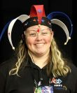Janet McKinley, Assistant Regional Director – Northern/Central California
Janet has been involved in FIRST activities for the past seven years. For the last three years, she has been part of the Regional Planning Committee as the Volunteer Coordinator for the Sacramento Regional. Her experience with FIRST started when her daughter joined the Robotics academic team at St. Francis High School in Sacramento, FRC Team 692, “The Fembots. ” She has mentored and supported the Fembots for six years before taking on her latest role of Head Coach of the team, a role she is now stepping away from.
Throughout her FIRST life, Janet has volunteered for many positions in all four programs within the FIRST progression. Her experience has grown from simply cheering and supporting the Fembots, to coaching the team in demonstrations, hosting FRC Kickoffs, full-field practice scrimmages, and FLL tournaments, as well as numerous diverse volunteering opportunities at local, regional, and Championship events.

