Brunswick Eruption
Robotics Triple Play off-season event
November 19, 2005
North Brunswick Township High School
Raider Rd and Rt 130 so
North Brunswick, N.J.
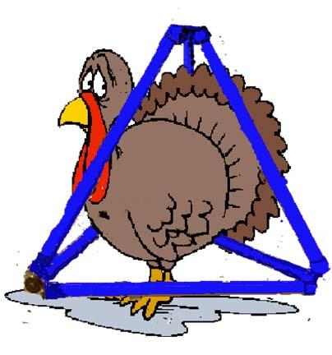
Tentative Itinerary
revised 10/5/05
7:00-7:30- Pits Open/Practice Rounds
7:45- drivers meeting
8:00- Opening Ceremonies
8:10-12:30- Seeding Rounds
(8 rotations)
12:30-Alliance Selection
12:45-1:30- Lunch Hour
1:45-4:30- Elimination Rounds
4:30-5:00- Closing Ceremonies and Awards
5:00-7:00- Takedown

Refreshments will be available
Other Teams: 11, 25, 56, 75, 222, 224, 237, 271, 303, 358, 369, 555, 999, 1048, 1089, 1403, 1546, 1626, 1676 plus three rookies

Directions to Brunswick Eruption
Hauppauge to North Brunswick Time: ~1 hour, 47 minutes Distance: ~86 miles

North Brunswick Township High School
Raider Rd and Rt 130 so,
North Brunswick, N.J.

From the NJ Turnpike-
-Take Turnpike to Exit 9- East Brunswick
-Get on Rt 18 West towards New Brunswick (for 1.4 miles)
-In about 1 mile get on Rt 1 South (for 2.3 miles)
-Two miles south get on Rt 130 South
-Make a right at the second light onto Raider Road- our High School access road

