Engineering Processes – Student Shop Laboratory Manual

Name:________________________ Section #______ Lab Group#______

General Lab Procedures

The laboratory work is the most important part of this course. It is expected that you be prepared for it by reading the lab manual before coming to the lab. It is important to read sections of this manual to completely understand what is going on. This will save you a lot of time, and keep you from making mistakes. This may determine whether or not you complete your project on time!
When you come to class, inform the instructor of your lab assignment for that day and she/he will give you the necessary raw materials and special tools needed in exchange for your I.D. When you have finished for the day, clean up the machines you used, and turn in your tools. At the end of every class, the entire shop will be cleaned; NO ONE MAY LEAVE OR WASH UP UNTIL THE INSTRUCTOR IS SATISFIED THAT THE SHOP IS CLEAN.
Safety must be exercised at all times while working in the machine shop. If you violate safety rules, you may be requested to leave the shop, and you may not be able to complete the project on time.

General Safety Rules

The following is a list of some basic safety rules that must be followed while you are in the machine shop. It should not be considered an exhaustive list.
- Always wear safety glasses while in the shop.
- People with long hair must tie it back.
- Do not wear any loose clothing or jewelry, which may be caught in moving machinery.
- Do not wear gloves while operating machinery (except welding equipment).
- Do not wear open-toed shoes of any kind.
- Do not use any machine unless you have been instructed in the use of that equipment.
- Do not leave machines unattended while running.
- Keep your hands away from moving machinery and cutters.
- Do not operate the equipment while under the influence of alcohol or drugs.
- Do not run or yell unnecessarily while in the shop.
- Report all spilled fluids immediately: they are an extreme slip hazard.
- If you are uncertain about any aspect of a machining operation you wish to perform then please ask the person in charge before proceeding.

Reading Assignments

For each day in the shop, it s necessary to read the following material in preparation for class:

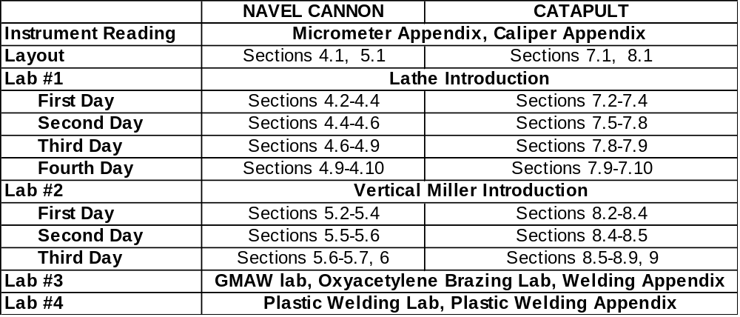

Problems With This Manual

If something in this manual is not clear, please let the instructors know. We will use this feedback to improve the next revision of the manual.

Problems with Tools

Do Not assume that the last person using any given tool kit put it away with the correct size drills, etc. in place. We strongly recommend that you measure the diameter of any drill or cutting bit before using it. Failure to do so by you is not an error on our part.

Contents

- Lathe – General Introduction…………………………………………………….13
  - Lathe Controls……………………………………………………………13
    - Main Functions………………………..………………………………13
    - Tool bit Motion Controls……………………………………………...13
    - Headstock and Auto-feed Controls…..………………………………..15
    - Tailstock…………………………….…………………………………18
  - Lathe Setup…………………………………………………………………19
    - Setting the Controls…………………………………………………….19
    - Installing the Lathe Tool bit……………………………………………20
    - Installing the Workpiece……………..…………………………………20
  - Lathe Cleanup………………………………………………………………21

- Vertical Miller – General Introduction…………………………………………….25
2.1 Miller Controls…………………………………………………………….25
    - Main Functions………………………………………………………..25
    - Speed Controls……………………….………………………………..26
    - Quill Feed Controls……………………………………………………28
    - Table Motion Controls…………………...……………………………30
  - Miller Setup………………………………………………………………..30
    - Installing the End-mill…………………………………………………30
    - Clamping the Work piece to the Table………………………………...31
    - Setting up the Controls…………….…………………………………..31
  - Miller Cleanup……………………………………………………………..31
    - Removing the End-mill………………………………………………..32

- Tapping……………………………………………………………………………33
  - Background…………………………………………………………………...33
  - Tapping Procedure……………………………………………………………34
    - Cannon Base………………………………………………………….34
    - Catapult Arm…………………………………………………………35
    - Catapult Base………………………………………………………...35

- Manufacturing the Cannon Barrel…………………………………………………38
  - Layout………………………………………………………………………...40
  - Cross-drilling the Barrel………………………………………………………40
  - Facing Off and Axial Drilling……………………………………………….....40
  - Turning the Outside Diameters………………………………………………..42
  - Cutting the Ridges……………………………………………………………..43
  - Angle Cuts and Additional Turning…………………………………………...44
  - Polishing the Barrel……………………………………………………………45
  - Making the Wheels…………………………………….………………………46
  - Finishing the Breech End of the Barrel………………..………………………47
4.10Making the Trunion…………………………………..………………………48

- Milling the Cannon Base………………………………………………………….50
  - Layout………………………………………………………………………..51
  - Horizontal Milling……………………………………………………………52
  - Drilling Holes…………………………………………………………………52
  - Tapping……………………………………………………………………….53
  - Band-sawing………………………………………………………………….53
  - Vertical Milling……………………………………………………………….53
  - Polishing the Base…………………………………………………………….55

- Cannon Assembly………………………………………………………………..55

- Manufacturing the Boiler stack………………………………………56
  - Layout………………………………………….……………………………..5
  - Cross Drilling the Boiler………...……………….…………………………….58
  - Drilling the Boiler……………………...……………………………………58
  - Facing Off and Center-drilling………………….……………………...…….59
  - Making the Stack……………………………………………...………60
  - Turning the Outside Diameters………………….………………………...…61
  - Finishing the Boiler…………………….…………………………….62
  - Tapping……………………...…………………….…………………………62
  - Polishing the boiler stack………………………………………………………...….63

- Milling the Train Cab…………………………………………………………64
  - Layout………………………………………………………………………..66
8.2Horizontal Milling……………………………………………………………66
8.3Drilling the Trunion Hole…………………………………………………….67
8.4Vertical Milling………………………………………………………………67
8.5Band-sawing………………………………………………………………….68
8.6Milling the Angles……………………………………………………………69
8.8Tapping………………………………………………………………………69
8.9Polishing the Base……………………………………………………………69

- Train Assembly……………………………………………………………….70

- Welding Lab………………………………………………………………………71

- Oxyacetylene Brazing…………………………………………………………….72

- Plastic Welding Lab………………………………………………………………73

- Appendix: Reading Micrometer………………………………………………….74

- Appendix: Reading a Vernier Caliper…………………………………………….77

- Appendix: Grinding………………………………………………………….79
C.1 Toolbit Grinding……………………………………………………79
C.2 Surface Grinding……………………………………………………84

- Appendix: Welding………………………………………………………….85
D.1 Electric Arc Welding……………………………………………….85
D.2 Brazing……………………………………………………………..88
D.3 Gas Metal Arc Welding…………………………………………….90
D.4 Safety………………………………………………………………97

- Appendix: Plastic Welding………………………………………………….98
E.1 Types of Welds………………….…………………………………..98
E.2 Tacking……………………………………………………………..100
E.3 Hand Welding………………………………………………………101
E.4 Instruction for Welding Individual Materials………………………105
- Appendix: Glossary…………………………………………………………107

References……………………………………………………………………….108

List of Figures

- Overview of Lathe
- Tool-bit Motion Controls
- Motor Speed Selection Switch
- Headstock and Auto-feed Controls
- Tailstock Assembly
- Aligning the Toolbit with the Live Center
- Three Jaw Chuck
- Collet Chuck (with Collet)
- Centerdrill
- Jacob’s Chuck
- Live Center
- Four Jaw Chuck
- Collet
- Knurler
- Counter sink
- Tool Holder
- Tool Post
- Overview of Vertical Milling Machine
- Speed Controls
- Quill Feed Control
- Table Motion Controls
- Two Flute End-mill
- Tap
- Tap Wrenches
- Steps in the Tapping Process
- Tapping the Hole in the End of the Arm
- Cannon Barrel Machine Diagram
- Aligning the Drill with the V-block in order to Crossdrill the Barrel
- Aligning the Roundnose Toolbit with the Live Center
- Aligning the Toolbit for Facing Off
- Turing the Diameter Down to 0.800”
- Cutting a Section Down to 0.680” in Diameter
- Top View of the Ridge Cutter
- Good and Bad Ridges
- Rotating the Compound Rest
- Aligning the Parting Tool so it is Perpendicular
- Using the Parting Tool to Cut the Wheels
- Placement of the Barrel in the 3-Jaw Chuck
- Toolbit Orientation for the Final Cuts on the Breech End of the Barrel
- Cutting the Steps on the Breech End of the Barrel
- Trunion Pin for the Cannon
- Cannon Base Machine Diagram
- Side View of Horizontal Milling Setup
- Positioning of the Base and T-block in the Vice for Drilling
- First Milling Setup for the Cannon Base
- Second Milling Setup for the Cannon Base
- The Difference Between Conventional and Climb Milling
- Train Machine Diagram
- Aligning the drill with the V-block in Order to Cross-drill the Barrel
- Aligning the Round-nose Tool-bit with the Live Center
- Aligning the Tool-bit for Facing Off
- Rotating the Compound Rest
- Train Cab Machine Diagram
- Side View of Horizontal Milling Setup
- Positioning of the Base and T-block in the Vice for Drilling
- The Difference Between Conventional and Climb Milling
- First Milling Setup for theTrain Cab
- Second Milling Setup for the Train Cab
- Sketch of an Inch Micrometer
- Sketch of Vernier Caliper
- Rake and Clearance Angles of Lathe Tool-bit
- A Lathe Toolbit with Zero Side Rake and Zero Back Rake
- Pattern for Making a Toolbit Grinding Gauge
- Various Types of Lathe Tool-bits
- The Arc Welding Process
- Proper Arc Gap
- Examples of Proper and Improper Weld Beads
- Examples of the Different Types of Flames
- Front View of GMAW Welding Machine
- Gas Metal Arc Welding
- Common Setup for the GMAW Process
- Types of Welds
- Beveling and Preparation
- Rosette Weld
- Plastic Welding
- Correct Angle of Welding Rod
- Methods of Re-positioning Grip on Welding Rod
- Butt Welding PVC Pipe

Shop Schedule

Lab #1  Lab #2  Lab #3  Lab #4  X | Canon Barrel /Boiler stack/ Lab  Base Lab/ Train Cab  Welding & Brazing  Plastic Welding  Any Lab

Week Number
Group Number |  | 1 | 2 | 3 | 4 | 5 | 6 | 7 | 8 | 9 | 10 | 11 | 12
Group Number | 1 | Introduction | Instrument Reading & Layout | 1 | X | 1 | 4 | 2 | 1 | 1 | 2 | 3 | 2
Group Number | 2 | Introduction | Instrument Reading & Layout | 1 | 4 | 1 | 1 | 2 | 1 | 3 | 2 | 2 | X
Group Number | 3 | Introduction | Instrument Reading & Layout | 1 | 4 | 1 | 2 | 2 | 1 | 1 | 2 | 3 | X
Group Number | 4 | Introduction | Instrument Reading & Layout | 1 | 4 | 1 | X | 2 | 1 | 1 | 2 | 3 | 2
Group Number | 5 | Introduction | Instrument Reading & Layout | 1 | 2 | 3 | 1 | 1 | 2 | 1 | 4 | 2 | X
Group Number | 6 | Introduction | Instrument Reading & Layout | 1 | 2 | 3 | 1 | 1 | 2 | 2 | 1 | X | 4
Group Number | 7 | Introduction | Instrument Reading & Layout | 1 | 2 | 2 | 1 | 3 | X | 1 | 1 | 2 | 4
Group Number | 8 | Introduction | Instrument Reading & Layout | 2 | 2 | 1 | 1 | 3 | 1 | X | 4 | 1 | 2
Group Number | 9 | Introduction | Instrument Reading & Layout | 2 | 1 | 1 | 4 | 1 | 2 | 3 | 1 | 2 | X
Group Number | 10 | Introduction | Instrument Reading & Layout | 2 | 1 | 1 | 4 | X | 1 | 3 | 2 | 1 | 2
Group Number | 11 | Introduction | Instrument Reading & Layout | 2 | 1 | 2 | 1 | 3 | 1 | 1 | 4 | 2 | X
Group Number | 12 | Introduction | Instrument Reading & Layout | 3 | 1 | 2 | 2 | 1 | 2 | 1 | 1 | X | 4
Group Number | 13 | Introduction | Instrument Reading & Layout | 3 | 1 | 2 | 2 | 1 | 4 | 2 | 1 | 1 | X
Group Number | 14 | Introduction | Instrument Reading & Layout | 3 | 1 | X | 2 | 1 | 4 | 2 | 1 | 1 | 2
Group Number | 15 | Introduction | Instrument Reading & Layout | X | 1 | 3 | 1 | 1 | 4 | 2 | 1 | 2 | 2

Grading Policy

Your grade in this class is determined from several factors:
- Class Attendance
- Completion of the Cannon / Catapult Project
- Completion of the GMAW and Brazing Lab
- Completion of the Plastic Welding Lab
- Submission of the Report (due the day of the final)
- Final Exam

We require completion of all the above items.

Final Exam

The final exam is usually given on the last day of class, before the final exams for the other classes begin. At least two weeks before the final exam, the exam schedule will be posted on the door of the machine shop. Note the date and room in which your exam will be given.
Your project (cannon or catapult) must be checked off as being completed by the day of your final. In addition, you final report is due the day of the final; bring your report with you and hand it in to the exam proctor when asked for it.
The exam is closed book. It is recommended that you bring a pencil and a calculator.
The exam covers all material that you learned in class. This includes (but is not limited to) instrument readings, machining operations, welding, and safety rules. Reviewing this manual is a good way to study for the exam.

Cheating and Academic Dishonesty

Cheating is unacceptable. There is no reason why anyone should not be able to pass this class, given a reasonable amount of effort.
The following is excerpted from the Rensselaer Student Handbook. Penalties for cheating are severe, even for a one credit hour course.

Academic Fraud: Alteration of documentation relating to the grading process. For example, changing exam solutions to negotiate for a higher grade or tampering with an instructor’s grade book.

Collaboration: Deliberate facilitation of academic dishonesty in any form. For example, allowing another student to observe an exam or allowing another student to “recycle” one’s old term paper.

Copying: Obtaining information pertaining to an exam question by deliberately observing the paper of another student. For example, noting which alternative a neighboring student has circled in a multiple-choice exam.

Cribbing: Use or attempted use of prohibited materials, information, or study aids in an academic exercise. For example, using unauthorized formula sheet during an exam.

Fabrication: Unauthorized falsification or invention of any information in an academic exercise. For example the use of “bought” or “ready-made” term papers, or falsifying lab records.

Plagiarism: Representing the work or words of another as one’s own through the omission of acknowledgement or reference. For example, using sentences verbatim from a published source in a term paper without appropriate referencing, or presenting, as one’s own the detailed argument of a published source.

Sabotage: Destruction of another student’s work related to an academic exercise. For example, destroying a model, lab experiment, computer program or term paper developed by another student.

Substitution: Utilizing a proxy, or acting as proxy, in any academic exercise. For example, taking an exam for another student or having a homework assignment done by someone else.

The definitions and examples presented above are samples of the various types of academic dishonesty and are not to be construed as an exhaustive or exclusive list. Additionally, attempts to commit academic dishonesty or to assist in violation of academic dishonesty policies, students may be subject to two types of penalties. The Instructor administers an academic penalty (i.e. failure of the course) and the student may also be subject to the procedures and penalties of the student judicial system outlined in the student handbook.
NOTE: Students who have been found in violation of academic dishonesty policies are prohibited from dropping a course to avoid the academic penalty.

Engineering Processes

Outline for Final Report – Page 1 of 2
For the Welding, Plastic Welding, Cannon Barrel (Boiler stack), and Cannon Base (Train Cab) Labs, discuss the following items in detail:

- The main objective of the operation.
- What the operation consisted of.
- What you learned from the lab.
- The major problems you encountered and how you solved them.

Answer the following questions in detail:

- What is your opinion of the course?
- Do you think the course is valuable?
- If you could change the course in some way, what would you change?
- If you could change the lab manual in some way, what would you change? (Be specific)

Guidelines:

- The report must be typed and must include a title page.
- The report should be approximately 2-5 pages in length.
- Reports are due on the day of the final; no late reports are accepted.
- The grade for the report will be based on the organization and content.
- Reports are to be done on an INDIVIDUAL basis. Cheating will be dealt with severely.

Final Exam Date: __________________________ Location: ____________________

Engineering Processes

Outline for Final Report – Page 2 of 2

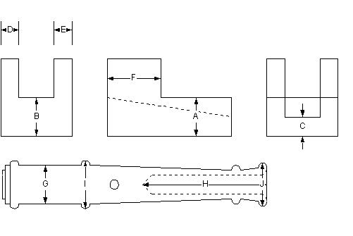

For the project you constructed, measure the indicated dimensions and fill in all of the information in the chart below, including units. Use a micrometer or vernier caliper to take your measurements.

Dimension | Specified Dimension | Permitted Tolerance | Actual Dimension | Deviation | Amount out of Tolerance
A
B
C
D
E
F
G
H
I
J

1 Lathe – General Introduction

  - Lathe Controls
1.1.1 Main Function

Figure 1 shows the main sections of the engine lathes used in our machine shop. Be sure to note the location of the On/Off switch and the Emergency Stop button.

Emergency Stop: This red button is located in the upper left corner of the control panel for the engine lathe. In case you need to stop to machine quickly, push the button straight in.
On/Off Switch: This lever turns the machine on and off. Note that this is a 3-position switch: the off position is in the middle. Push the lever down and the headstock of the lathe will rotate “toward” you (i.e. counterclockwise). This is the normal way of operating the machine. If you lift the lever instead, the headstock will rotate clockwise.
Headstock: This is the part of the lathe that rotates when the machine is turned on. Various types of chucks can be attached to the headstock; the chucks will hold the work piece that is to be machined. When the lathe is turned on, the headstock rotates, rotating the chuck and the work piece along with it.
Chip Collection Drawer: As the work piece is cut, the chips fall into the drawer at the bottom of the lathe. This gets the waste material out of the way, and prevents an oily mess from hitting the floor. Be sure to clean out the drawer when you are finished working for the day.

1.1.2 Tool bit Motion Controls

Figure 2 shows the controls on the carriage of the lathe. The carriage rides along the ways of the lathe, and can be driven either by hand or by use of the auto feed.
The following features are of note:

Tool post: The tool post is the attachment point for the tool holder, in which the lathe tool bit is installed. The nut at the top of the tool post allows the tool post to be rotated if necessary.
Tool post Lever: This lever locks and releases the tool holder from the tool post. When the lever is pulled clockwise, the tool holder is locked onto the tool post. When the lever is pushed counterclockwise, the tool holder is released.
Apron Hand wheel: This large hand wheel allows the lathe operator to move the tool bit in or out from the axis of rotation.
Auto feed Selection Lever: This lever is a 3-position switch, which allows the lathe operator to select the direction of the auto feed. If the lever is pushed in (away from the operator), the tool bit will move across the axis of rotation (either in or out). If the lever is pulled all the way out (close to the operator), the auto feed will move the tool bit side-to-side.

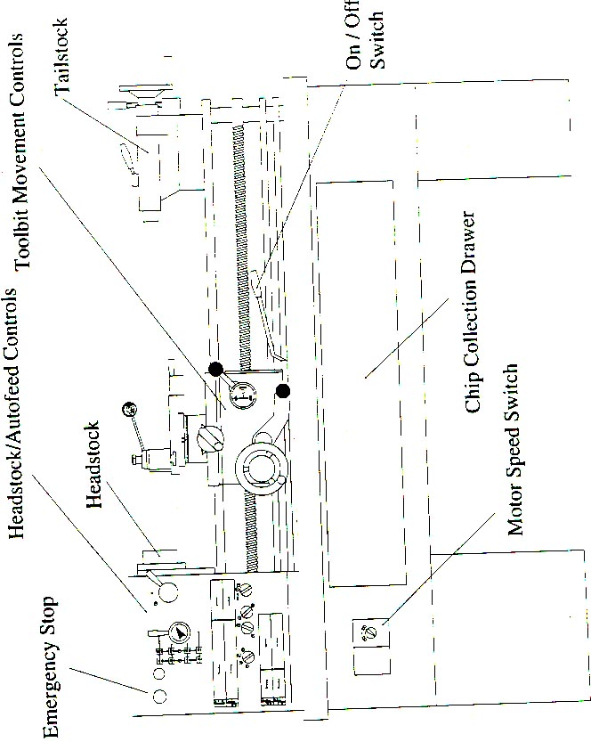
Figure 1: Overview of Lathe

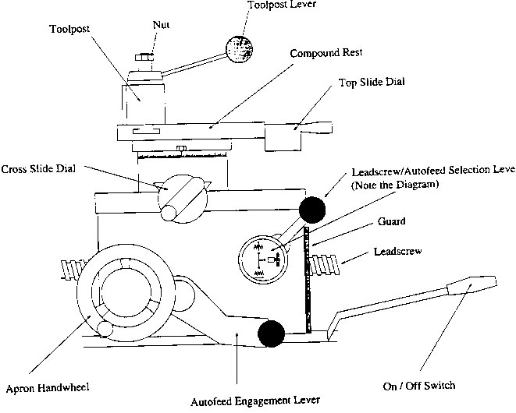
Figure 2: Tool-bit Motion Controls

The diagram on the front of this lever shows the various positions of the lever and its effect on the motion of the tool-bit. The zigzag lines represent the work-piece and the small arrows represent the motion of the tool-bit.
Compound Rest: This part of the carriage can be rotated to a specific angle by undoing the two locknuts. This is useful for making angle cuts. Note: The auto-feed will not make angle cuts; they must be made by hand.
Top Slide Dial: This hand-wheel moves the compound rest, thereby moving the tool bit. Turning this hand-wheel while the compound rest is rotated creates angle cuts.

    - Headstock and Auto-feed Controls

Figure 3 and 4 show the main controls, which affect the headstock rotation, and the auto-feed controls. Three controls affect how fast the headstock rotates: the motor speed switch and the two-headstock speed control levers. These must be set properly for the work-piece, which you are going to turn.

Motor Speed Selection Switch: This switch allows the user to select between high and low motor speeds.

Headstock Speed Control Levers: These two levers select a row and a column from the turning speed chart. The leftmost lever selects one of the four rows of numbers, and the rightmost lever selects the column (either “X” or “Y”). The figures show the lathe set up with a turning speed of 315 RPM: the motor switch is in the high speed range, the top row of the chart has been selected, and the “X” column has been selected.

The right most speed control lever is another 3-position switch. The middle position is a neutral position: when it is selected, the headstock will be disengaged from the gears, and thus will spin freely. This can be useful, as there are times when you will want to rotate the chuck manually.

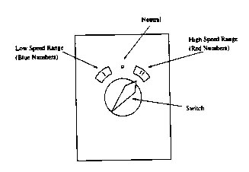
Figure 3: Motor Speed Selection Switch

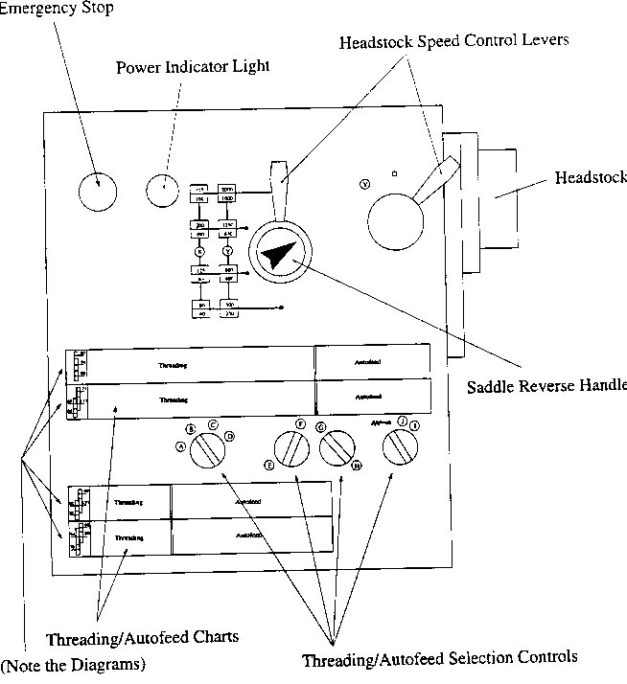
Figure 4: Headstock and Auto-feed Controls

NOTE: DO NOT run the machine in the “Y” speed range. The lather can not handle running this fast for long periods of time and damage to the lathe will result. Also the increased momentum makes accidents more energetic, i.e. severe.

Saddle Reverse Handle: This dial controls the polarity of the auto feed movement. When the arrow is pointed upwards, and the auto feed is engaged the tool bit will either move left-to-right, or it will move away from you toward the axis of rotation of the work piece. If the arrow is pointing downward, the exact opposite will occur: the tool bit will move right-to-left or will move toward you. Note that there is a third (middle) position on this dial as well: in this position, the auto feed will not move at all.
Threading/Auto feed Selection Controls: When the auto feed is engaged, the carriage will be driven either side-to-side, or in-and-out. Since the tool bit is mounted on the carriage, the tool bit will move with it. In this way, controlled cuts can be taken.

The controls on the panel allow the user to choose how fast the tool bit moves, relative to one rotation of the headstock. By selecting the appropriate letter combination, you can get the tool bit to move at the desired speed. Note that too fast of a cut will give poor finish, but too slow of a cut will waste time.

Threading/Auto feed Charts: There are four charts on the main panel, which depict the letter combinations needed to obtain a certain relative speed of the tool bit when using auto feed. On each chart is listed a series of letter combinations, and the speed it corresponds to, in units of inches per revolution (of the headstock).

NOTE: Each of the four charts contains the same series of letter combinations, but with different speeds associated with the letters. Only one of these charts can be correct. At the left side of each chart is a diagram showing a particular gear pattern. The reason for the four charts is that it is possible to swap gears in the transmission of the lathe, thereby requiring a different chart.

    - Tailstock

The tailstock assembly rides along the ways of the lathe (the two long rails along the top of the lathe). It can be used for a variety of different tasks; its main uses are for drilling holes in the work piece along the axis, and for supporting the work piece. The tailstock has been set up so that any tools installed into the quill will be centered on the axis of rotation of the work piece. The tailstock has the following main features:

Tailstock Brake: This lever (shown in the locked position in figure 5) clamps the tailstock to the ways of the lathe, so the tailstock cannot move.

Quill: This is a hollow tube in the tailstock. Various tools (such as Jacob’s drill chucks and live centers) can be inserted into the quill as needed. The quill also has riled markings on it: this allows the user to move the quill a measured distance.

Tailstock Hand wheel: By turning this hand wheel, the quill is extended from or retracted into the tailstock. If the quill is retracted into the tailstock past the 1” mark, any tool installed in the quill will be ejected. DO NOT extend the quill past the 5” mark; the quill will come off the track inside the tailstock.

Quill Clamping Lever: This is a brake on the motion of the quill. By tightening this lever down, the quill is locked in position.

1.2 Lathe Setup

Before turning any material on the lathe, it is necessary to set up the machine properly for the material that you are going to turn. Setting up the machine involves three main tasks:
- Setting the controls of the machine properly.
- Installing the tool bit.
- Installing the work piece.

1.2.1 Setting the Controls

In general, the lathe controls should be adjusted with the machine OFF. Most of the controls select gears in the lathe’s transmission; if you try changing gears while the machine is running, you will grind the gears and damage the lathe.
If you find that a particular control resists being put into a certain position, do not force it. Usually, this happens because the gears are not lined up properly. Rotate the headstock a short distance and try again; this will move the gears enough to permit the control to be moved.

- Select the proper turning speed for your work piece by adjusting the motor speed selection switch, and the headstock speed control levers.
- Select the desired speed for the auto feed function, and move the auto feed selection controls to the appropriate positions.
- Move the saddle reverse control so the arrow points in the proper direction.

1.2.2 Installing the Lathe Tool bit

The tool bit is held in the tool holder by two or more Allen screws. Holding the tool holder with the knurled washer and lick nut on top, insert the tool bit right side up, so that the tool bit extends outward from the tool holder about three quarters of an inch. Tighten up the Allen screws.
Every time you change a tool bit, or install a tool holder onto the tool post, you must align the tool bit. To do this:

- Mount the tool holder onto the lathe’s tool post. The dovetail of the tool holder slides onto the dovetail of the tool post.
- Extend the tailstock quill so that the 1-inch mark on the quill is visible. Clean off any chips or debris from the inside of the quill.
- To center the tool bit, loosen the tool-post lever, and loosen the lock nut on the tool holder. Turn the knurled nut (just under the lock nut) to raise or lower the tool holder on the tool post, until the cutting tip of the tool bit is centered with the tip of the live center. See figure 6. When the tool bit is aligned, retighten the tool-post lever, and re-check the alignment. When you have completed aligning the tool bit, retract the tailstock quill so that the live center is ejected.
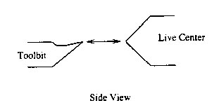

Figure 6: Aligning the tool bit with the live center.

    - Installing the Work piece

If a chuck is not already in place, you must install one on the headstock. Note that the studs on the chuck must be absolutely clean and free of all chips before installing the chuck.

- Use an air hose with a blowgun to clean the studs, AND wipe them clean with a rag.
- Stubborn chips may still remain on the mating surfaces (where the headstock and chuck come together); scrape these off with a scribe and/or wipe off with a shop rag.
- Make sure the cam lock sockets on the headstock are tightened CLOCKWISE, and are tight.

Once the chuck is properly installed, the work-piece can be installed in the chuck.

  - Lathe Cleanup

When you are finished for the day, you must clean up the lathe. The following things should be done:

- Remove your work-piece from the lathe.
- Remove any tool bit from the tool holder, and any tool from the quill of the tailstock. Straighten the compound rest if you were making angle cuts.
- Put the appropriate tools back into the lathe toolkit, and check your toolkit back in.
- Using compressed air, blow the accumulated chips from the top of the lathe into the chip collection drawer.
- Pull out the drawer, and use the scraper to scoop up the chips. Do not use a hand brush for this, as had brushes are also used on the floor; oil will get transferred to the floor via the brushes. If the chips are aluminum and there is not any foreign material (brass, steel, plastic, etc) mixed in with them, put the chips in the aluminum-recycling can. Otherwise, just throw out the chips in the nearest trashcan.
- Sweep up the floor around the lathe, and discard the chips. We cannot recycle floor sweepings as they are hopelessly contaminated.

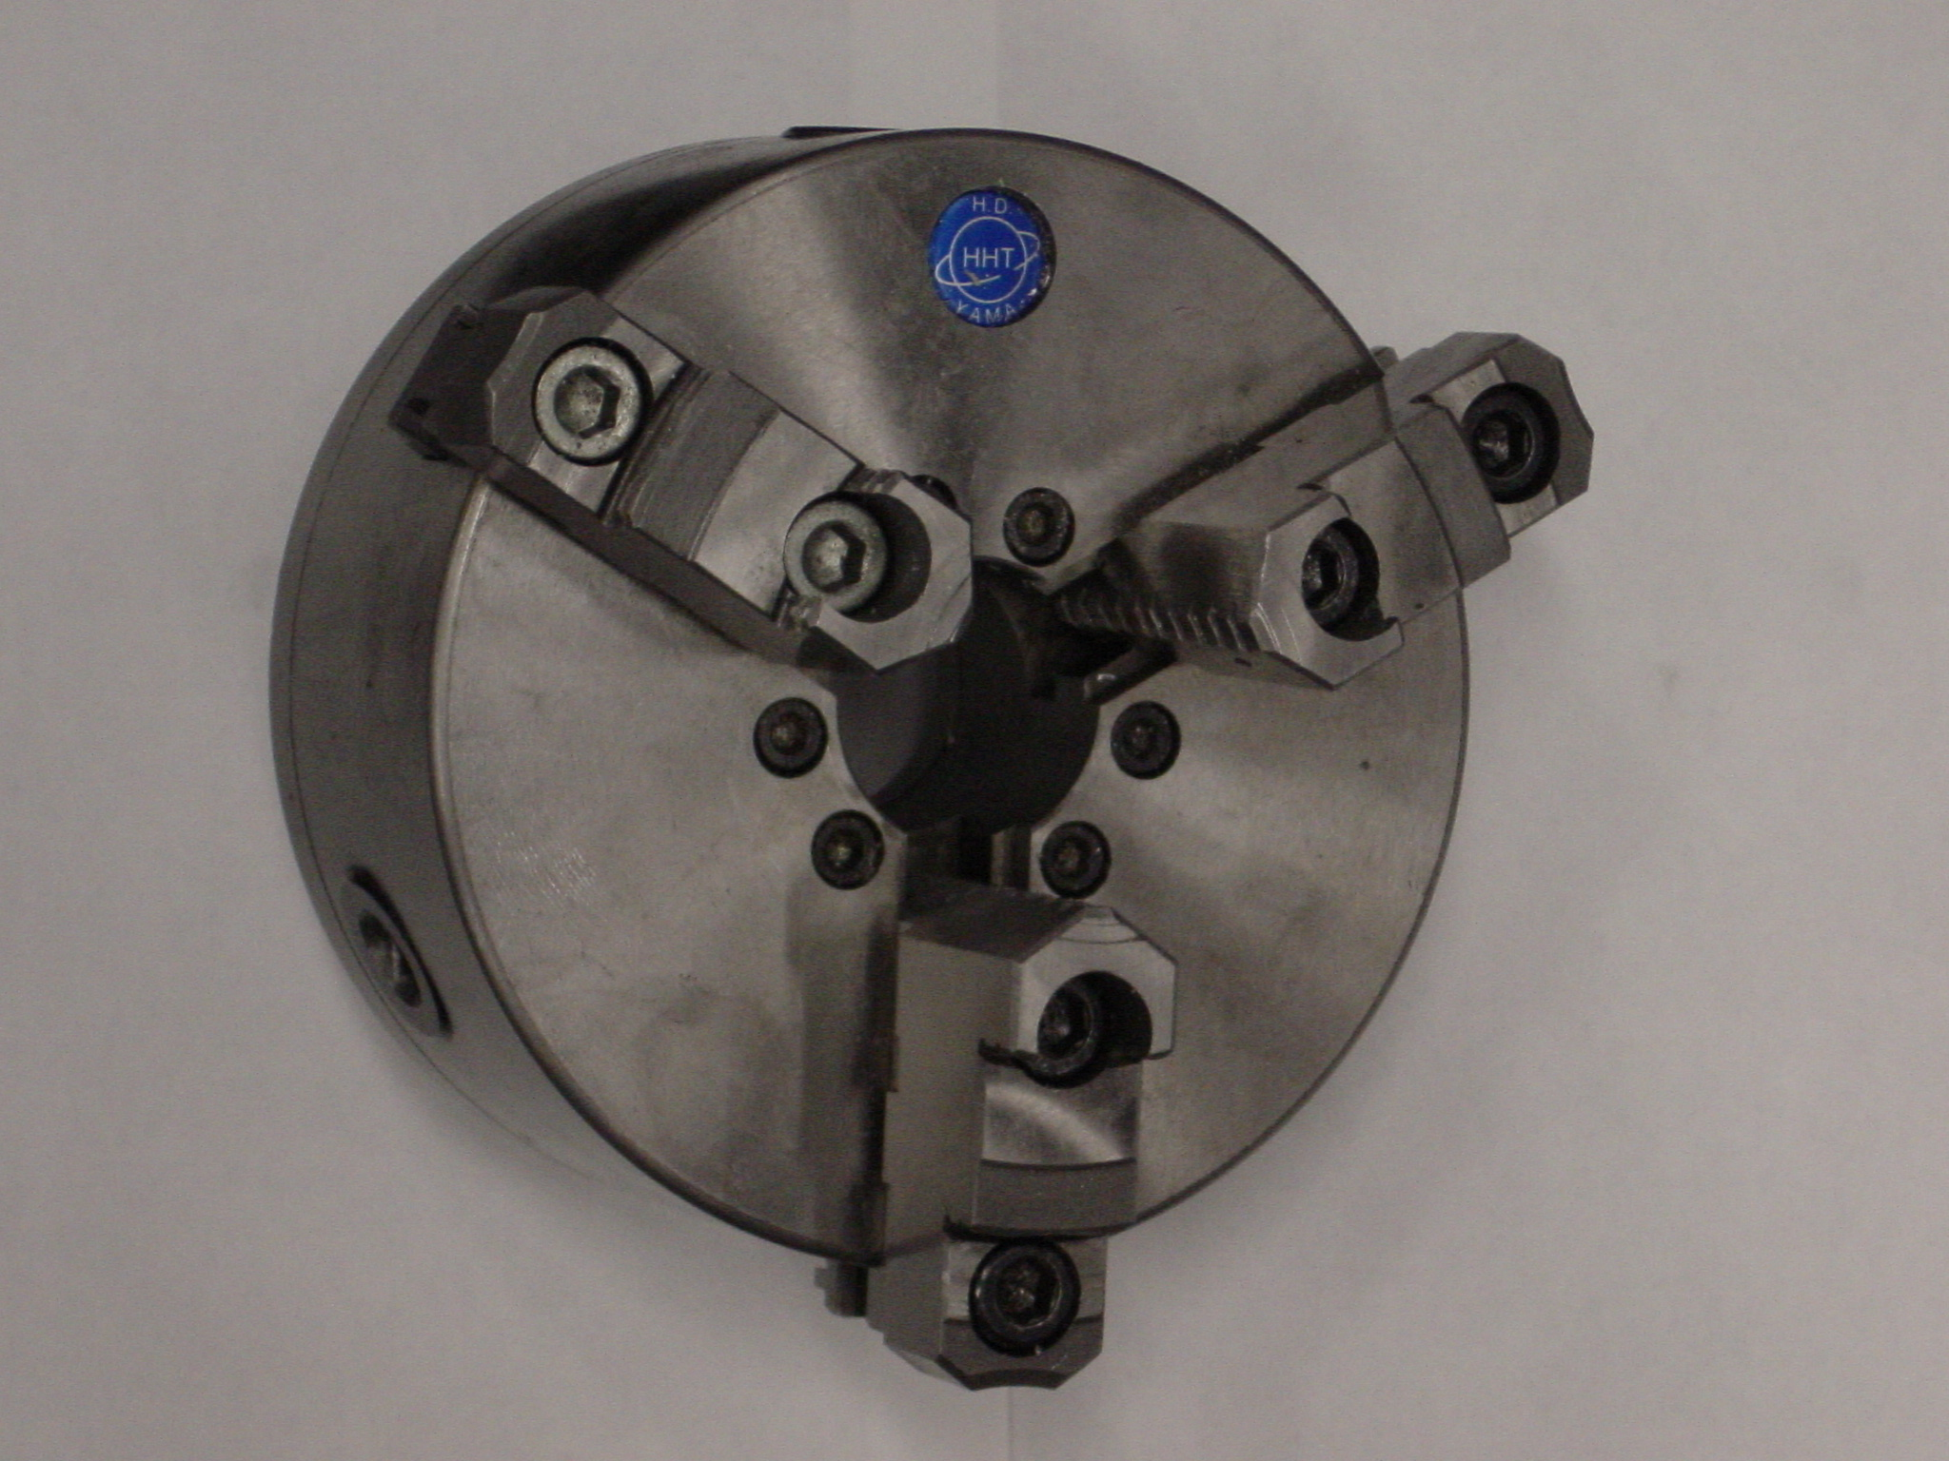
Figure 7: Three Jaw Chuck

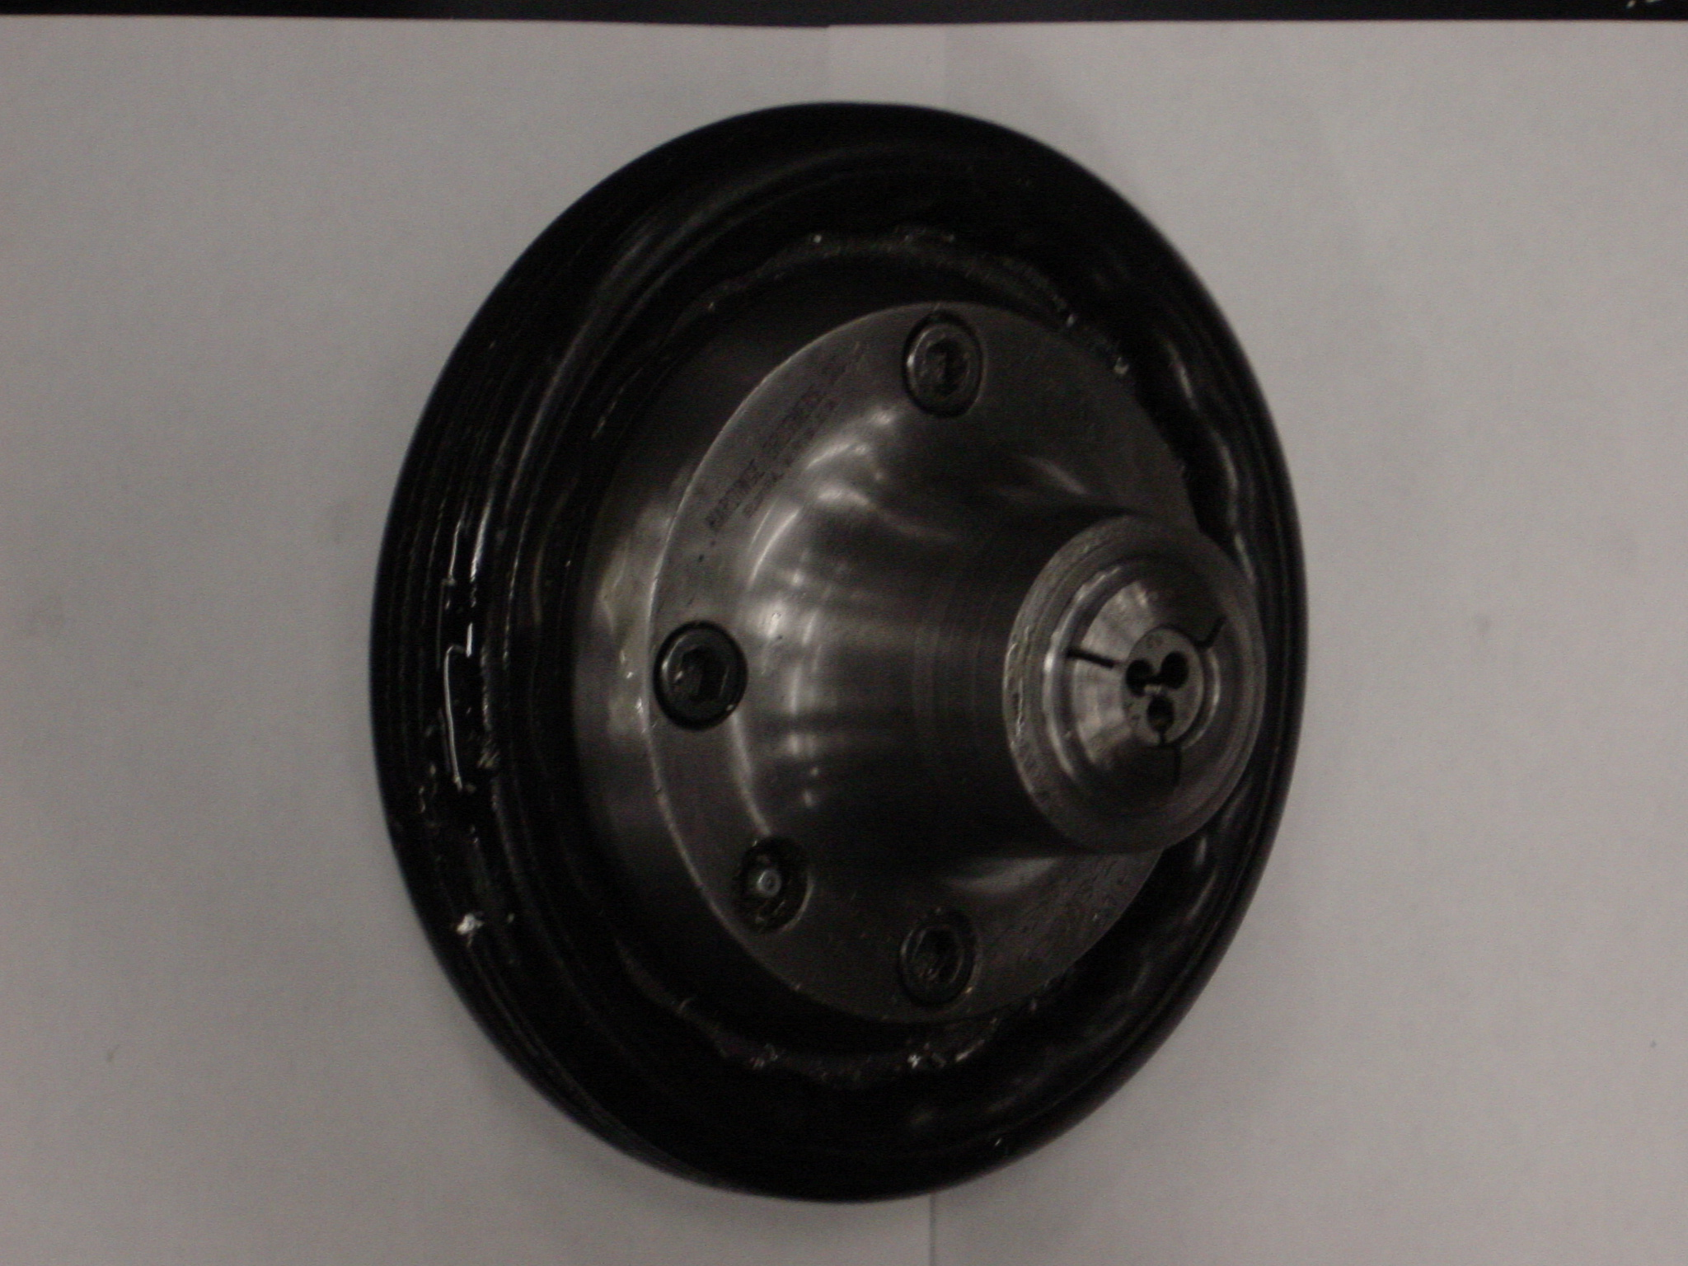
Figure 8: Collet Chuck (with Collet)

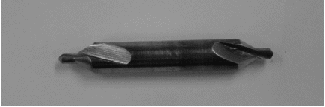

Figure 9: Center drill

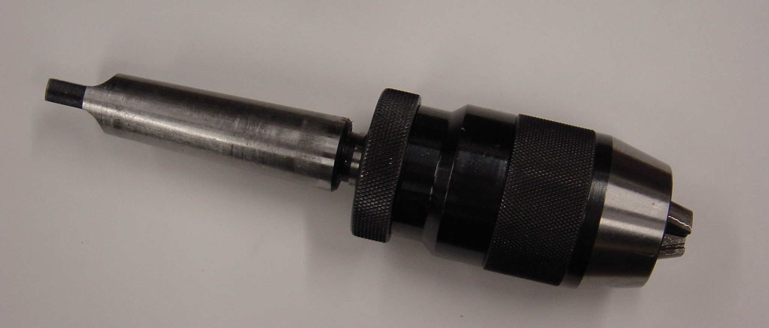
Figure 10: Jacob’s Chuck

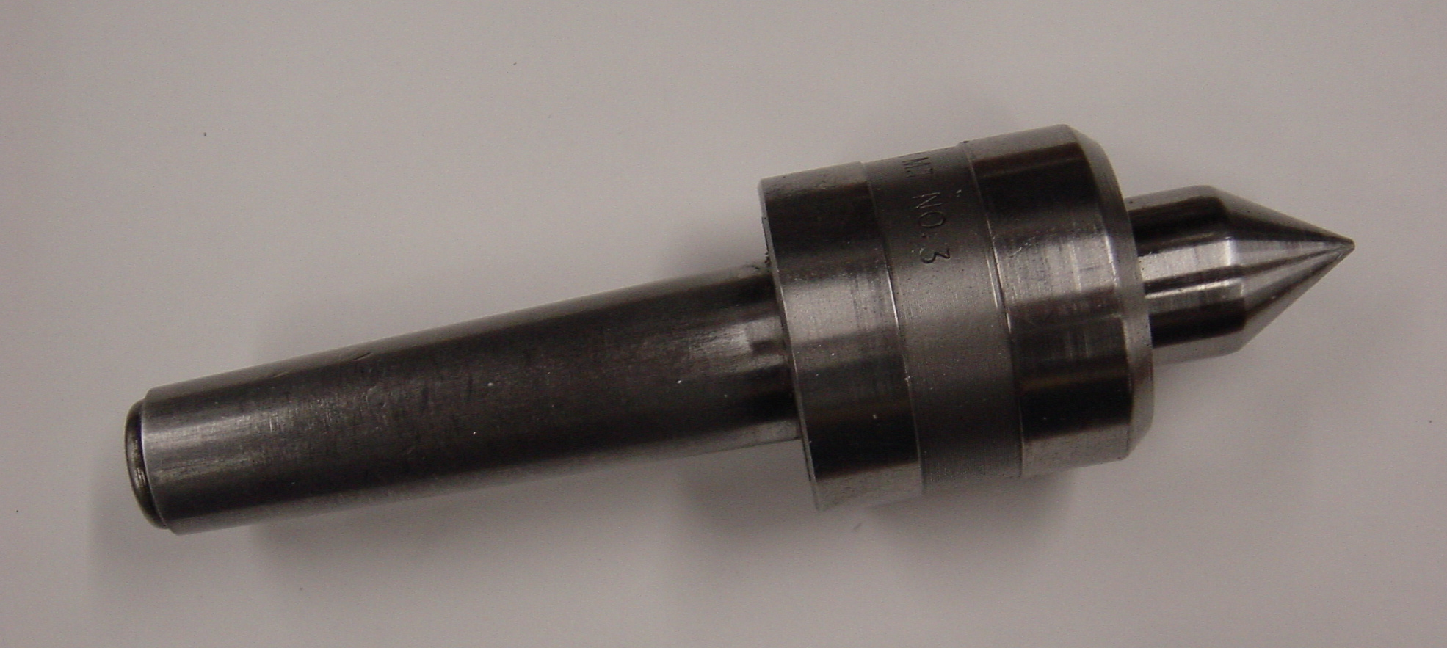
Figure 11: Live Center

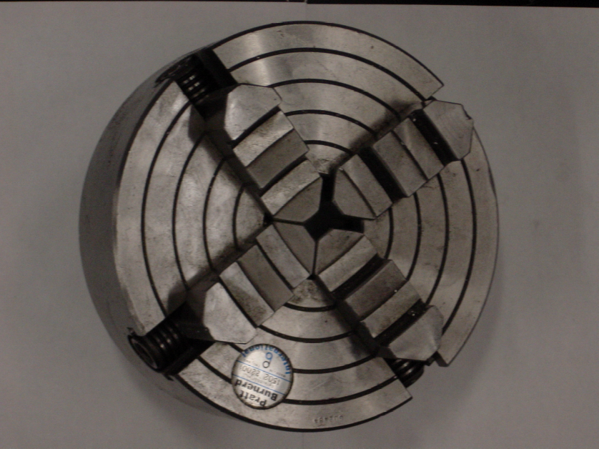

Figure 12: Four-Jaw Chuck

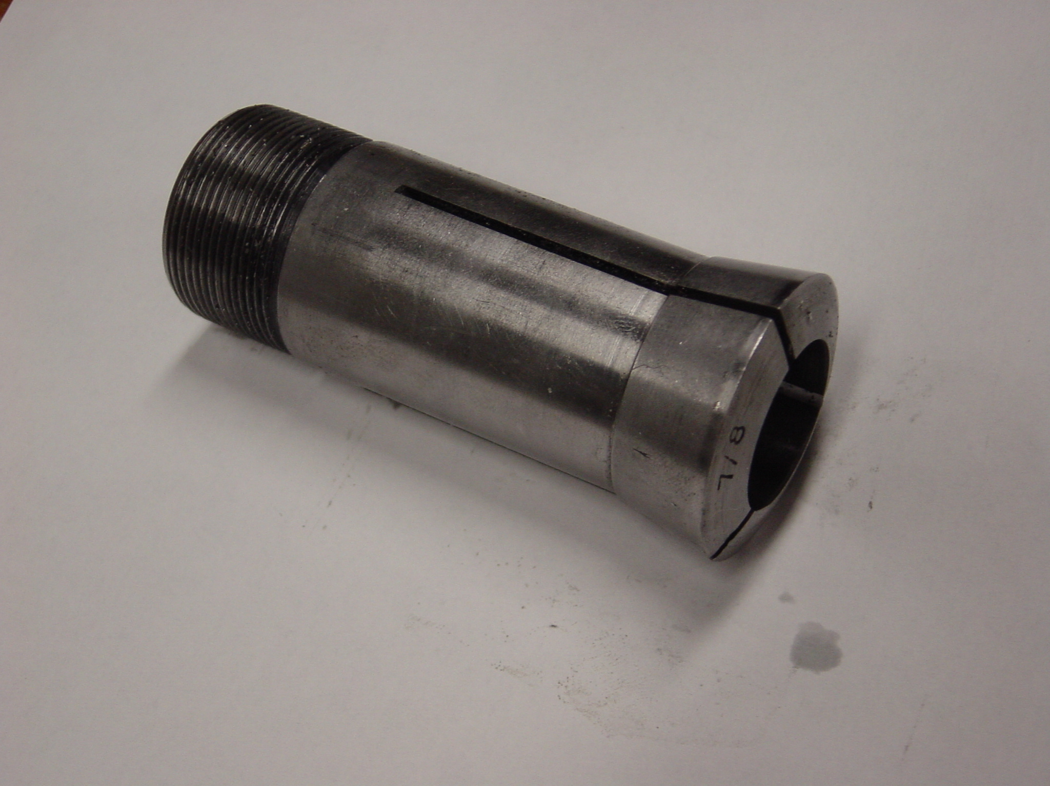
Figure 13: Collet

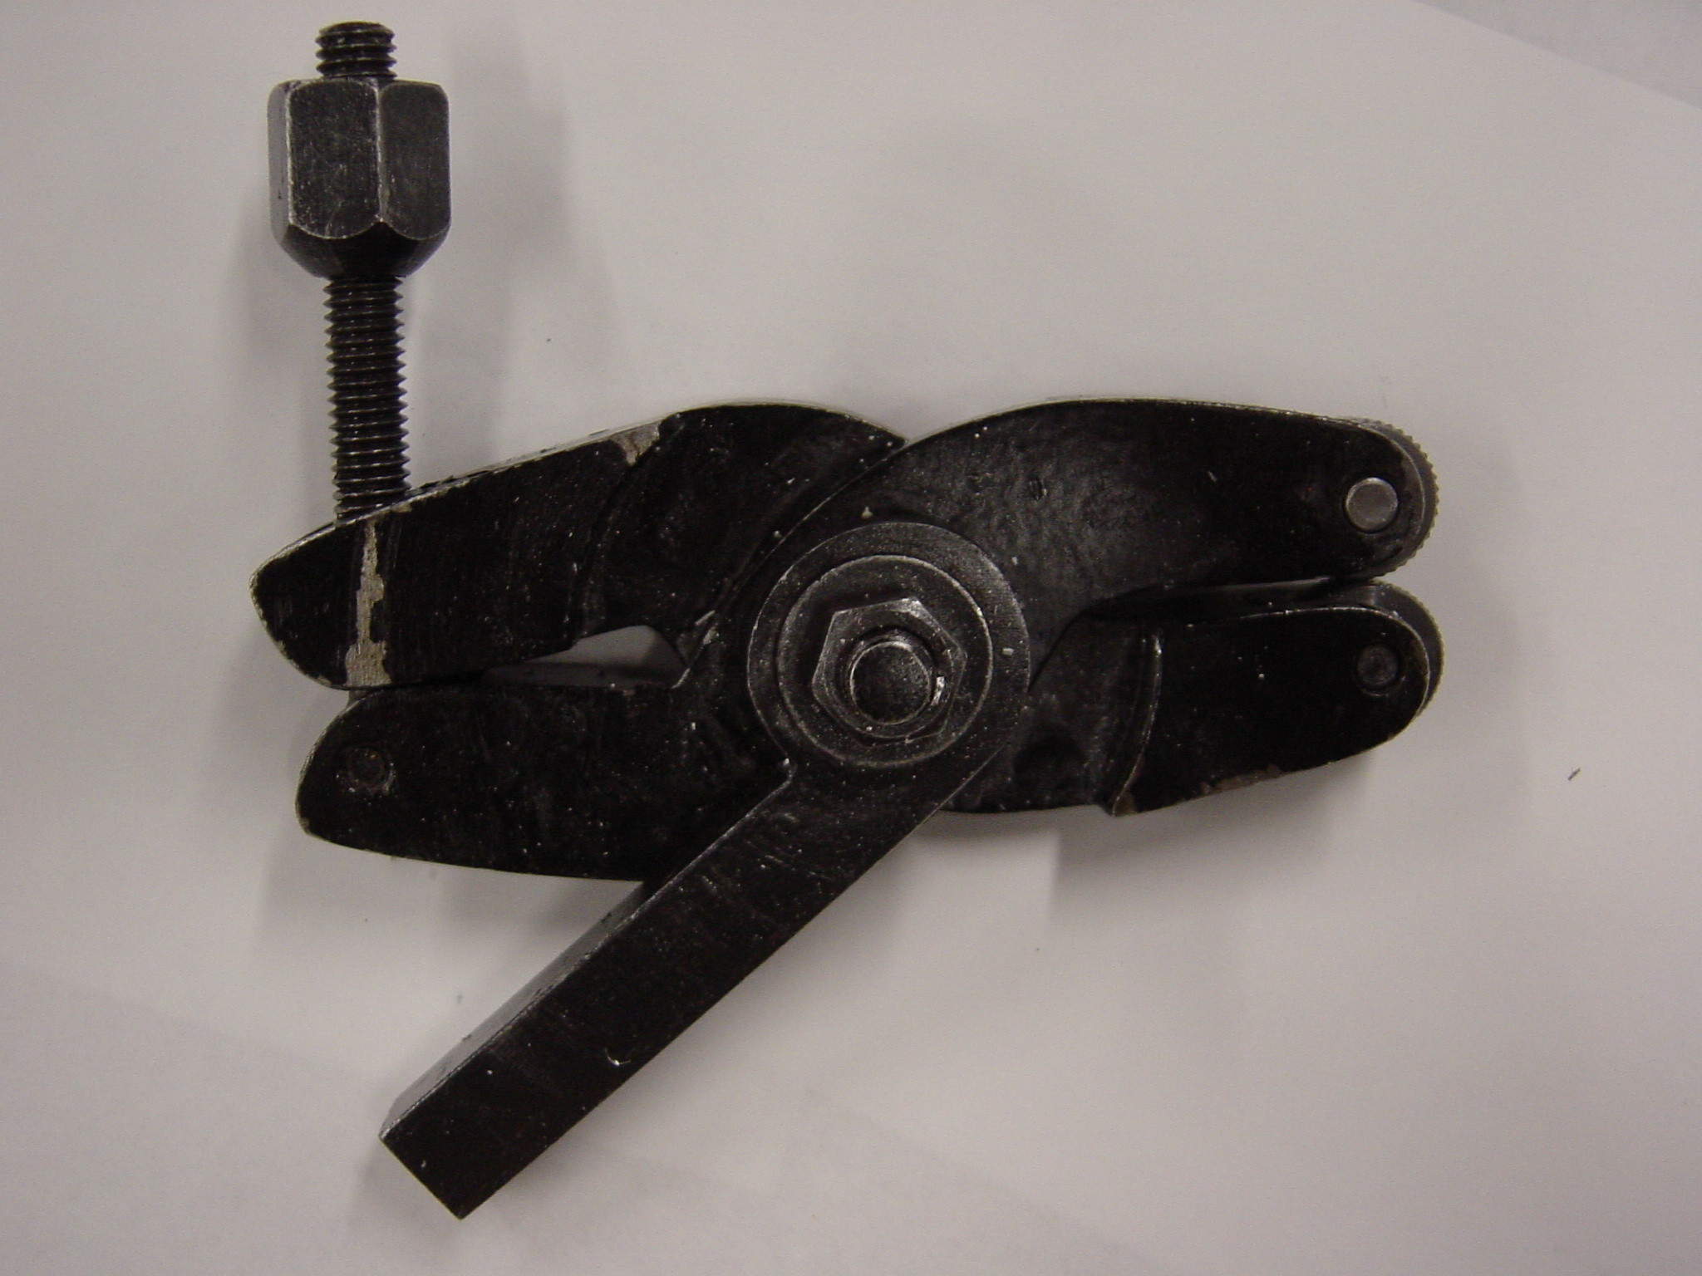
Figure 14: Knurler

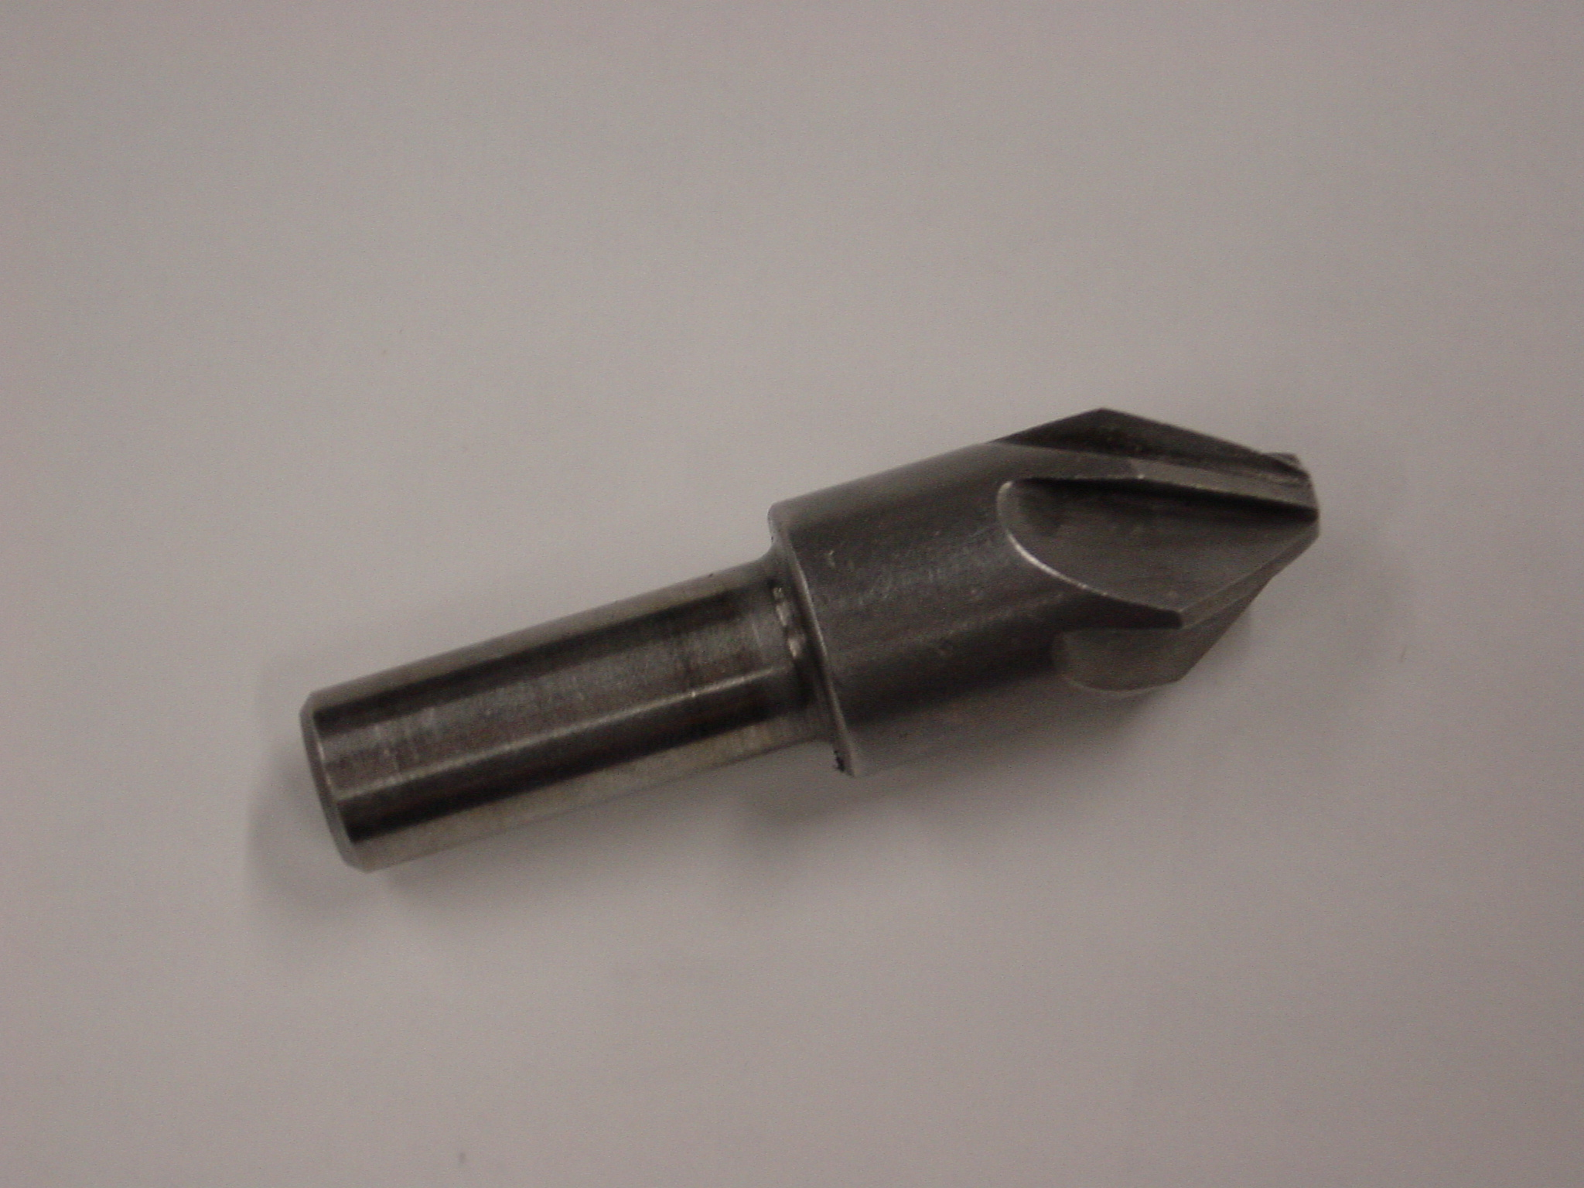
Figure 15: Counter Sink

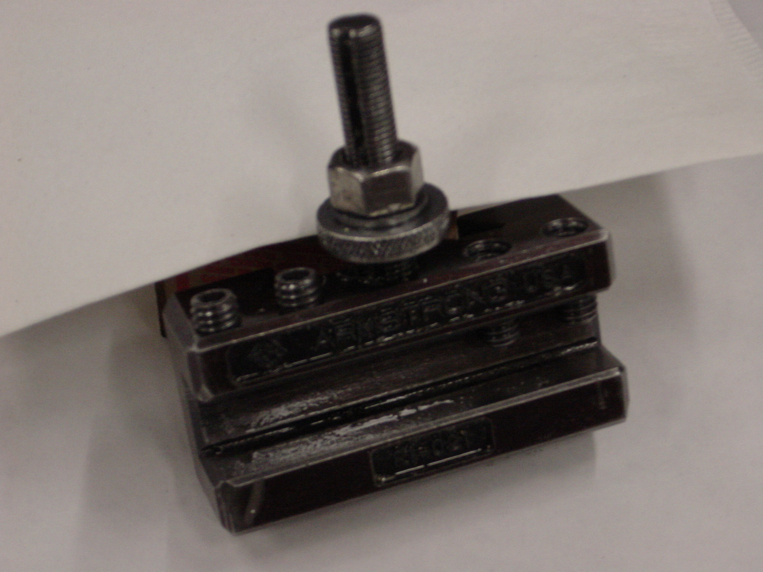
Figure 16: Tool Holder

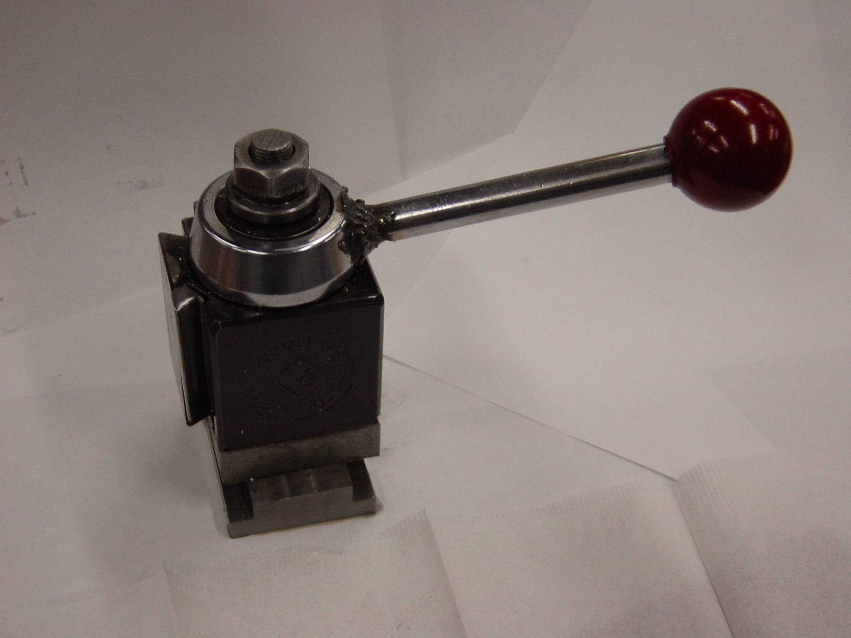
Figure 17: Tool Post

2 Vertical Miller – General Introduction
  - Miller Controls

    - Main Features
Figure 18 shows the main sections of the vertical millers used in our machine shop. Be sure to note the location of the Forward, Reverse, and Stop buttons.

Stop: This red button is located high on the miller, on the left. When you need to stop the machine, push it straight in.

Forward: This green button turns the machine on in the forward direction. When the high-speed range is selected, this is usually the button, which will cause the end mill to turn in the appropriate direction.

Reverse: This black button turns the machine on in the reverse direction. When the low speed range is selected, this is usually the button, which will cause the end mill to turn in the appropriate direction.

Collet Rack: This rack holds a variety of collets; these collets are designed to work with the vertical miller, and are used to hold various end mills in the quill of the machine.

Quill: This tube holds a collet, and spins when the machine is turned on, turning the collet (and end mill) with it.

Drawbar: This looks like a hexagonal bolt head, at the top of the miller. It really is long bolt, which extends down into the machine, and has threads on the lower end. These threads engage the threads of the collet, and pull the collet tight into the quill.

    - Speed Controls
Figure 19 shows the items and controls, which affect the speed of rotation of the quill.
The following features are of note:

Motor: This is located at the very top of the vertical miller, and is activated by the Forward or Reverse buttons. Note: if the motor is powered up, but is prevented from turning, it will be damaged. If you ever turn the miller on and the motor does not spin, turn the machine off IMMEDIATELY and find an instructor.

Brake: This lever clamps onto the quill and prevents it from turning. This is useful when tightening the drawbar; by applying the brake, you can tighten the drawbar to the required torque.

Speed Range Selection Lever: This lever is located on the right side of the machine, and is best viewed from there. It is a 3-position switch, (the middle position is neutral), and selects between high and low gear. Never change this lever when the motor is running.

Note: When the miller is running in high gear, the quill will rotate in the opposite direction to when it is running in low gear. For this reason, both a Forward and a Reverse switch have been provided. Use the switch, which will cause the end mill to rotate in the proper direction.

Make sure the miller is in gear before turning it on.

Speed Selector Hand wheel: This is a dial which adjusts a continuously variable speed changer inside the machine. This allows, the user to set the quill speed to any desired value within the gear range, which was selected. This control must only be moved when the machine is running.

Quill Speed Indicator: This dial indicated the rotation speed of the quill, in revolutions per minute. The dial will rotate as the speed selector hand wheel is turned, constantly displaying the spindle speed to the operator. There are two sets of numbers on the dial; the smaller (in value) numbers on the outside of the dial indicate the speeds for the low gear range. The higher numbers, closer to the middle of the dial, indicate the speeds for the high gear range.

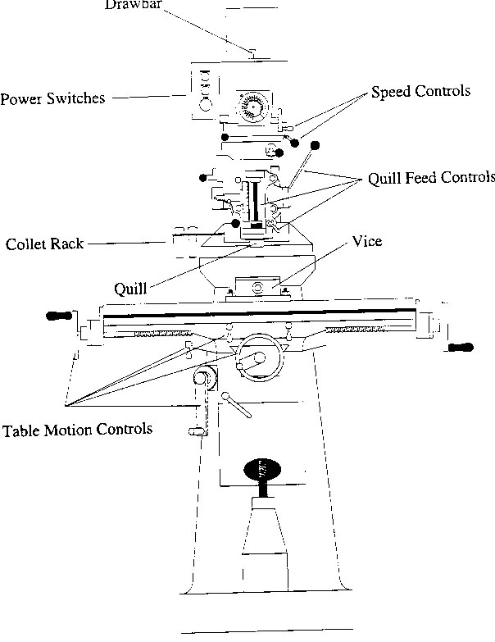
Figure 18: Overview of Vertical Milling Machine

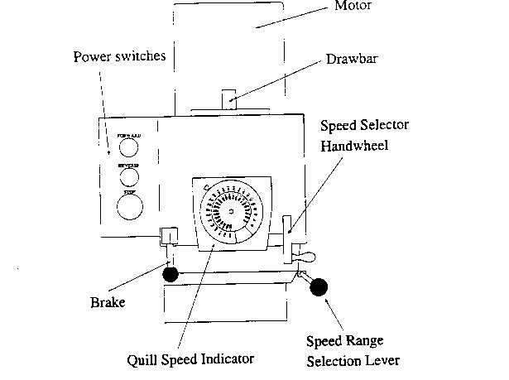
Figure 19: Speed Controls

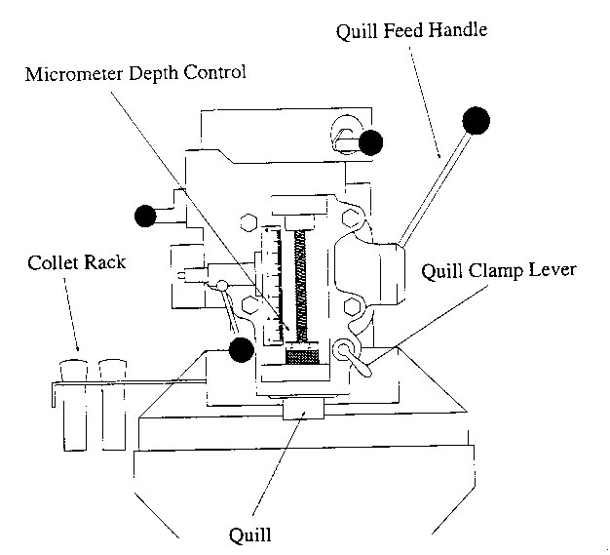
Figure 20: Quill Feed Controls

    - Quill Feed Controls
The quill of the vertical miller can be raised or lowered to aid in performing some machine operations, such as drilling. Figure 20 shows the main controls, which affect this quill movement.

Quill Feed Handle: This lever moves the quill of the machine up and down, just as the lever on a drill press moves the drill chuck up and down. This handle permits the user to use the milling machine like a drill press.

When the quill feed handle is not all the way up, the drawbar may not be accessible at the top of the machine. Should you need to access the drawbar, raise the quill all the way up first.

Quill Clamp Lever: This lever is a brake for the vertical motion of the quill. This must be loosened before the quill feed handle can be used. After using the quill feed handle, the quill clamp lever should be tightened (clockwise) to prevent the quill from shifting.

Micrometer Depth Control: This consists of a threaded machine screw, with a precision depth stop, which rides along the screw. When the quill feed handle is pulled, a metal bracket slides over the screw until it contacts the depth stop. The height of the depth stop can be adjusted to 0.001 inch. This permits the user to mill or drill holes to a specific depth.

    - Table Motion Controls
The miller table (see Figure 21) also has controls, which move it in a precise fashion. The following controls are important for you to be familiar with.

Vise: This is generally used to hold the work piece to be machined. It is a smooth-jawed vise, to help prevent marring the work piece. Also, the jaw faced can be moved to other parts of the vise to increase its holding capacity. In some cases, for very large or bulky stock, it may be necessary to remove the vise, and to clamp the stock directly to the table.

Longitudinal Feed Hand wheel: This hand wheel moves the table side-to-side. There are actually two of these hand wheels, one on each side of the table.

Cross Feed Hand wheel: This hand wheel moves the table in or out from the bas of the machine

Elevating Feed Handle: This handle raises or lowers the table. Turning the handle clockwise raises the table.

Table Lock Lever: These levers are brakes on the side-to-side motion of the table. These should be loosened before using the longitudinal feed hand wheels.

Saddle Lock Handle: This lever is a brake on the in-and-out motion of the table. It should be loosened before using the cross feed hand wheel.

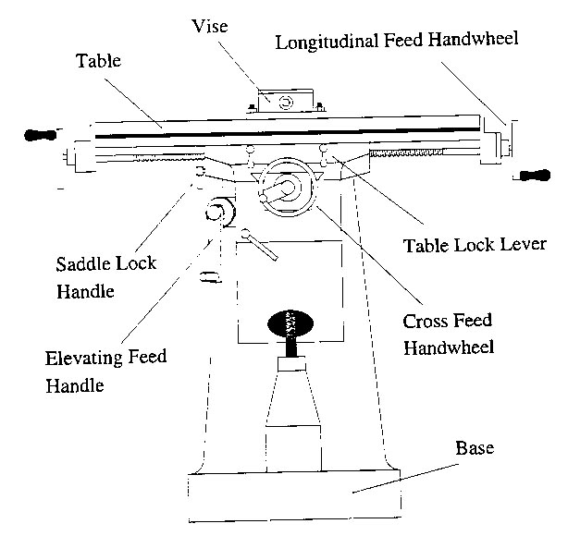
Figure 21:Table Motion Controls

2.2 Miller Setup
Before machining any material on the vertical miller, it is necessary to set up the machine properly for the material that you are going to turn. Setting up the machine involves three main tasks:
- Installing the end mill.
- Clamping the work piece to the table.
- Setting the controls of the machine properly.

2.2.1 Installing the End mill
- Insert the end mill into an appropriately sized collet. The shank of the end mill should fit snugly into the collet.
- Insert the collet into the quill of the vertical miller. Make sure that the key in the quill lines up with the keyway on the outside of the collet.
- Tighten the drawbar on top of the machine by hand.
- When you cannot further tighten the drawbar by hand, apply the hand brake, and tighten the drawbar with a wrench. Do not apply more than 10 pounds of force to the wrench: you will over-tighten the drawbar. Also do NOT leave the wrench on the drawbar; remove it and put it away.

    - Clamping the Work piece to the Table
Make sure the vice is free of chips and that any burrs have been filed off of the work piece to be machined. Chips and burrs will prevent the vise jaws from contacting the full surface of the work piece. This may result in the piece slipping, or the surface of the work piece being marred.

When the piece is aligned properly in the vise, tighten the vise handle firmly (clockwise). If the vise is not tight enough, the piece may slip during the milling process. Remove the vise handle and lay it on the milling table.

    - Setting the Controls
In general, the miller controls should be adjusted with the machine OFF. Any exceptions to this rule will be clearly marked on the machine. Most of the controls select gears in the miller’s transmission; if you try changing gears while the machine is running, you can easily damage the miller.

If you find that a particular control resists being put into a certain position, DO NOT FORCE IT. Usually, this happens because the gears are not lined up properly. Rotate the quill a short distance and try again; this will move the gears enough to permit the control to be moved.
- With the machine OFF, move the spindle speed-range selector into the appropriate speed range for the machining operation you want to perform.
- Make sure the end mill is not contacting anything. Turn the machine on, and make sure the end mill is spinning in the proper direction. Turn the speed-selector hand wheel in the appropriate direction until the end mill speed is at the desired value.

Miller Cleanup
When you are finished for the day, you must clean up the miller. The following things should be done:
- Remove your work piece from the miller.
- Remove the end mill from the machine (see section 2.3.1).
- Put the appropriate tools back into the milling toolkit, and check your toolkit back in.
- If you were milling aluminum, brush the chips from the boards covering the miller table into the aluminum-recycling bin.
- Using compressed air, blow off the accumulated chips from the top of the miller.
- Reverse the elevating feed handle, and remove the vise handle and lay it on the milling table.
- Sweep up the floor around the miller, and discard the chips.

2.3.1 Removing the End Mill
The procedure for removing the end mill from the vertical miller is not quite the reverse of the installation process. This is due to the fact that when the drawbar is tightened the collet becomes wedged up into the quill.
- Make sure that the machine is turned OFF, and that the cutter is not moving.
- Apply the hand brake, and use the wrench to loosen the drawbar. When the drawbar is loose enough to turn by hand, turn it TWO full turns only. This leaves most of the threads of the drawbar still engaged with the threads of the collet.
- Hold onto the end mill and using a lead mallet, strike the drawbar. This will dislodge the end mill. The impact force of the lead mallet will be distributed among all of the threads, which are still engaged, they will not be damaged by the impact as the stress of the blow is distributed among nearly all of the threads. Please catch it in your hand. It is quite brittle and can fracture if dropped.
- Remove the end mill.
- Continue to loosen the drawbar until the collet comes out of the quill.
- Please do not drop the collet, it is very hard and somewhat brittle; it will crack if dropped.
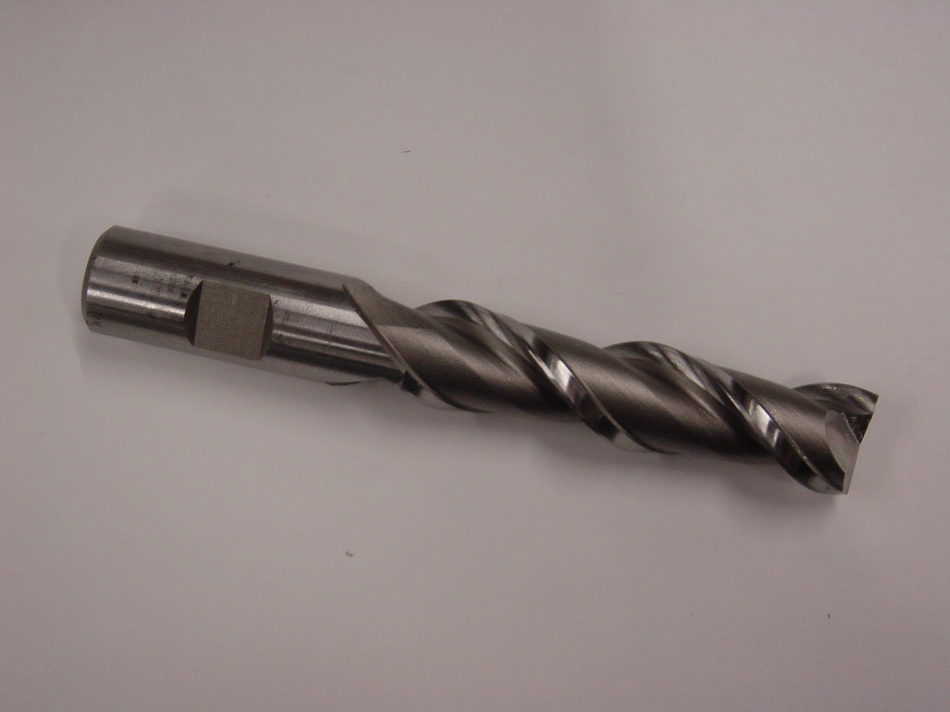
Figure 22: Two-Flute End Mill

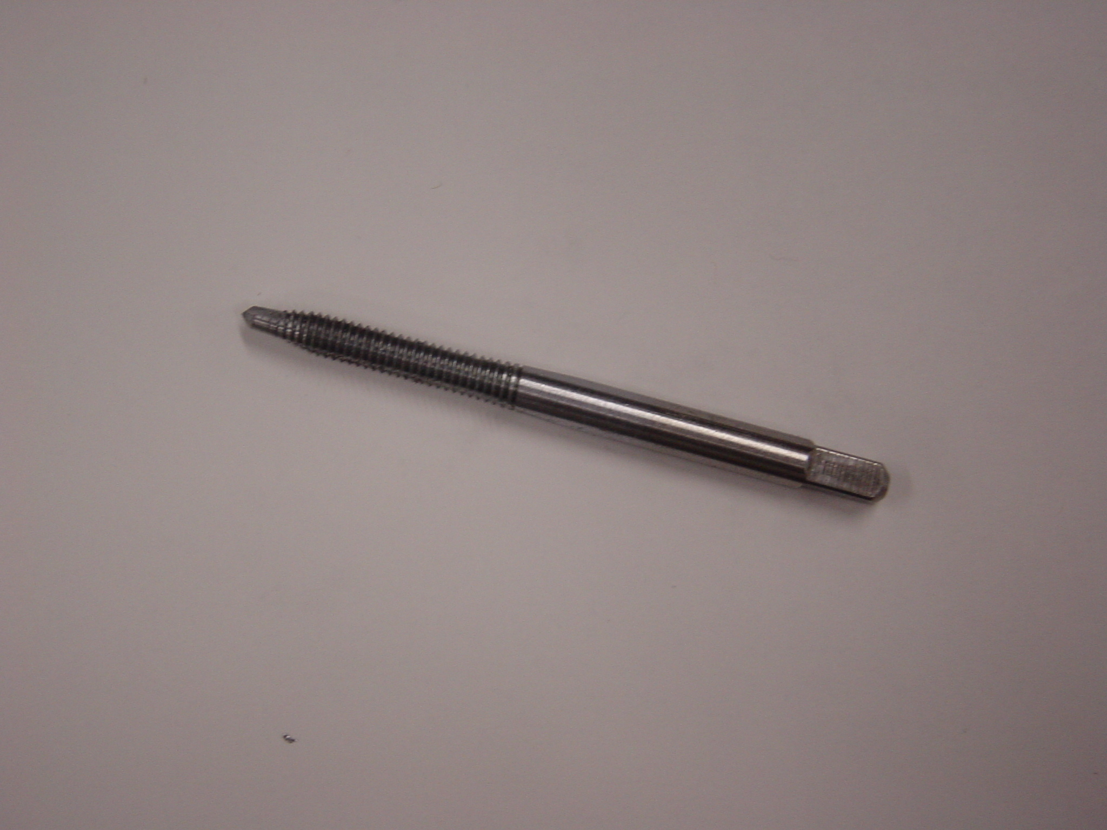
Figure 23: Tap
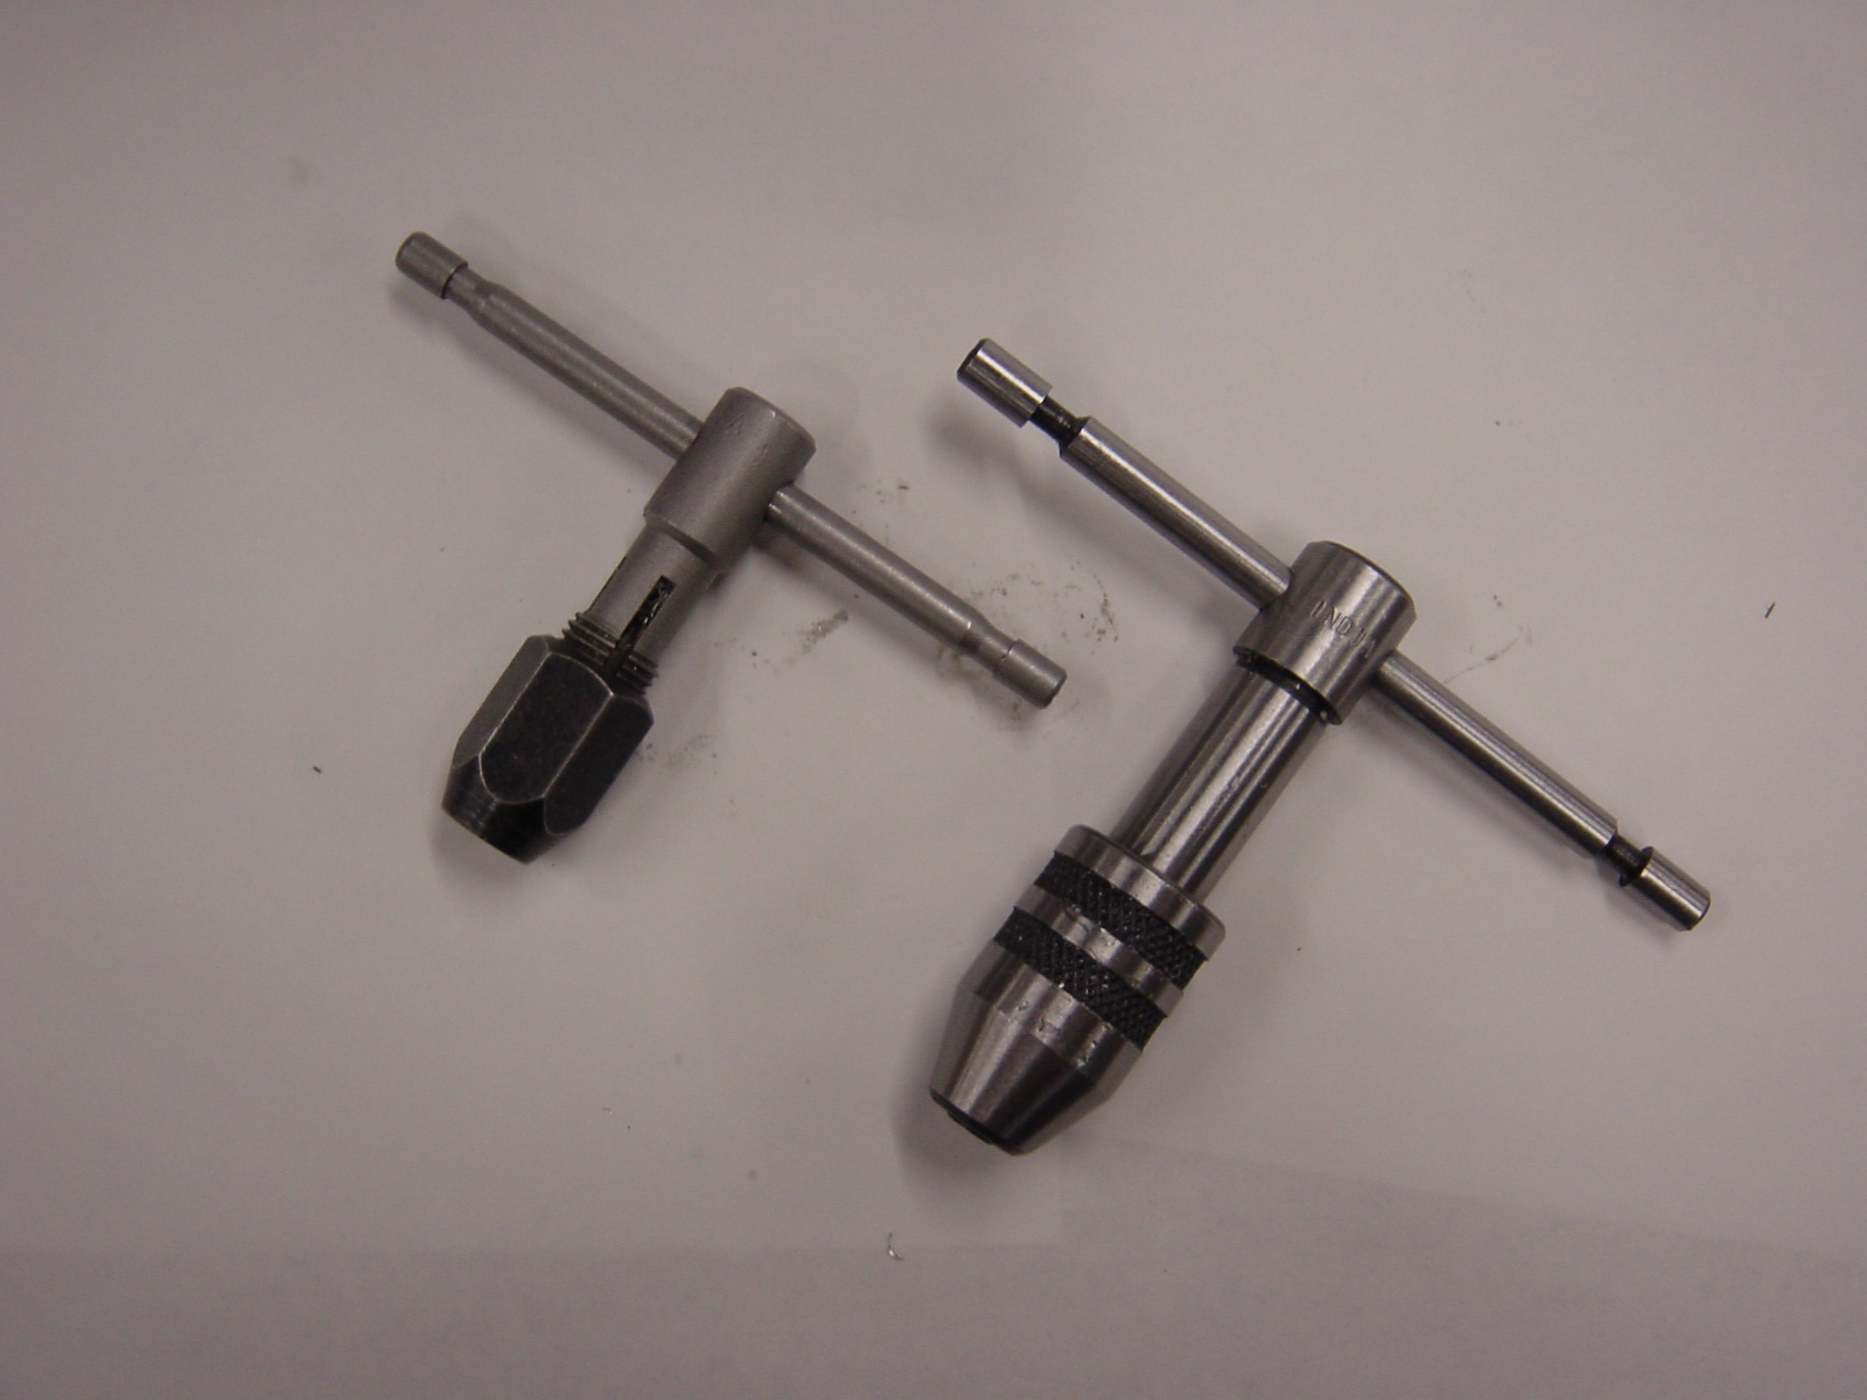
Figure 24: Tap Wrenches

Tapping

3.1 Background
In order to fasten a machine screw into a hole, it is necessary to cut out matching threads on the inside of the hole to accommodate the threads of the screw. Without threads, the screw will not go into the hole.

Tapping is the processes of cutting the threads in a hole. The process is done with a tool called a tap (see Figure 23), which is held in a tap wrench (Figure 24). Figure 25 shows the basic machining steps needed in order to make a threaded hole for a screw.
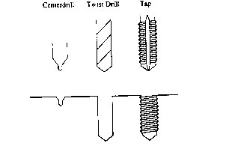
Figure 25: Steps in the Tapping Process: 1) Center-drilling, 2) Drilling to Depth, 3) Tapping

While most drills are specified only by their diameter, taps (and screws) must be specified by both their diameter and the thread pitch (the distance from a point on one thread to a corresponding point on the next thread).

For example, you will be tapping a 10-32 UNF hole for the end of the catapult arm and for the four wheels. The number “10” in the “10-32” indicates the screw’s diameter, and the “32” indicates that there are 32 threads per inch along the thread’s length. “UNF” stands for “United National Fine”.

At one time, every company made whatever arbitrary diameter and pitch screw it wanted. For an increasingly industrialized nation, this situation was unacceptable. A convention was held, and standard sizes were adopted. In most diameters, two pitches were adopted, “fine” and “coarse”. The pitches were called “United”(all manufacturers agreed to abide by the convention “National” (the agreement was nationwide) “Fine” or “Coarse”. A chart of commonly used screw sizes is included for general information (Table 1 on page 38).

  - Tapping Procedure
In general, taps are made of very hard steel. They are also quite brittle, so it is easy to break them. For this reason, EXTREME CAUTION SHOULD BE USED WHEN TAPPING. If it becomes hard to turn the tap, remove it from the hole, clean and oil it, and continue tapping. Consult the instructor if you have a problem.

3.2.1 Cannon Base
- Using a file, remove any burrs from the holes to be tapped.
- Install a tap into the tap wrench.
- Place the base in a vise, making sure to use the aluminum guards to protect your base.
- Brush some oil onto the tap, and brush plenty of oil into the hole.
- Insert the tap through the hole in the tapping guide, and place the tip of the tap in the hole to be tapped.
- Slide the tap guide down so that it rests on the aluminum block. Hold the tap guide flat against the block; this will ensure that the tap is perpendicular to the surface of the block.
- Turn the tap wrench clockwise to begin cutting threads. Do not press down on the tap; the tap should guide itself into the hole. After every two full clockwise turns, turn the tap wrench counter-clockwise 1 full turn. This will help loosen up the chips that form and bring them to the surface.
- Once the tap is established (5-10 threads have been cut), the tapping guide is no longer necessary. You may remove the tapping guide by unscrewing the tap, removing the guide, and reinserting the tap into the hole.
- Continue tapping the hole until there are about 4-5 threads on the tap left showing above the surface of the block.
- After tapping the first hole, repeat the process for the other hole. Then, turn your base over, and tap the holes from the other side.

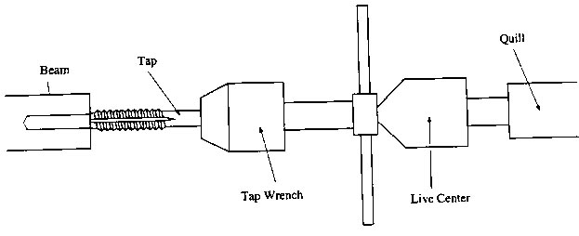
Figure 26:Tapping the hole in the end of the Arm

3.2.2 Train Cab
- Using a file, remove all burs from the holes to be tapped.
- Install a tap into the tap wrench.
- Place the cab on a flat surface.
- Brush oil onto the tap and into the hole.
- Insert the tap through the hole in the tap guide and place the tip of the tap into the hole to be tapped.
- Slide the tap guide down until it rests against the aluminum block. Hold the tap guide flat against the block; this will ensure the tap is perpendicular to the surface of the block.
- Turn the tap wrench clockwise to begin cutting threads. DO NOT press down on the tap; the tap should guide itself into the hole.
- After 5-10 threads have been cut, the tap guide is no longer necessary. You may remove the tap guide by unscrewing the tap, removing the guide, and reinserting the tap into the hole.
- Continue tapping the hole until there are about 4-5 threads on the tap left showing above the surface. Should tapping become difficult before this, back the tap out of the hole, remove any chips on the tap and inside the hole, and reinsert the tap.
- After tapping the first hole, repeat for the other holes. Then, turn your base over and tap the holes from the other side.

3.2.3 Smoke Stack & Boiler
- Remove any burrs from the holes to be tapped. Lightly face off the end of the smoke stack if necessary.
- Install a tap into the tap wrench. Grip the tap only by the square part on the end of the tap.
- Install the live center into the quill of the tailstock, and extend the quill until the 2” mark is showing on the quill.
- Brush some oil onto the tap and brush plenty of oil onto the hole.
- Place the tip of the tap in the hole to be tapped and slide the tailstock toward the headstock, until the tip of the live center rests in the hole in the back of the tap wrench. This will ensure that the tap is perpendicular to the end of the stock.
- Turn the tap wrench clockwise to begin cutting threads. While you are doing this, turn the tailstock hand wheel to keep the live center snug (but no tight) against the tap wrench.
- Once the tap is established (5-10 threads have been cut), the live center is no longer necessary. You may slide the tailstock away from the work piece to get it out of the way.
- Continue tapping the hole until there are about 4-5 threads on the tap left showing outside the hole.
- Repeat this process for the Boiler

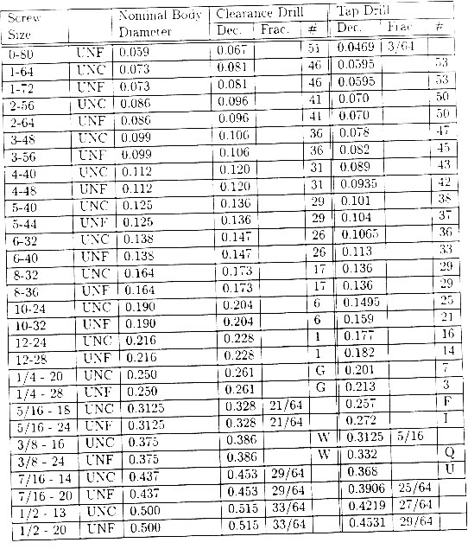
Table 1: A chart of commonly Used Taps and Screw Sizes.

Manufacturing the Cannon Barrel

Purpose
To manufacture, as part of an ongoing project, the barrel of the model naval cannon in order to become familiar with the operation of an engine lathe, drill press, band saw, and other related equipment, and to be able to use this equipment safely and knowledgeably, with minimum amount of instruction.

Materials

7 ½” x 7/8” diameter aluminum bar stock.

Tools and Equipment

Cross drilling the Barrel: 6” rule, hammer, center punch, center drill, “F” twist drill (0.257” diameter), drill press vise, V-block, drill press with various table clamps, and cutting oil.

Facing Off and Axial Drilling: Engine lather, collet and collet chuck, Jacob’s chuck with tapered shank, chuck key (if necessary), center drill, round nose tool bit, tool holder, 3/8” twist drill, 60º countersink, Allen wrenches, rubber mallet, and cutting oil.

Turning Outside Diameters and Forming Ridges: Engine lathe, collet and collet chuck, live center, chuck cradle, air hose, tool holders, form tool bit with 1/32” x 1/16” notch, Allen wrenches, round nose tool bit, inch micrometer, vernier calipers, emery paper, rubber mallet, and cutting oil.

Finishing the Breech End: 3-jaw chuck, aluminum split jaw inserts, round nose tool bit, vernier calipers, and inch micrometer.

Safety
- Never start the lathe with the tool bit touching the work piece.
- Make sure the chuck will not hit any part of the lathe before starting the machine.
- Make sure the cam locks of the headstock are tightened CLOCKWISE.
- Hold the work piece securely while drilling holes in it.
- Always clamp round stock to prevent it from rolling while cutting it on the band saw.

General Procedure
Following the instructions provided in this lab manual. If something does not seem right, consult the instructor. There may be things that are not completely correct, so do not be afraid to ask; you may end up saving yourself some time. PRACTICE SAFETY FIRST! All machines can be dangerous if not used properly.

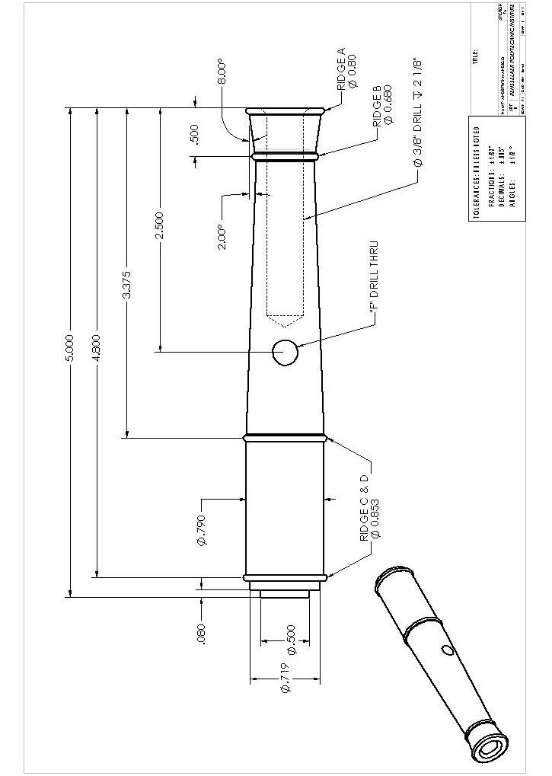
Figure 27: Cannon Barrel Machine Diagram
4.1 Layout

Clean the barrel stock with a rag to remove oil and dirt. Coat one side thinly with Dykem. Using a square, mark a reference line approximately 1/16” – 1/8” from one end of the 7 ½” barrel stock. This line is the location of the surface of the muzzle end, and is also a reference line from which you will mark layout measurements. Consult the drawing (Figure 27) and locate and mark the position of the cross hole. Center punch that mark. Next, locate the breech end of the barrel, located 5” from the reference line. Mark this location with on the pointed feet of your dividers.

  - Cross drilling the Barrel

Install the center drill in the Jacob’s chuck of the drill press. Clamp the V-block into the vise of the drill press. Position the center of the “V” of the V-block directly under the drill tip (see Figure 28) and clamp the vise to the table of the drill press. Have your partner hold your bar stock FIRMLY while you drill. Using cutting oil, center drill the center punched hole. This provides a reference hole to guide the larger twist drill. Replace the center drill with the “F” drill (0.257” diameter) and complete the hole. Make sure that you use cutting oil during the drilling process, and also make sure that you do not drill into the V-block.

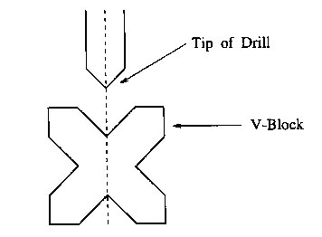
Figure 28: Aligning the Drill with the V-block in order to Cross drill the Barrel

  - Facing Off and Axial Drilling
- Aluminum is turned at 315 RPM on the lathes in the machine shop. Set the controls on the lathe to obtain this turning speed.
- If it is not already in place, you must install the collet chuck on the lathe. Consult the instructor before attempting this. MAKE SURE THE CAM LOCKS ARE THIGHTENED CLOCKWISE AND ARE TIGHT. Put the collet into the collet chuck, making sure that the key and keyway are aligned.
- Install the round nose tool bit. Be certain that the tool bit’s cutting tip is centered as per section 1.2.2. In this case, position the tool holder on the side of the quick change tool post that is parallel with the long axis of the quill (see Figures 29 and 30)
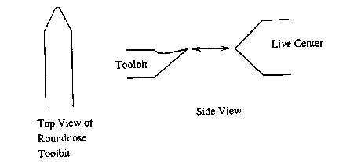
Figure 29: Aligning the round nose tool bit with the live center.

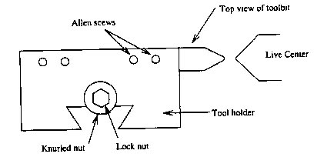
Figure 30: Aligning the tool bit for facing off. In order to face off the barrel, the tool bit must be repositioned to point in the opposite direction.

- Once the tool bit is aligned, take the tool bit out of the tool holder by loosening the Allen screws and turn it around so that the tip of the tool post is facing the collet chuck. If you do not align the tool bit correctly, you will not be able to face off your work piece completely to its center (a dimple of metal will be left at the center), and you may damage the tool bit.
- Install the stock into the collet (be sure no chips are in the collet) so that about 1 inch of the muzzle end (the short end) is sticking out of the collet. Install the collet into the collet chuck (be sure to align the keyway of the collet) and tighten the chuck.
- Before using the auto feed, make sure you test it away from your work piece by turning on the lathe, engaging the auto feed, and checking the direction that the tool bit is moving. Face off the muzzle end of the work piece to the scribed length.
- Extend that tailstock quill past the 1” mark, and install the Jacob’s chuck in the quill. Be sure to seat the Jacob’s chuck with the rubber mallet. Install the center drill in the Jacob’s chuck.
- Center drill the muzzle end up to 2/3 of the center drill taper.
- Drill to the specified depth with the 3/8” drill (see Figure 27) by using the scale on the tailstock quill as a guide. Use the depth gauge on the vernier calipers to check the precise depth of the hole.
- Finish the axial hole by chamfering to a ½” diameter with the 60o countersink (chamfer tool). Consult the barrel diagram (Figure 27). See the instructor for advice on the optimal method for accomplishing the above.
- Now do your partner’s barrel.

  - Turning the Outside Diameters
- Loosen the collet chuck and extend the stock so that roughly 5 ½” of material is protruding from the collet; then retighten the collet chuck. This is to ensure proper tool bit clearance with the collet chuck. Install the live center in the tailstock quill.
- Replace the tool bit in the tool holder, and place the tool holder on the tool post. Check the alignment of the tool bit. Orient the round nose tool bit on the tool post so that the tool bit is perpendicular to the bar stock’s axis of rotation.
- Making sure that all locks on the tailstock are disengaged, extend the tailstock quill and the live center so that about 4 ½” is showing on the quill. Slowly (and carefully) slide the tailstock to the point where it almost contacts the muzzle chamfer of the barrel. Now, slowly tighten the live center against the barrel. The guideline for tightening the live center is that when the headstock is in neutral, the live center and barrel should rotate together when the headstock is turned. CAUTION: Do not over tighten the live center against the work piece, and do not extend the quill past the 5” mark. CONSULT THE INSTRUCTOR BEFORE TURNING ON THE LATHE.
Note: Use cutting oil for the following operations. The order of the operations given below is recommended. NEVER start the machine with the tool bit contacting the material. To guard against this, put the headstock in neutral, and rotate the lathe chuck by hand to make sure that nothing will hit the tool bit. Re-engage the headstock.

- The diameter of the entire barrel must be reduced to 0.853”. To do this, turn the barrel stock down to 0.853”, starting 5 1/8” from the muzzle end of the barrel. You will need to do this in several passes. Do not cut more than 0.020” off on any one pass. Consult the instructor for the recommended cutting speeds.
- Turn the muzzle diameter down to 0.800” for 1 inch from the muzzle end. (Figure 31).
- Cut to 0.680 diameter inches a section ¼” wide, beginning 3/8” from the muzzle end, and ending at 5/8” from the muzzle end. Note that the sides of the cut will be angled because of the angled sides of the tool bit. (See Figure 32)
- Now stop and do your partner’s barrel.

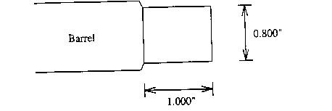
Figure 31: Turning the diameter down to 0.800” one inch from the muzzle end.

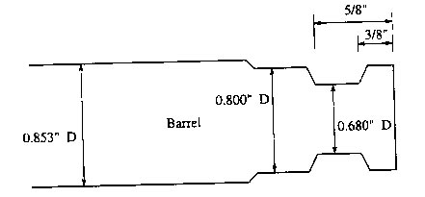
Figure 32: Cutting a section to 0.680 inches in diameter.

  - Cutting the Ridges
Note: The diameters of the ridges to be cut are the same as the outer diameter of the stock at these points. The diameter of the bar stock will determine the ridge diameter at this area. At the instant when the back of the ridge cutter touches the bar stock, the ridge should: 1) be round, 2) have the diameter of the bar stock at that point.

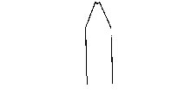
Figure 33: Top view of ridge cutter.
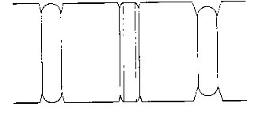
Figure 34: Good and Bad Ridges: X) A properly made ridge, Y) Tool bit not pushed in far enough, Z) Tool bit pushed in too far.

- At this point, install the form tool bit (ridge cutter – see Figure 33) into the tool holder, and center the tool bit. Install the tool holder on the tool post so that the tool bit is perpendicular to the axis of rotation.
- Cut Ridges C and D to 0.853” in diameter.
- Cut Ridge B to 0.680” in diameter.
- Cut Ridge A to 0.800” in diameter.
- Now, do your partner’s barrel.

  - Angle Cuts and Additional Turning
- Return the round nose tool bit to the tool holder and center it.
- Turn down the barrel diameter between ridges A and B to 0.790”. Consult the drawing (Figure 27). If you use the auto feed on this section, pay close attention, and be sure to disengage the auto feed when the tool bit comes close to the ridge. If you do not, you will cut the ridge off.
- Set up the lathe to make the 2o and 8o tapers on the barrel. To do this:
  - Loosen the two nuts in front of and behind the compound rest with the ½” wrench. See Figure 35.
  - Adjust the angle of the compound rest to 8o. Make sure that the edge of the compound rest is parallel to the surface of the taper, which you plan to cut. Note that each tick mark on the rest is one degree.
  - Re-tighten the two nuts on both sides of the compound rest.
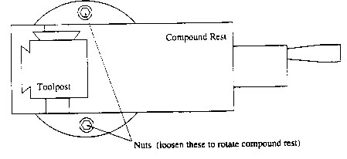
Figure 35: Rotating the Compound Rest.

NOTE: Using the small hand wheel on the compound rest itself can only make the angle cuts. All other hand wheels will make perpendicular cuts. NO NOT USE AUTOFEED; auto feed controls the larger hand wheels, not the one attached to the compound feed.

- Cut the 8º taper from the base of ridge C to D, using the cross slide dial to determine the depth of cut, and the top slide dial on the compound rest to make a pass.
- Readjust the angle on the compound rest, and cut the 2º taper from the base of ridge C to B.
- Return the compound rest to 0º.
- Now stop, and do your partner’s barrel.

  - Polishing the Barrel
In order to remove any tool marks made by the round nose tool bit, you must use emery paper to polish the surface of the barrel. It is easiest to polish the barrel while it is mounted on the lathe. This section is optional, and the final surface finish is up to you.

For best results, tear a narrow (1/2 inch) strip of emery paper, and wrap it around the barrel. Hold one end of the emery paper in each hand, and pull it toward you while the barrel is turning. Move the paper slowly side to side to sand the entire surface.
- Start with coarse grit (120) emery paper, and polish the surface until the scratches in the barrel are uniform in appearance.
- Using medium grit (240) emery paper, repeat the process until the surface scratches again look uniform.
- Repeat the process with a find grit (500) emery paper.
- After the sanding is complete, you may want to buff your work piece. This final step will only help shine the surface. It will not remove major scratch marks from the surface. Consult the instructor before using this machine.

  - Making the Wheels
- Once the Barrel is complete, cut off most of the remaining stock using the band saw 5-1/8 inches from the muzzle end.
- Install the stub of the remaining 7/8” diameter aluminum stock into the collet so that about ½” of material is in the collet. Tighten the collet.
- Face off the end of the stub, just like you faced off the muzzle end of the cannon barrel. Review section 2.3 for more detailed instructions.
- Center drill the end of the stub, and drill all the way through it with the #6 twist drill (0.204”). This forms the hole required by the retaining screws, which will attach the wheels to the cannon base. Again, refer to section 4.3.
- Sand the stock with rough emery paper lightly to remove any Dykem or dirt.

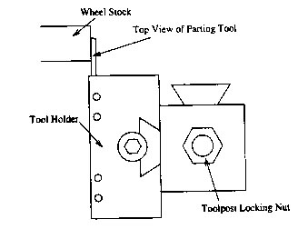
Figure36: Aligning the Parting Tool so it is Perpendicular.

- This is an optional step. If you want wheels with “treads”, obtain the knurling tool from your tool kit. This tool will put diamond-shaped patterns, called knurls on the surface of the aluminum. The instructor will show you how to perform this operation.
- Obtain a parting tool and wheel thickness gauge from an instructor. Be certain that the parting tool is at precisely 90o to the longitudinal axis of material; to do this, place the side of the parting tool against the faced off end of your work piece (see Figure 37).
If there is a gap at the front edge where the parting tool touches the wheel stock, the tool post must be straightened. Loosen the nut at the top of the tool post, and rotate the tool post until the parting tool touches the wheel stock all along it edge. Re-tighten the nut.
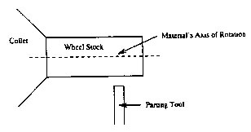
Figure 37: Using the parting tool to cut the wheels.

- Using the parting tool and wheel gauge, measure and slice off four wheels from the stub (Figure 37). Do NOT use auto feed for this process. Be sure to bathe the parting tool and the aluminum piece with cutting oil continuously as you cut into the aluminum. Also, do not feed the parting tool past the center of the aluminum bar stock.

  - Finishing the Breech End of the Barrel
- Install the 3-jaw chuck in the lathe. Make sure the cam locks are tight. See section 1 on changing the lathe chucks. Wipe off the inside surfaces of the jaws (where the jaws will touch the work piece) with a rag to remove any chips.
- Lace the 3-split jaw aluminum, or plastic pieces around the 0.790” diameter section of the barrel. Place the barrel with the breech end out. Make sure that one split jaw is centered under each of the three chuck jaws. See Figure 38 to identify the aluminum/plastic pieces.
- Face off the breech end of the barrel with the round nose tool bit so that the total length of the barrel is 5”.
- See Figure 39. Loosen the central nut on top of the tool post and pivot it until the round nose tool bit is at an angle to the breech such that the cutting edge is almost parallel to the axis of rotation. Make sure that the 3-jaw chuck will not contact the compound tool rest or tool post in any way. To do this, put the tool bit in a position, which simulates the cuts to be made, and rotate the headstock while it is in NEUTRAL.
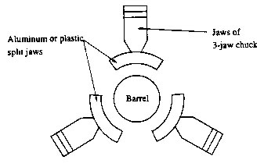
Figure 38: Placement of the barrel in the 3-jaw chuck.

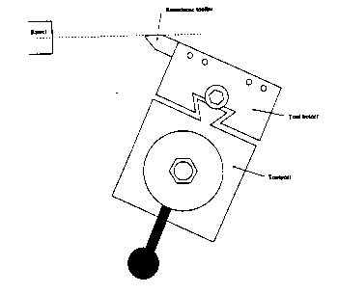
Figure 39: Tool bit Orientation for the Final Cuts on the Breech End of the Barrel.

- Consult the machine diagram and Figure 40 for the following cuts. Move the round nose tool in 1/16”, and turn a step 0.5” in diameter. Move the tool in 1/16” again, and turn a step 0.719” in diameter. These dimensions are not critical. If you wish, you may deviate from the design here. Be creative.

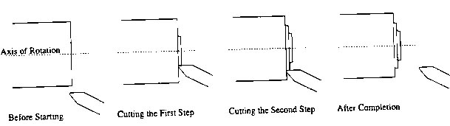
Figure 40: Cutting the stops on the breech end of the barrel.

4.10 Making the Trunion
The trunion is the pin that holds the barrel in the base.
- Obtain a piece of ¼” diameter stock from an instructor.
- Install the 3-jaw chuck on the lathe (see the section on changing the lathe chuck). Wipe off the jaws with a rag to remove any chips. Install the trunion pin in the 3-jaw chuck.
- Face off on end of the pin.
- Scribe a line 1.5” from the faced off end.
- Face off the other end of the pin to that line.
- Test fit the pin in the base. The ends of the pin should both be even with the sides of the base when the pin is inserted into the hole. If the pin is too long, face off one end slightly, until the ends of the pin are flush with the sides of the base.
- Using a knurling tool, knurl a ¼” wide strip on ONE end of the pin. This effectively expands the diameter of the pin. When this expanded end is forced into the base hole, it will create a press fit. CONSULT THE INSTRUCTOR ON HOW TO KNURL.
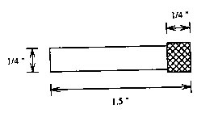
Figure 41: Trunion Pin for Cannon.

Milling the Cannon Base

Purpose
To manufacture the base of a model naval cannon and to become familiar with the safe operation of the horizontal and vertical milling machines.

Materials

1 ½” x 1 ½” x 2 7/8” aluminum block.

Tools and Equipment

Layout: Dykem, rag, scribe, combination square, center punch, hammer, 6-inch ruler, morphodite, divider.

Drilling: Drill press, center punch, center drill, “F” twist drill (0.257” diameter), drill press vice, cutting oil.

Tapping: Tap, tap wrench, tapping guide, cutting oil, file.

Horizontal Milling: Horizontal miller, combination square, clamp and mounting setup, spacer blocks, cutting oil, file.

Band sawing: Band saw marked “Aluminum Only”, wooden push block, cutting oil.

Vertical Milling: Vertical miller with vise, spacer block, end mill, collet, micrometer, file, scribe.

Safety
- Never start the vertical miller with the end mill touching the work piece.
- Keep you hands AWAY from the work piece until the end mill has come to a complete stop.

General Procedure
Caution: Milling machines should be used with the greatest caution! Respect them, and follow all safety rules. Consult an instructor before turning these machines on so that YOU do not get hurt. Do not be afraid to ask questions, or have the instructor check you work or setup.

An instructor will generally assign you an order in which to perform sections 5.2 – 5.4. in order to maximize the use of the available machinery. Otherwise, follow the order of operations as given.
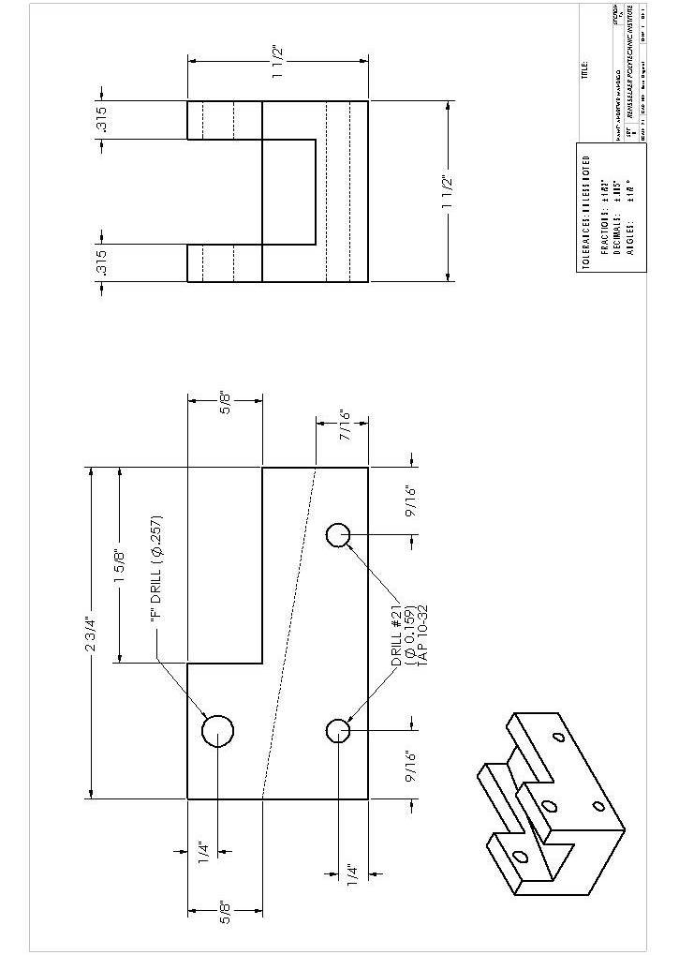
Figure 42: Cannon Base Machine Diagram.

5.1 Layout
- Clean the block with a rag to remove any oil and dirt and coat two adjacent sides thinly with Dykem.
- Using a square, mark a reference line approximately 1/16” from one end of the block. Consult the drawing (Figure 42).
- Following the instructor’s directions, scribe on the side of the block all the lines as indicated in the side view of the drawing.
- Using a center punch and hammer, center punch the location of the three holes.
- Using a morphodite, scribe the lines that are 0.315” from each edge on the top of the block.

5.2 Horizontal Milling
- Clamp your base, and your partner’s base, to the table of the horizontal milling machine. Make sure that the end lines of the bases are aligned with the cutting wheels, and that the blocks are square to the cutters. The instructor will explain in detail how this is done.

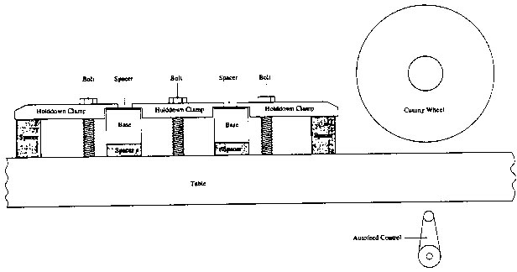
Figure 43: Side View of Horizontal Milling Setup.

- Adjust the table height so that both ends of the block will be cut at the same time, and so that the cutters will machine the entire face of the block. Make sure that the machine table will not be cut into.
- Cut the block using conventional milling and the automatic feed. Use plenty of cutting oil; oil the insides and the circumferences of the cutters AWAY FROM WHERE THE ALUMINUM BLOCK IS CONTACTING THEM. Keep your hands away from the cutting wheels.

5.3 Drilling Holes
When drilling holes, it is important to make sure that the twist drill is positioned so that it does not flex (i.e. bend) when it is pushed into the hole. Check to make sure the drill is not flexing before you attempt to drill the holes. Otherwise, the hole may be oversized, and/or not round or penetrate the block at an angle.

It may be necessary to determine the actual diameter of a twist drill before you use it. Occasionally, a twist drill of the wrong size will be put into the drilling kit by mistake. To check the size of a twist drill, use a micrometer to measure the diameter. Measure across the cutting flutes, not the shank portion.

- Center drill the three hole locations. When drilling, put an aluminum T-block under the base to prevent drilling into the vice or the drill press table. (See Figure 44).
- Drill the barrel hole with an “F” twist drill (0.257”).
- Drill the axle holes with a #21 twist drill (0.159”).

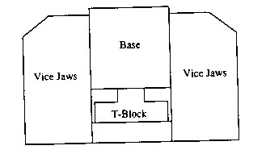
Figure 44: Positioning of the Base and T-block in the Vice for Drilling.

5.4 Tapping

Please see Section 3 and especially section 3.2.1.

5.5 Band sawing
Cut out the 5/8 inch x 1 5/8 inch slot with the band saw marked “Aluminum Only”. Use a wooden push block, and cut about 1/16” – 1/8” on the scrap side of the lines. This will leave excess material on your block, which you will remove later with the vertical milling machine.

5.6 Vertical Milling
- Obtain a vertical milling kit from an instructor.
- Install a ¾” two-flute end mill into the milling machine. Refer to section

- Make sure the vice is free of chips, and that any burrs have been filed off the blocks to be milled. Mount the blocks side by side, with a spacer block underneath. The band saw lines should be a little higher than the edges of the vise. Have an instructor check your setup before proceeding.
- Adjust the speed of the end mill. For aluminum, the end mill should rotate at 1800 RPM.
- Mill the 5/8” section, using cutting oil. CAUTION: It is extremely dangerous to put your fingers or an oil brush near a moving end mill. DO NOT DO IT! Cut all the way to the scribed lines. Use conventional milling (See Figure 47). Never cut deeper than 0.050” along the vertical axis of the miller. When using the side of the end mill to make a cut. Do not cut deeper than 0.010”.
- Mount the blocks next to each other in the vise such that the diagonal lines are even with the top of the vise. This is done so that the center slot can be milled at an angle with respect to the bottom of the base.
- Mark the bottom of the slot on one end of the blocks. You will be milling to this line.
- Cut down the center of the slot removing about 0.05” of material (about half a turn of the vertical control wheel) with each pass, until the proper depth is obtained. Remove handle to the vertical control so that the depth setting is not disturbed.
- Mill each side to the proper dimensions. Take no more than 0.010” of material off on each pass. All cuts should be made using conventional milling, except for the last cut. The last cut should be only about 0.005” deep, using climb milling for a better finish. See Figure 47. Note: DO NOT run the machine in reverse.

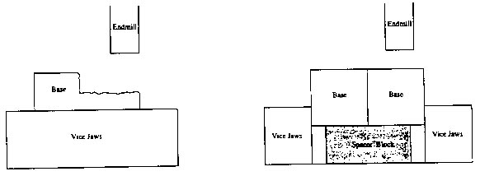
Figure 45: First Milling Setup for the Cannon Base.

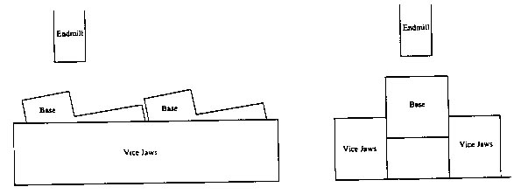
Figure 46: Second Milling Setup for the Cannon Base.

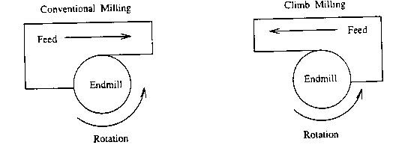
Figure 47: The Difference Between Conventional and Climb Milling.

5.7 Polishing the Base
Now, that the machining of the base is complete, file off any burrs that are on the edges of the base. Using emery paper, sand the sides of the base to remove any scratches and Dykem. Begin with coarse grit of emery paper (120), and sand until each surface looks uniform. Then proceed to finer grit of emery paper (240, 500), and repeat the process.

For the best results, use one of the flat steel lapping blocks on the long wooden bench. Set the emery paper on the surface, and secure it. Hold your base, and move the base against the emery paper, using slow, deliberate strokes. Sand in only one direction.

Cannon Assembly
At this point, your cannon base and barrel should be polished to your satisfaction.

- Using a rag, clean off any dirt from the barrel and the base.
- Obtain the letter and number stamps from the instructor. Stamp your name (or initials, class, year, favorite saying, or anything else you like) on the bottom of your base. Use the cannon-stamping jig to support the base while you do this.
- Put the barrel into the slot in the base, making sure the basket is facing in the correct direction, and slide the trunion pin through the holes in the base and barrel. Make sure that the trunion pin goes all the way through the barrel, and part way into the second hole of the base.
- Clean a milling machine vise with a rag to remove any chips. Wrap your base and barrel in a clean paper towel or rag, and place it in the milling machine vice. Tighten the vise so that the trunion pin is pushed the remainder of the way into the base.
- Obtain 4 screws from and instructor. Using an Allen wrench, put on the wheels.
- When you cannon is assembled, make sure that an instructor checks you off as having completed the project.

7 Train

Manufacturing the Boiler and Smoke Stack

Purpose

To manufacture, as part of an ongoing project, the boiler and smoke stack for a model steam locomotive in order to become familiar with the operation of a engine lathe, drill press, band saw, and other related equipment, an to be able to use this equipment safely and knowledgably with the minimum amount of instruction.

Materials

7 ½” X 7/8” diameter aluminum bar stock

Tools and Equipment
Cross drilling the Boiler: 6” Rule, hammer, center punch, center drill, #6 twist drill (0.2040” diameter), 3/8” twist drill, drill press vice, V-block, drill press and cutting oil

Facing off and Axial Drilling: Lathe, collet and collet chuck, Jacob’s Chuck with tapered shank, chuck key (if necessary), center drill, round nose tool bit, tool holder, #21 twist drill, ¼” twist drill, 90° counter sink, Allen wrenches, rubber mallet, and cutting oil.

Turning Outside Diameters and Forming Ridges: Lathe, collet and collet chuck, live center, forming tool with 1/32” x 1/16” notch, Allen wrenches, round nose tool bit, inch micrometer, vernier calipers, emery paper, rubber mallet, and cutting oil.

Safety
- Never start the lathe with the tool bit touching the work piece
- Make sure the chuck will not hit any part of the lathe before starting the machine
- Make sure the cam locks of the head stock are tightened CLOCKWISE.
- Hold the work piece securely while drilling holes in it.
- Always clamp round stock to prevent it from rolling while cutting it on the band saw.

General Procedure
Following the instructions provided in this lab manual. If something does not seem right, consult the instructor. There may be things that are not completely correct, so do not be afraid to ask; you may end up saving yourself some time. PRACTICE SAFETY FIRST! All machines can be dangerous if not used properly.

Figure A 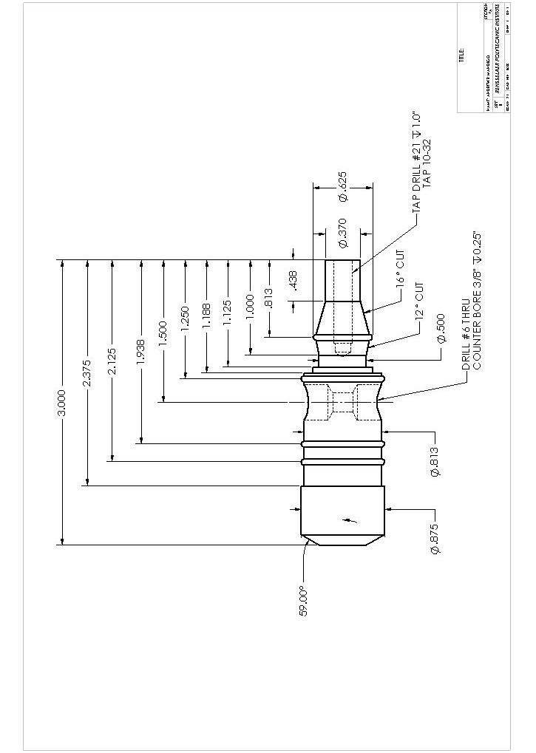
7.1 Layout
Clean the barrel stock with a rag to remove oil and dirt. Coat one side thinly with Dykem. Using a square, mark a reference line approximately 1/16” – 1/8” from one end of the 7 ½” barrel stock. This line is the location of the surface of the bottom end of the smoke stack, and is also a reference line from which you will mark layout measurements. Consult the drawing (Figure 27) and locate and mark the position of the cross hole. Center punch that mark. Next, locate the back of the boiler, located X” from the reference line. Mark this location with the pointed feet of your dividers.

7.2 Cross drilling the Boiler
Install the center drill in the Jacob’s chuck of the drill press. Clamp the V-block into the vise of the drill press. Position the center of the “V” of the V-block directly under the drill tip (see Figure 28) and clamp the vise to the table of the drill press. Have your partner hold your bar stock FIRMLY while you drill. Using cutting oil, center drill the center punched hole. This provides a reference hole to guide the larger twist drill. Replace the center drill with the #6 drill (0.204” diameter) and complete the hole. Make sure that you use cutting oil during the drilling process, and also make sure that you do not drill into the V-block. Next, replace the #6 drill with the 3/8” drill and drill the first counter bore 0.25” deep. Flip the stock over and drill the second counter bore from the other side, again 0.25” deep.

7.3 Facing Off and Axial Drilling
- Aluminum is turned at 300-400 RPM on the lathes in the machine shop. Set the controls on the lathe to obtain this turning speed.
- If it is not already in place, you must install the collet chuck on the lathe. Consult the instructor before attempting this. MAKE SURE THE CAM LOCKS ARE THIGHTENED CLOCKWISE AND ARE TIGHT. Put the collet into the collet chuck, making sure that the key and keyway are aligned.
- Install the round nose tool bit. Be certain that the tool bit’s cutting tip is centered as per section 1.2.2. In this case, position the tool holder on the side of the quick change tool post that is parallel with the long axis of the quill (see Figures 29 and 30)
Figure 29: Aligning the round nose tool bit with the live center.

Figure 30: Aligning the tool bit for facing off. In order to face off the barrel, the tool bit must be repositioned to point in the opposite direction.

- Once the tool bit is aligned, take the tool bit out of the tool holder by loosening the Allen screws and turn it around so that the tip of the tool post is facing the collet chuck. If you do not align the tool bit correctly, you will not be able to face off your work piece completely to its center (a dimple of metal will be left at the center), and you may damage the tool bit.
- Install the stock into the collet (be sure no chips are in the collet) so that about 1 inch of the smoke stack end (the short end) is sticking out of the collet. Install the collet into the collet chuck (be sure to align the keyway of the collet) and tighten the chuck.
- Before using the auto feed, make sure you test it away from your work piece by turning on the lathe, engaging the auto feed, and checking the direction that the tool bit is moving. Face off the smoke stack end of the work piece to the scribed length.
- Extend that tailstock quill past the 1” mark, and install the drill chuck in the quill. Be sure to seat the drill chuck with the rubber mallet. Install the center drill in the drill chuck.
- Center drill the smoke stack end up to 2/3 of the center drill taper.
- Drill to the specified depth with the #21 drill (see Figure A) by using the scale on the tailstock quill as a guide. Use the depth gauge on the vernier calipers to check the precise depth of the hole.
- Now do your partner’s boiler & smoke stack.

7.4 Turning the Outside Diameters
- Loosen the collet chuck and extend the stock so that roughly 3.5” of material is protruding from the collet; then retighten the collet chuck. This is to ensure proper tool bit clearance with the collet chuck. Install the live center in the tailstock quill.
- Replace the tool bit in the tool holder, and place the tool holder on the tool post. Check the alignment of the tool bit. Orient the round nose tool bit on the tool post so that the tool bit is perpendicular to the bar stock’s axis of rotation.
- Making sure that all locks on the tailstock are disengaged, extend the tailstock quill and the live center so that about 4 ½” is showing on the quill. Slowly (and carefully) slide the tailstock to the point where it almost contacts the drilled hole in the smoke stack. Now, slowly tighten the live center against the smoke stack. The guideline for tightening the live center is that when the headstock is in neutral, the live center and barrel should rotate together when the headstock is turned. CAUTION: Do not over tighten the live center against the work piece, and do not extend the quill past the 5” mark. CONSULT THE INSTRUCTOR BEFORE TURNING ON THE LATHE.
Note: Use cutting oil for the following operations. The order of the operations given below is recommended. NEVER start the machine with the tool bit contacting the material. To guard against this, put the headstock in neutral, and rotate the lathe chuck by hand to make sure that nothing will hit the tool bit. Re-engage the headstock.

- The first roughing step is to turn down the outer diameter of the smoke stack to 0.65” starting 1 1/8” from the smoke stack end of the stock.
- Next, turn down the smaller portion of the smoke stack to 0.4” diameter starting 7/16” from the smoke stack end of the stock.
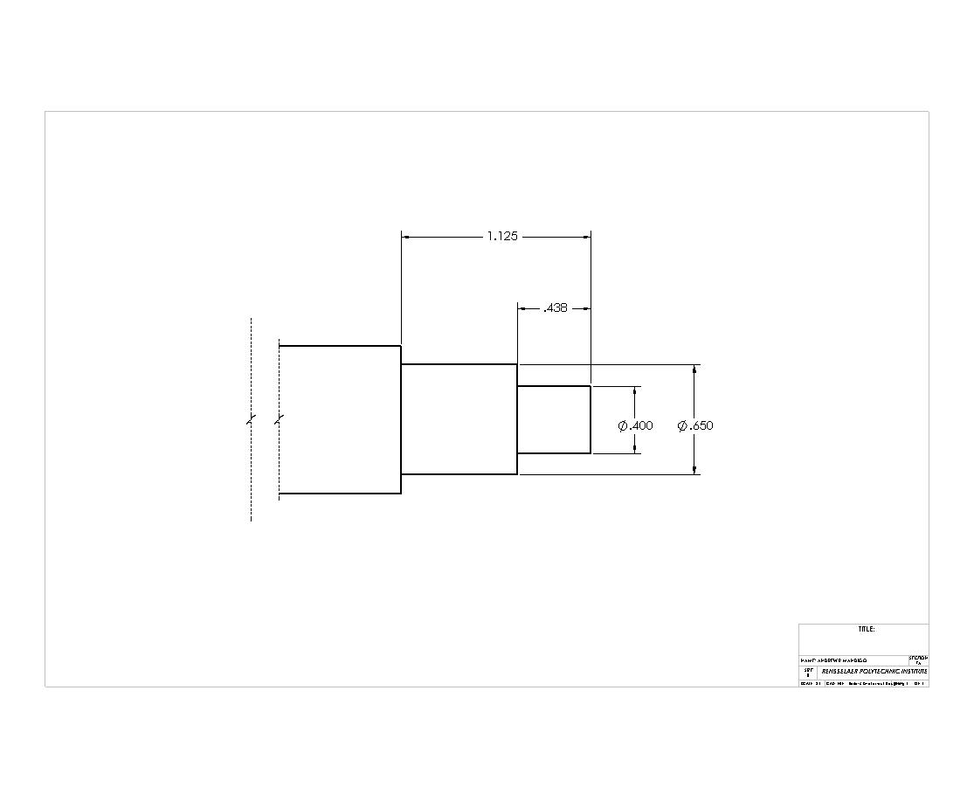

Figure 32: Roughing Smoke Stack.

7.5 Cutting the Ridges
Note: The diameters of the ridges to be cut are the same as the outer diameter of the stock at these points. The diameter of the bar stock will determine the ridge diameter at this area. At the instant when the back of the ridge cutter touches the bar stock, the ridge should: 1) be round, 2) have the diameter of the bar stock at that point.

Figure 33: Top view of ridge cutter.
Figure 34: Good and Bad Ridges: X) A properly made ridge, Y) Tool bit not pushed in far enough, Z) Tool bit pushed in too far.

- At this point, install the form tool bit (ridge cutter – see Figure 33) into the tool holder, and center the tool bit. Install the tool holder on the tool post so that the tool bit is perpendicular to the axis of rotation.
- Cut Smoke Stack Ridge to 0.65” in diameter.
- Cut Boiler Ridges to .875” in diameter.
- Now, do your partner’s barrel.

7.6 Angle Cuts and Additional Turning
1. Return the round nose tool bit to the tool holder and center it.
- Turn down the barrel diameter between the Boiler Ridges to .812”. Consult the drawing (Figure 27). If you use the auto feed on this section, pay close attention, and be sure to disengage the auto feed when the tool bit comes close to the ridge. If you do not, you will cut the ridge off.
- Turn down the .375 diameter of Smoke Stack
- Set up the lathe to make the 16° taper on the Smoke Stack. To do this:
Loosen the two nuts in front of and behind the compound rest with the ½” wrench. See Figure 35.
Adjust the angle of the compound rest to 16°. Make sure that the edge of the compound rest is parallel to the surface of the taper, which you plan to cut. Note that each tick mark on the rest is one degree.
Re-tighten the two nuts on both sides of the compound rest.
Figure 35: Rotating the Compound Rest.

NOTE: Using the small hand wheel on the compound rest itself can only make the angle cuts. All other hand wheels will make perpendicular cuts. NO NOT USE AUTOFEED; auto feed controls the larger hand wheels, not the one attached to the compound feed.

- Cut the 16° taper from the base of the smoke stack ridge the final diameter, using the cross slide dial to determine the depth of cut, and the top slide dial on the compound rest to make a pass.

This Procedure will be followed for finishing the Smoke Stack once it has been parted off.

7.7 Polishing the Boiler & Smoke Stack
In order to remove any tool marks made by the round nose tool bit, you must use emery paper to polish the surface of the barrel. It is easiest to polish the Boiler & Smoke Stack while it is mounted on the lathe. This section is optional, and the final surface finish is up to you.

For best results, tear a narrow (1/2 inch) strip of emery paper, and wrap it around the barrel. Hold one end of the emery paper in each hand, and pull it toward you while the part is turning. Move the paper slowly side to side to sand the entire surface.
- Start with coarse grit (120) emery paper, and polish the surface until the scratches in the barrel are uniform in appearance.
- Using medium grit (240) emery paper, repeat the process until the surface scratches again look uniform.
- Repeat the process with a find grit (500) emery paper.
- After the sanding is complete, you may want to buff your work piece. This final step will only help shine the surface. It will not remove major scratch marks from the surface. Consult the instructor before using this machine.

7.8 Parting Off The Smoke Stack and Making the Wheels
1. Once the Boiler and Smoke Stack are ready for removal of the Smoke Stack, obtain a parting tool. Before Cutting, ensure the live center is not in place.
- Install the parting tool on the tool post and ensure that it is at precisely 90° to the longitudinal axis of the material; to do this, this, place the side of the parting tool against the faced off end of your work piece (see Figure 36).

Figure36: Aligning the Parting Tool so it is Perpendicular.

- Using the parting tool cut off the Smoke Stack at 1” from the end of the Smoke Stack. DO NOT use auto feed for this process. Be sure to bathe the parting tool and the aluminum piece with cutting oil continuously as you cut into the aluminum. Also, do not feed the parting tool past the center of the aluminum bar stock.
- Remove the boiler from the collet and cut the boiler from the remainder of the stock using the band saw.
- Reinstall the stub of the stock into the collet and face off the stock.
- Center drill the end of the stub, and drill all the way through it with the #6 twist drill (0.204”). This forms the hole required by the retaining screws, which will attach the wheels to the cannon base. Again, refer to section 4.3.
- Sand the stock with rough emery paper lightly to remove any Dykem or dirt.
Figure 37: Using the parting tool to cut the wheels.

- Using the parting tool and wheel gauge, measure and slice off twp wheels from the stub (Figure 37). Again, Do NOT use auto feed for this process. Be sure to bathe the parting tool and the aluminum piece with cutting oil continuously as you cut into the aluminum.
- Obtain a piece of 1/2” stock, replace the 7/8” collet with a 1/2” collet and repeat steps 5 through 8, producing the 4 small wheels of the train.

7.9 Finishing the Boiler & Smoke Stacks
- Reinstall the 7/8” collet into the head stock and insert the Boiler rear end out.
- Face off the rear end of the Boiler. Using the procedure for the angle cuts as described above, cut the 60° chamfer onto the back of the Boiler.
- Center drill the rear end of the boiler up to 2/3 of the center drill taper.
- Drill to the specified depth with the #21 drill (see Figure A) by using the scale on the tailstock quill as a guide. Use the depth gauge on the vernier calipers to check the precise depth of the hole.
- With the Boiler still in the collet, tap the 10-32 hole in the end of the Boiler.
- Remove the Boiler & 7/8” collet and replace with the 3/8” collet and install the Smoke Stack into it.
- Using the angle cut procedure, cut the 16° taper on the top of the Smoke Stack.
- Optionally, a ¼” drill may be used to create a bowl in the top of the Smoke Stack.

The Boiler & Smoke Stack are now finished.

8 Milling the Train Cab

Purpose
To manufacture the cab of a steam locomotive and to become familiar with the safe operation of the horizontal and vertical milling machines.

Materials

1 ½” x 1 ½” x 2 7/8” aluminum block.

Tools and Equipment

Layout: Dykem, rag, scribe, combination square, center punch, hammer, 6-inch ruler, morphodite, divider.

Drilling: Drill press, center punch, center drill, “F” twist drill (0.257” diameter), drill press vice, cutting oil.

Tapping: Tap, tap wrench, tapping guide, cutting oil, file.

Horizontal Milling: Horizontal miller, combination square, clamp and mounting setup, spacer blocks, cutting oil, file.

Band sawing: Band saw marked “Aluminum Only”, wooden push block, cutting oil.

Vertical Milling: Vertical miller with vise, spacer block, end mill, collet, micrometer, file, scribe.

Safety
- Never start the vertical miller with the end mill touching the work piece.
- Keep you hands AWAY from the work piece until the end mill has come to a complete stop.

General Procedure
Caution: Milling machines should be used with the greatest caution! Respect them, and follow all safety rules. Consult an instructor before turning these machines on so that YOU do not get hurt. Do not be afraid to ask questions, or have the instructor check you work or setup.

An instructor will generally assign you an order in which to perform sections 5.2 – 5.4. in order to maximize the use of the available machinery. Otherwise, follow the order of operations as given.
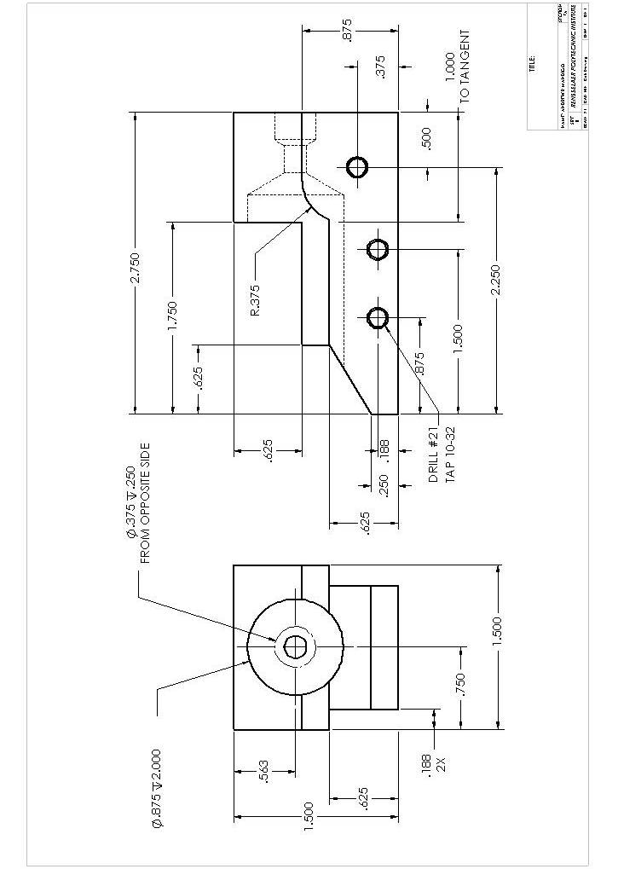
Figure 42: Train Cab Machining Diagram.

8.1 Layout
- Clean the block with a rag to remove any oil and dirt and coat two adjacent sides thinly with Dykem.
- Using a square, mark a reference line approximately 1/16” from one end of the block. Consult the drawing (Figure 42).
- Following the instructor’s directions, scribe on the side of the block all the lines as indicated in the side view of the drawing.
- Using a center punch and hammer, center punch the location of the three holes.

8.2 Horizontal Milling
1. Clamp your cab, and your partner’s cab, to the table of the horizontal milling machine. Make sure that the end lines of the cabs are aligned with the cutting wheels, and that the blocks are square to the cutters. The instructor will explain in detail how this is done.

Figure 43: Side View of Horizontal Milling Setup.

- Adjust the table height so that both ends of the block will be cut at the same time, and so that the cutters will machine the entire face of the block. Make sure that the machine table will not be cut into.
- Cut the block using conventional milling and the automatic feed. Use plenty of cutting oil; oil the insides and the circumferences of the cutters AWAY FROM WHERE THE ALUMINUM BLOCK IS CONTACTING THEM. Keep your hands away from the cutting wheels.

8.3 Drilling Holes
When drilling holes, it is important to make sure that the twist drill is positioned so that it does not flex (i.e. bend) when it is pushed into the hole. Check to make sure the drill is not flexing before you attempt to drill the holes. Otherwise, the hole may be oversized, and/or not round or penetrate the block at an angle.

It may be necessary to determine the actual diameter of a twist drill before you use it. Occasionally, a twist drill of the wrong size will be put into the drilling kit by mistake. To check the size of a twist drill, use a micrometer to measure the diameter. Measure across the cutting flutes, not the shank portion.

When drilling, be certain to use adequate (LARGE) amounts of cutting oil to prevent galling and assist in chip removal. This is especially true when drilling with large (>1/2”) drill bits.

- Prior to drilling, measure, scribe, and center punch the location of the boiler (7/8 inch) hole.
- Center drill the three cross-hole locations. When drilling, put an aluminum T-block or plywood spacer under the base to prevent drilling into the vice or the drill press table. (See Figure 44).
- Drill the axle holes with a #21 twist drill (0.159”).
- Unclamp the block and place the front end up in the vice.
- Center drill the location of the boiler hole.
- Pre-Drill the boiler hole using “F” (0.257”) twist drill
- Pre-Drill the boiler hole using a 1/2” twist drill
- Remove drill chuck & install 7/8” Morse taper drill bit directly into the spindle
- Drill the 7/8” hole down 2 inches.
- Remove the 7/8” drill bit and replace the drill chuck directly into the spindle
- Drill #6 twist drill thru remaining distance
- Turn over block and counter bore using 3/8” twist drill

Figure 44: Positioning of the Cab and T-block in the Vice for Drilling.

8.4 Tapping

Please see Section 3 and especially section 3.2.1.

8.5 Band sawing
Cut out the 5/8 inch x 1 3/4 inch slot with the band saw marked “Aluminum Only”. Use a wooden push block, and cut about 1/16” – 1/8” on the scrap side of the lines. This will leave excess material on your block, which you will remove later with the vertical milling machine.

8.6 Vertical Milling
- Obtain a vertical milling kit from an instructor.
- Install a ¾” two-flute end mill into the milling machine. Refer to section

- Make sure the vice is free of chips, and that any burrs have been filed off the blocks to be milled. Mount the blocks side by side, with a spacer block underneath. The band saw lines should be a little higher than the edges of the vise. Have an instructor check your setup before proceeding.
- Adjust the speed of the end mill. For aluminum, the end mill should rotate at 1800 RPM.
- Mill the 5/8” section, using cutting oil. CAUTION: It is extremely dangerous to put your fingers or an oil brush near a moving end mill. DO NOT DO IT! Cut all the way to the scribed lines. Use conventional milling (See Figure 47). Never cut deeper than 0.050” along the vertical axis of the miller. When using the side of the end mill to make a cut. Do not cut deeper than 0.010”.
- Mount the blocks next to each other in the vise such that the diagonal lines are parallel with the top of the vise. This is done so that the “cow catcher” can be milled at an angle with respect to the bottom of the cab.
- Next, place one cab into the vice and mill the side profiles of the cab using the same cut depths as described above. First mill the straight section to depth on one side and then cut the recess for the large wheel. Flip the cab over and repeat for the opposite side.

Figure 45: First Milling Setup for the train cab.

Figure 46: Second Milling Setup for the train cab.

Figure 47: The Difference Between Conventional and Climb Milling.

8.7 Polishing the Cab
Now, that the machining of the cab is complete, file off any burrs that are on the edges of the cab. Using emery paper, sand the sides of the cab to remove any scratches and Dykem. Begin with coarse grit of emery paper (120), and sand until each surface looks uniform. Then proceed to finer grit of emery paper (240, 500), and repeat the process.

For the best results, use one of the flat steel lapping blocks on the long wooden bench. Set the emery paper on the surface, and secure it. Hold your cab, and move the cab against the emery paper, using slow, deliberate strokes. Sand in only one direction.

Train Assembly
At this point, your train cab, boiler and smoke stack should be polished to your satisfaction.

  - Using a rag, clean off any dirt from the boiler, smoke stack, and cab.
  - Obtain the letter and number stamps from the instructor. Stamp your name (or initials, class, year, favorite saying, or anything else you like) on the bottom of your cab. Use the cannon-stamping jig to support the cab while you do this.
  - Obtain 8 screws from and instructor. Using an Allen wrench, put on the wheels.
  - Place the smoke stack into the accepting counter bore in the boiler and attach using a screw from the opposite side.
  - Place the boiler & smoke stack into the groove of the cab and ensure the smoke stack is perpendicular to the top of the cab. Place the remaining screw through the counter bore in the back of the cab and into the boiler. Should it not reach, remove the boiler and wheels, drill the counter bore deeper, and replace boiler.
  - When your train is assembled, make sure that an instructor checks you off as having completed the project.

- Welding Lab

All of the following should be accomplished only while under the supervision of a lab instructor.

Purpose
To practice arc initiation, fabrication, and testing of a butt-weld.

Material
3/16” x 1 ½” x 2” hot rolled steel plates.

Tools and Equipment
Gas Metal Arc Welder, breaker bar, vice, pliers, welder’s helmet, gloves, apron.

Safety
- Make sure there is proper ventilation in the area that you are welding in.
- Always wear a functional welding helmet while welding.
- Always wear a leather apron and leather gloves while welding. Long sleeved shirts are also recommended.
- People wearing nylon-topped shoes should wear a pair of leather spats when welding.
- Do not attempt to touch recently welded objects (even with gloves) until they have cooled.

Procedure
- Ensure that the ventilation system is on.
- Attach the ground cable to the clamp on the workbench, if it has not already been done.
- Place a piece of scrap steel on the welding bench.
- Adjust the controls on the welding machine to the proper settings.
- Turn on the shielding gas supply to the welding machine.
- After the safety of all individuals in the welding area has been checked, initiate an arc, and practice laying a short bead on the scrap metal. Remember to maintain a proper arc gap, and move the welding gun slowly, in a circular motion.
- Practice until the weld bead looks uniform along its entire length.
- Make a butt weld by laying two test plates side by side and laying a short bead 1 to 2 inches long on the joint between them.
- The instructor will show you how to test the welds.
- At this point, you have a welding project to do in order to practice your welding technique. The instructor will show you what materials are available for your project and what she/he expects. You may work together or individually.

- Oxyacetylene Brazing

Purpose
To practice adjusting regulators, lighting the torch, adjusting the flame, brazing and bend testing.

Tools and Equipment
Oxygen and acetylene tanks with regulators, welding torch and tip, spark lighter, brazing goggles, welder’s apron, and gloves.

Materials
1/16” x ½” x 6” steel pieces, 1/16” brass brazing rods, brazing flux.

Safety
- Make sure there is proper ventilation in the area that you are brazing in.
- NEVER set the acetylene pressure above 15 psi.
- Always wear brazing goggles before lighting torch.
- Point the torch in a safe direction before lighting it.

Procedure
- Make sure that everyone is wearing a leather apron, leather gloves, and brazing goggles.
- Open main valves of acetylene and oxygen tanks. Adjust regulators to provide proper working pressure for the gases (acetylene = 5 PSI, oxygen = 20 PSI).
- Place two pieces of steel on a firebrick so that they overlap each other.
- Open the acetylene needle valve on the torch (red hose = acetylene) approximately ¾ of a turn, and light the torch with a spark lighter.
- Adjust the acetylene needle valve until there is a gap of about ¼” between the tip of the torch and the base of the flame.
- SLOWLY open the oxygen needle valve on the torch. Keep adding oxygen until the flame just turns from orange to blue. This will result in a carburizing flame. Note the three different zones of the flame; the inner cone, the acetylene feather, and the outer envelope.
- Heat the tip of the brazing rod until it just begins to melt (a few seconds) and dip it into the brazing flux. This will cause some flux to stick to the end of the rod.
- Fan the flame over both pieces of steel. Make sure both pieces of steel are heated.
- Touch the brazing rod to the edge where the pieces overlap. Concentrate the flame on this point, until the brazing rod begins to melt. As it melts, feed more brazing rod into the joint.
- More flux can be added at any time by dipping the already hot brazing rod into the container of flux. Be sure to add brazing rod to the other edge where the pieces touch.
- In order to draw the brass into a joint, heat the steel, which lies in the direction in which you want the brass to flow.
- When extinguishing the flame, turn off the acetylene needle valve first; then the oxygen needle valve.
- Plastic Welding Lab

Purpose
To practice adjusting the controls of the plastic welder, making the welds and strength testing.

Tools and Equipment
Plastic Welder, clean rag or paper towel.

Materials
Pieces of PVC, Lexan, or acrylic, 1/8” welding rod (PVC or acrylic)

Safety
- Make sure there is proper ventilation in the area that you are plastic welding in.
- Keep your fingers as far away from the hot air stream as possible.
- Do not touch the metal portions of the plastic welding gun.

Procedure
- Open the main air valve on the plastic welding apparatus FIRST. Adjust the air pressure to 3 PSI.
- Once the air is flowing, turn on the heating element. The welder will take about 10 minutes to heat up.
- Clean the pieces of plastic with the rag. Make sure the pieces are free of dirt, chips, and oil.
- Hold the pieces of plastic together in the desired configuration, and use the tacking tip of the welding gun to tack the pieces together.
- After the pieces are tacked together, use the appropriate type of welding rod to weld the pieces together.
- The instructor will show you to test the strength of the weld.
- At this point, you have a welding project to do, in order to practice your welding technique. The instructor will show you what materials are available for your project, and what she/he expects. You may work together or individually.
- When turning the plastic welder off, turn off the heating element FIRST. Wait until the air coming out of the gun is at room temperature (about 10 minutes) before turning off the air valve.

A Appendix: Reading a Micrometer

Standard Inch Micrometer (graduated in thousandths of an inch)

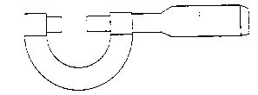
Figure 59: Inch Micrometer

In order to understand the principle of the inch micrometer, the student should be familiar with two important terms concerning screw threads:

Pitch: The distance from a point on one thread to a corresponding point on the next thread. For inch threads, this is expressed as 1/N (where N is the number of threads per inch). For metric thread, pitch is expressed in millimeters.

Lead: The distance a screw thread advances axially in one complete revolution or turn.

Since there are 40 threads per inch on the micrometer, the pitch is 1/40 (0.025) inch. Thus, one complete revolution for the thimble will either increase or decrease the distance between the measuring faces by 1/40 (0.025) inch. The 1-inch distance marked on the micrometer sleeve is divided into 40 equal divisions, each of which equals 1/40 (0.025) inch.

If the micrometer is closed until the measuring faces just touch, the zero line on the thimble should line up with the index line on the sleeve. If the thimble is rotated counter-clockwise one complete revolution, it will be noted that one line has appeared on the sleeve. Each line on the sleeve indicates 0.025 inches. Thus, if three lines were showing on the sleeve, the micrometer would have opened 3 x 0.025, or 0.075 inches.

Every fourth line on the sleeve is longer than the others and is numbered to permit easy reading. Each numbered line indicated a distance of about 0.100 inch. For example the #4 showing on the sleeve indicates a distance between the measure faces of 4 x 0.100 or 0.400 inches.

The thimble has 25 equal divisions about its circumference. Since one turn moves the thimble 0.025 inches, one division would represent 1/25 of 0.025 or 0.001 inch. Therefore, each line on the thimble represents 0.001 inch.

Reading a Standard Inch Micrometer
- Note the last number showing on the sleeve. Multiply this number by 0.100.
- Note the number of small lines visible to the right of the last known shown. Multiply this number by 0.025.
- Add the number of divisions on the thimble from zero to the line that coincides with the index line on the sleeve.

Example 1

See the figure below. The above steps are followed in order to obtain the reading.
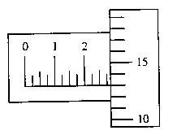
Answer:________________
An inch micrometer reading of 0.288 inch

#2 shown on the sleeve: 2 x 0.100 = 0.200
3 lines visible past the number: 3 x 0.025 = 0.075
#13 line on thimble coincides with the index line: 13 x 0.001= 0.013
Adding up these numbers, the total reading is: 0.288 inch

Example 2

The figure below shows a micrometer with a different reading.
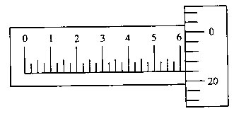
Answer:________________
An inch micrometer reading of 0.621 inch

#6 shown on the sleeve: 6 x 0.100 = 0.600
0 lines visible past the number: 0 x 0.025 = 0.000
#21 line on thimble coincides with index line: 21 x 0.001 = 0.021
Adding up these numbers, the total reading is: 0.621 inch
Inch Micrometer (graduated in ten-thousandths of an inch)

Some inch micrometers have, in addition to the graduations found on a standard micrometer, a vernier scale on the sleeve. This vernier scale consists of 10 divisions, which run parallel to and above the index line. It will be noted that these 10 divisions on the sleeve occupy the same distance as 9 divisions (0.009) on the thimble. One division on the vernier scale represents 1/10 x 0.009 or 0.0009 inch. Since one graduation on the thimble represents 0.001 or 0.0010 inch, the difference between one thimble division and one vernier scale division represents 0.0010 – 0.0009 or 0.0001 inch. Therefore, each division on the vernier scale has a value of 0.0001 inch.

Reading a Micrometer to Ten-Thousandths of an Inch

- Read the micrometer in the same manner as you would a standard inch micrometer.
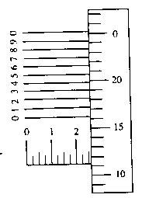
- Note the line on the vernier scale that coincides with a line on the thimble. This line will indicate the number of ten-thousandths that must be added to the above reading.

Examples
Answer:________________
A micrometer reading of 0.2613 inch

See the figure above. The micrometer is read as follows:

#2 shown on the sleeve: 2 x 0.100 = 0.200
2 lines visible past the number: 2 x 0.025 = 0.050
#11 line on the thimble coincides with the index line: 11 x 0.001= 0.011
#3 line on the vernier scale coincides with a line on the thimble: 3 x 0.0001= 0.0003
Adding up these numbers, the total reading is: 0.2613 inch

B Appendix: Reading a Vernier Caliper
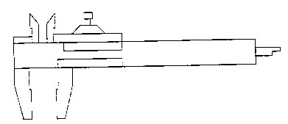
Figure 60: Vernier Calipers.

A vernier caliper is a tool, which can measure objects to the nearest thousandth of an inch, just as an inch micrometer can.

One advantage of the vernier caliper is that it can be used to measure larger objects than an inch micrometer can. The inch micrometer is limited to measuring objects that are under an inch in size. The vernier caliper, on the other hand, can measure objects, which are several inches long.

In addition to measuring outside diameters, the vernier caliper can also be used to measure inside diameters. Thus, the diameter of a hole can be determined using this tool. An additional feature of the vernier caliper is that it also has a depth gauge; thus, the depth of a hole can be measured as well.

Measuring outside diameters, inside diameters, and depth are done with different parts of the vernier caliper. Once the measurement is taken however, reading the instrument is done in exactly the same way.

If you look at the vernier caliper, you will note that one jaw is fixed, while the other jaw slides. A vernier scale, numbered 0-25, is attached to the sliding jaw, and moves with it. In order to take a reading, it is necessary to determine the position of the zero mark of this scale, relative to the scale on the flat, fixed portion of the caliper.

The scale on the flat, fixed portion of the caliper is divided into inches, and tenths of an inch. Each inch mark is noted with large numerals, while each tenth of an inch is marked with smaller numerals. Each tenth of an inch is also segmented into four equal parts. Thus, each small line on this scale is ¼ x 1/10 = 1/40, or 0.025 inch.

Using just fixed scale on the caliper, it is possible to obtain the position to 0.025 inch. In order to obtain the position 0.001 inch, we must use the vernier scale. The vernier scale is divided into 25 segments, and is used just like the vernier scale on the vernier micrometer. By finding the line on the vernier scale, which matches up with a line on the fixed scale, we determine the number of thousandths of an inch, which must be added to our result to get the final reading.
Reading a Vernier Caliper
- Note the number of large digits that the 0 mark on the vernier scale is to the right of. Multiply this number by 1.
- Note the number of small digits past the large digit, that the 0 mark is to the right of. Multiply this number by 0.1.
- Note the number of small divisions past the small digit, that the 0 mark is to the right of. Multiply this number by 0.025.
- Note the line on the vernier scale that coincides with a line on the fixed scale. (Only one line will match although some others may come close.) This line will indicate the number of thousandths.
- Add all of these numbers together to obtain the reading.

Example 1
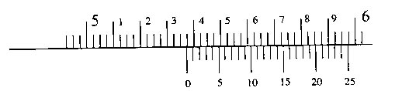
A vernier caliper reading of 5.372 inches.

See the figure above. The steps are followed in order to get the reading:
0 mark is to the right of the large digit 5: 5 x 1 = 5.000
0 mark is to the right of the small digit 3: 3 x 0.1= 0.300
0 mark is to the right of 2 small divisions: 2 x 0.025 = 0.050
#22 line on the vernier scale coincides with a line on the fixed scale: 22 x 0.001= 0.022
Adding up these numbers, the total reading is: 5.372 inch

Example 2
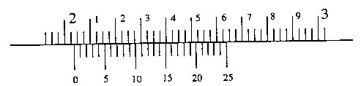
A vernier caliper reading of 2.038 inches.

See the above figure. Again, the steps are followed in order to get the reading:
0 mark is to the right of the large digit 2: 2 x 1 = 2.000
0 mark is to the right of no small digits: 0 x 0.1 = 0.000
0 mark is to the right of 1 small divisions: 1 x 0.025 = 0.025
#13 line on the vernier scale coincides with a line on the fixed scale: 13 x 0.001 = 0.013
Adding up these numbers, the total reading is: 2.038 inch

C Appendix: Grinding

C.1 Tool bit Grinding
The lathe tool bit, or cutter bit, is part of the lathe, which cuts the metal that must be removed in order to bring the work piece to the desired size and shape. The tool bit is usually made of high-speed steel, and held in a lathe tool holder.

High-speed steel cutter bits are hardened, and are ready for use when properly ground. Correct grinding of the lathe tool cutter bit is essential for good lathe work, because a properly ground cutter bit will produce better results, will last longer, and will cut more readily than a tool bit which has been improperly ground.

Correct grinding of the lathe tool cuter bit involves grinding the correct angles on the tool bit for the turning job that is to be done, and for the material that is to be turned.

Angles of the Lathe Tool bit
Several definitions are provided below, along with diagrams to illustrate the terms.

Tool Angle: (also called the included angle, or angle of keenness) This is the included angle of the cutting edge formed by the top surface and the side surface of the cutting bit.

Different materials will require different tool angles. For machining soft steel, an angle of 61 degrees is the most efficient. For ordinary cast iron, the included angle should be approximately 71 degrees. However, for machining chilled iron or very hard grades of cast iron, the tool angle may be as great as 85 degrees.

Side Clearance: This is the angle between the side surface of the cutting bit and the vertical. Note that there is side clearance on both sides of a cutting bit. This permits the cutting edge to advance freely without the heel of the tool rubbing against the work piece.

The side clearance should be from 3 degrees to 10 degrees, depending on the amount used, and the nature of the work.

Front Clearance: This is the angle between the front edge of the cutting bit and the line tangent to the work surface (usually the vertical). This permits the cutting edge to cut freely as the tool bit is fed into the work piece.

The front clearance should be from 3 degrees to 15 degrees, depending on the nature of the work, and the height of the cutter bit.

Back Rake: The angle between the top surface of the cutting bit (at the tool tip) and the horizontal, as viewed from the side of the cutting bit.

Side Rake: The angle between the top surface of the cutting bit (at the tool tip) and the horizontal, as viewed from the front or back of the cutting bit.

See Figures 61 and 62. These figures illustrate the various clearance and rake angles of the tool bits.

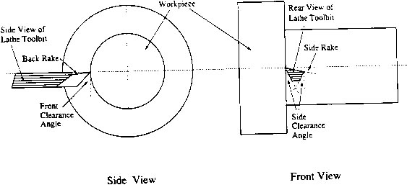
Figure 61: Rake and clearance angles of the Lathe Tool bit.

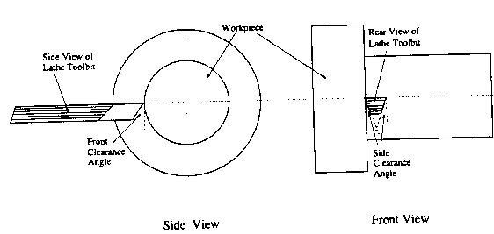
Figure 62: A Lathe Tool bit with Zero Rake and Zero Back Rake.

Tool bit Gauge
A cutter bit grinding gauge is shown in Figure 63. It is helpful tool for the beginner in grinding the correct angle on the various faces of the cutter bit. This gauge can easily be made of sheet metal, using the figure as a pattern, which is full size. If you have time, it would be a useful tool to construct.

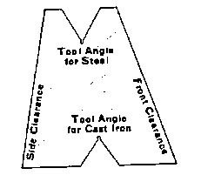
Figure 63: Pattern for Making a Tool bit Grinding Gauge.

Grinding a Round-nose Tool bit
The following illustrations show each step in the grinding of a round-nose turning tool for general machine work. The various steps in grinding the cutter bit are as follows:

Grind the left side of the cutter bit, holding the cutter bit at the correct angle against the wheel to form the side clearance. See the figure below. Use a coarse grinding wheel to remove most of the metal, and then finish on the side of the find-grinding wheel to produce a straight surface. (If ground on the periphery of a small diameter wheel, the cutting edge will be undercut, and will not have the correct angle.) Dip the cutter bit into water frequently while grinding to prevent the bit from overheating.
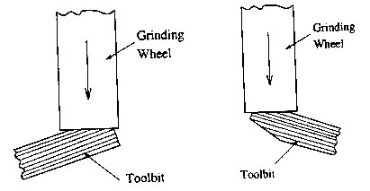

Grind the right side of the cutter bit, holding it at the required angle in order to form the right side clearance. See the above figure.
Grind the radius by rounding on the end of the cutter bit (see below). A small radius (approximately 1/32”) is preferable, as a larger radius may cause chatter. Hold the cutter bit lightly against the wheel and turn from side to side to produce the desired radius. Be careful to hold the cutter bit at the correct angle to obtain the proper front clearance.
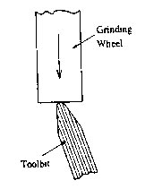

Hold the cutter bit at an angle as shown while grinding the radius on the end of the cutter bit, in order to form the required front clearance. See below.
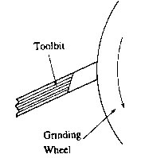

Grind the top of the cutter bit, holding the cutter bit at the required angles in order to form the necessary side rake and back rake.
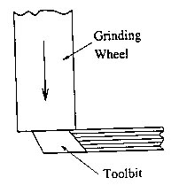
Types of Lathe Tool bits

The illustrations in Figure 64 show the most popular shapes of ground lathe tool cutter bits and their application.
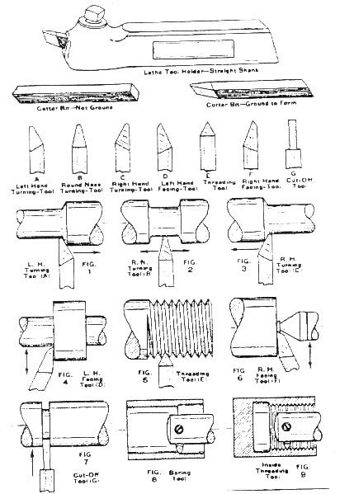
Figure 64: Various Types of Lathe Tool bits.

C.2 Surface Grinding

Dressing the Wheel
As a grinder is operated, the wheel will gradually become impregnated with small steel filings. It may begin to develop irregularities in its surface geometry from hitting one or more high spots in steel, causing one part of the wheel to wear a bit more than the rest of the wheel. When this happens it becomes necessary to remove the outer layer of the wheel and square up the edge. This is referred to as ‘dressing’ the grinding wheel. This is done in the following manner.
- Mount a small industrial diamond in a steel holder, and then mount the holder on a magnetic chuck.
- Nest, start the grinding wheel and slowly move it down until it just touches the tip of the diamond.
CAUTION: Never stand in line with the wheel because the material of the wheel is quite brittle. If there is any accident causing wheel breakage the wheel will shatter and the pieces will fly along paths in line with the wheel.
- Slowly move the grinding wheel back and forth to clean the entire surface of the grinding wheel face. Feed the grinding wheel down in increments of 0.001” per pass.
- Repeat this at least four times or until the wheel’s face is clean. The face will be of uniform color with no dark areas present at the edges of the wheel’s face.
- Once the wheel is dressed shut it off and wait until is stops rotating. Then remove the dressing assembly.

Grinding the Work piece
Be sure that no small burrs remain on the edges of the work piece you intend to grind. If there are any burrs, remove then with a file. This will enable maximum surface area to be in contact with the magnetic chuck so as to provide the best grip on the steel.

Once the work piece is secured to the magnetic chuck, start the coolant pump, but do not turn on the valve for the coolant flow. Now start the grinding wheel. Slowly bring the wheel down until it just barely touches the steel. Now turn on the coolant flow, and make a series of cutting passes over the surface of the steel until you have covered about ½ to 1/3 of the surface. Now lower the wheel another 0.001 inches and go over the same surface again. Repeat this process until the surface is bright and uniform. For the final pass, use a cut of just 0.005 inches.

In order to produce a really good finish, you would at this point dress the wheel again, and take off only 0.0002 inches then 0.0001 inches per pass. Note that too fast a traverse across the piece of 0.003 inches or more metal removal may cause the wheel to stall or burn the work. The wheel may also tend to stall if it needs to be dressed again. Too deep a cut may result in the work piece being thrown from the magnetic chuck.

D Appendix: Welding

The primary objective of any welding operation is to produce a weld that has the same properties as the base metal. While the perfect weld can never theoretically be achieved, in practice we can come very close and impurities in the weld can be kept to a minimum if proper care is taken.

In terms of impurities in welding, the biggest obstacle, which must be overcome, next to surface dirt and grime, is the atmosphere. When the metal is heated to its molten state, the molten puddle absorbs oxygen and nitrogen from the atmosphere, and upon cooling the metal becomes weak and porous. Since the purpose of welding is to join two pieces of metal together or to strengthen an existing piece this is obviously an unwanted condition, and contamination by the atmosphere should be controlled.

There are several different ways of accomplishing this task and each has its own application. Usually some sort of flux is used when welding, which when burned in addition to cleaning the base metal surface, provides a gaseous shield from the atmosphere.

There are several types of welding techniques as well. While all of them will not be discussed here, it is the purpose of this article to give the student a basic knowledge of the most prevalent welding techniques in use today. Three techniques will be considered: Electric Arc welding, Oxyacetylene Brazing, and Gas Metal Arc Welding (GMAW).

D.1 Electric Arc Welding
The heat generated for Electric Arc Welding (sometimes called stick welding) comes from an arc which develops when electricity jumps across an air gap between the end of an electrode and the base metal. The air gap creates a high resistance to current flow, which generates an intense amount of heat capable of producing temperatures anywhere in the range of 6000 degrees F to 10.000 degrees F (approximately 3300º C to 55000º C). Either provides welding current in AC or DC source.

If a direct current source is used, welding may be performed with either straight or reverse polarity. Straight polarity simply means that the electrode is connected to the negative (-) terminal of the current source and the base metal is connected to the positive (+). For terminal reverse polarity, the opposite is true. The reason for the difference is that electrons flow from the negative terminal to the positive; depending on the type of electrode used and the weld penetration, it may be desirable to have the base metal hotter than the electrode of vice versa. Tripping a switch on the welding machine itself can usually change polarity.

The Electrode
The electrode is a coated metal wire having the same composition as the base metal. When an arc is formed between the electrode and the base metal, both the electrode and the base metal are melted. The melted electrode flows into the molten base metal and becomes a part of it. Most electrodes are designed for either AC or DC welding, but a few work equally well for both.

There are two kinds of electrodes: bare and shielded. Originally, a bare electrode was just an uncoated metal rod, but today they have a light coating. Their use is limited however, because they have a tendency to produce brittle welds with low strength, and they are difficult to weld with. A shielded electrode has a heavy coating made of various substances, each of which performs a particular function in the welding process, including:
- To act as a cleansing and de-oxidizing agent in the molten metal.
- To release an inert gas to protect the weld from oxygen and nitrogen in the atmosphere.
- To form a slag over the deposited metal, which further protects the weld from the atmosphere until it has cooled sufficiently to prevent contamination.
- To provide easier arc starting and stabilize the arc.
- To permit better penetration of the weld into the base metal.

A coated electrode in the process of welding is shown in Figure 65. As a rule of thumb, the electrode never has a larger diameter than the thickness of the metal to be welded.
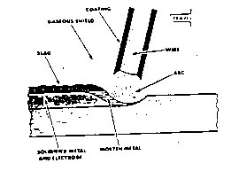
Figure 65: The Arc Welding Process.

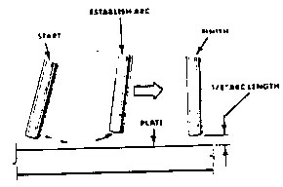
Figure 66: Proper Arc Gap.
For the beginning welder, the easiest way to strike an arc is by using a scratching method similar to striking a match. Upon contact with the metal, the electrode should be raised to a height approximately equal to the diameter of the electrode (Figure 66). Otherwise, the electrode will stick to the metal and within a short time weld itself to it.

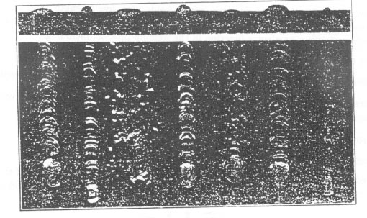
Figure 67: Examples of Proper and Improper Weld Beads (From Left to Right: Current, Voltage and Speed Correct; Current too low; Current too high; Voltage too low; Voltage too high; Speed too slow; Speed too fast)

Running a Bead
To run a continuous bead on a flat surface, the electrode should be held at an angle of approximately 15º from the vertical. After striking an arc, the electrode should be moved from left to right (for a right handed person) slowly enough to allow the deposited metal to penetrate into the base metal. A slight weaving or circular motion may help to distribute the deposited metal more evenly. At the same time, the electrode should be continuously fed towards the molten pool in order to maintain the proper arc length. The proper arc length will have a constant crackling or frying noise. An arc that is too short will have a louder, popping noise. Too long an arc will have somewhat of a humming sound. Examples of properly and improperly formed beads are shown in Figure 67.

When the weld is complete, the slag should be removed by striking the weld with a chipping hammer in a direction away from the body, eyes and face. Brushing with a stiff wire brush should follow chipping. Always war protective eye shields (goggles) when removing slag from the weld bead.

D.3 Gas Metal Arc Welding
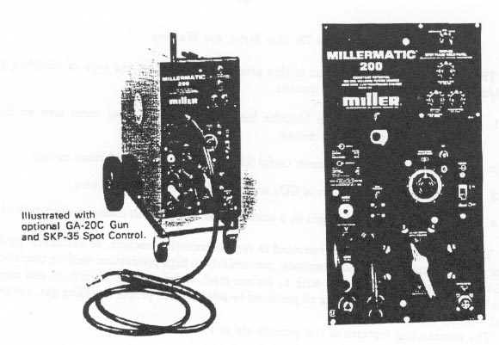
Figure 69: Front View of GMAW Welding Machine.

The gas metal arc welding has grown more rapidly than any other type of welding in the last 20 years. GMAW has now become the major production welding process inmost of the industrial applications around the world today.

In GMA welding (Figure 70), an electric arc is struck between the work piece and consumable wire electrode that is fed continuously through the torch at controlled speeds. Shielding gas is fed simultaneously through the torch into the weld zone surrounding the wire and protecting the weld from the contaminating effects of the atmosphere.
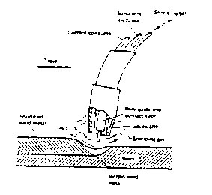
Figure 70: Gas Metal Arc Welding.

There are four major variations of this process depending on the type of shielding gas and/or the type of electrode wire transfer.
- GMAW, formerly known as Metallic Inert Gas, MIG, in most cases uses an inert shielding gas on non-ferrous metals.
- Short circulating transfer is most useful for all position work on ferrous metals.
- GMAW uses a shielding gas of CO2 and a small ferrous electrode wire.
- Spray arc-using argon/oxygen as a shielding gas and a small diameter electrode wire.

The GMAW process may be operated in semi-automatic, or automatic modes. The semi-automatic is the most common, particularly in high production welding operations. All industrially common metals, such as carbon steel, stainless steel, aluminum and copper can be welded with this process in all positions by selecting the proper shielding gas, electrode and welding condition.

The outstanding features of this process are as follows:
- It is able to make good quality welds on almost every metal or alloy used in industry today.
- Minimum post weld cleaning in necessary.
- The arc and molten puddle are clearly visible to the welder.
- Welding is possible in all positions depending on various process conditions.
- High welding deposition rates and speeds make the process economical.
- There is no heavy slag produced, therefore less possibility of slag inclusions. In some conditions when welding carbon steel, a surface discoloration takes place that appears as a light slag.

A typical GMAW setup (Figure 72) consists of a constant DC power source, an electrode wire drive unit and control box, shielding gas cylinders with regulatory flow meter, power and gas cables and hoses, and the welding gun. The filler metal or wire can be supplied to the weld either from an external spool (25 pound, 40 pound) or from a 5-pound spool located inside the gun. The consumable wire electrode is fed from a spool through a torch or welding gun. The wire passes through a contact tube in the gun where it picks up the welding current. This current level is transmitted to the wire feed motor, which determines the wire feed speed. Once the arc has been established, the filler metal is transferred across the arc in the form of fine spray or plasma. The arc can be regulated to give a wide variation of forms, depending upon the kind of metal being welded, the thickness of the work piece and the type of weld desired.

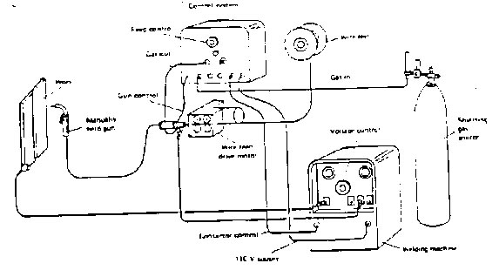
Figure 71: Common Setup for the GMAW Process

Electrode Wires
One of the most important factors to consider in GMA welding is the correct filler wire. The filler wire in combination with the shielding gas will produce a weld bead that must have the proper characteristics of the structure being welded. There are five major factors that influence the choice of filler wire to be used:
- Chemical composition of the metal to be welded.
- Mechanical properties of the metal to be welded.
- Type of shielding gas to be used.
- Application requirements of the finished product.
- Type of weld joint design.
After many years of development, wire electrodes are now manufactured that continually produce excellent results on a number of metals and joint designs. Although there is no industry-wide set of specifications, most electrode wires conform to an American Welding Society standard.

Ferrous Metals
When GMA welding carbon steels, the primary function of the alloying additions is to control the de-oxidation of the weld puddle and help determine the weld mechanical properties. The removal of oxygen from the puddle eliminates the chance of weld metal porosity and causes the formation of a fine slag or glass on the surface of the bead.

Alloying Elements Added to GMAW Wires

Silicon (Si): Most commonly used as a de-oxidizer, most wires contain 0.40 to 1.00 percent Si depending upon their intended use. Increasing amounts of Si will increase the strength of the weld with a small decrease in ductility and toughness.

Manganese (Mn): Most often used as a de-oxidizer and strengthener in amounts of 1.00 to 2.00 percent in mild steel wires. Mn will increase the weld metal strength to an even greater degree than Si.

Aluminum (Al), Titanium (Ti) and Zirconium (Zr): These elements are all strong de-oxidizers. Very small additions, not more than 0.20 percent combined will also cause an increase in weld metal strength.

Carbon ( C ): Carbon, more than any other element influences the structure and mechanical properties of the weld. In most GMAW wires, the carbon content usually ranges between 0.05 and 0.12 percent. Carbon content of 0.12 percent or less provides the necessary weld strength without affecting ductility, toughness or porosity.

Others: Nickel, chromium and molybdenum are often added to improve the mechanical and corrosion resistant properties of the finished weld.

Non-Ferrous Metals
The primary elements used in aluminum alloy wire are magnesium, manganese, zinc, silicon, and copper. The major reason for adding these elements is to increase the strength if the pure aluminum. Most aluminum-alloy wires contain a number of elements that will improve the weld properties, increase corrosion resistance and increase weld ability. The most popular general-purpose electrode wires are magnesium 5356 and silicon 4043 aluminum alloys.

Shielding Gases
The purpose of the shielding gas is to displace the air in the weld zone, thereby preventing contamination of the molten weld metal. In general, nitrogen, oxygen and water vapor are responsible for most of the contamination in the weld zone.

Nitrogen trapped in the weld causes cracking and deduction in ductility and impact strength. Excess oxygen in a weld combines with iron to form iron oxide, resulting in reducing physical and mechanical properties. Trapped oxygen will cause porosity and inclusions in most weld beads.

To avoid problems of contamination of the weld puddle, three main gases or combinations are used to shield the GMAW process: argon, helium and carbon dioxide. In some cases, small amounts of oxygen are combined with one of the major gases. Compensation for the oxidizing tendencies of CO2 and O2 are made by special wire electrode formulas. Argon, helium and carbon dioxide can be used alone ore in combination to provide defect-free welds in a variety of materials and applications.

The shielding gas will affect the following aspects of the welding operation and the final weld produced:
- Arc characteristics.
- Mode of metal transfer.
- Penetration and weld bead profile.
- Speed of travel.
- Tendency of undercutting.
- Cleaning action.
- Volume of spatter.

Argon and Helium Shielding Gases
Argon and helium are inert gases and are primarily used in the welding of non-ferrous metals, stainless steel and low alloy steels. The major difference between argon and helium is density, with argon being much heavier, thus more effective in shielding the weld zone in a flat position weld. Helium, because it is lighter in density, would require two or three times the flow rate to provide the same protection to a weld: therefore, its most economical use is in overhead welds.

Helium possesses a higher thermal conductivity than argon and therefore the bead contour tends to be deeper and broader, which tends to produce a narrow bead with less penetration. At a given wire feed speed, the voltage of the argon will be noticeably less than that of the helium arc. The arc will remain more stable with the argon shield and thus fewer spatters and a better weld bead appearance are produced.

Oxygen and CO2 Additions to Argon and Helium
Argon and helium produce excellent results with non-ferrous metals but less than satisfactory welds with ferrous metals. Generally 3 % oxygen or 9% CO2 will give good results and compensates for such variables as parent metal surface conditions, joint design and position welding technique and base metal composition.

Carbon Dioxide
Carbon Dioxide (CO2) is used in its pure form for GMAW of carbon and low alloy steels. Higher welding speeds, greater joint penetration and lower costs are the major advantages that have made CO2 so popular for most ferrous GMA welding.
With the CO2 shield, metal transfer is either of the short circulating or globular mode, which is quite harsh and produces a much higher spatter count than an argon shield. When compared to argon, CO2 produces excellent penetration with rougher bead surface and less “washing” at the extremity of the weld bead. Sound weld deposits may be achieved, but mechanical properties may be adversely affected due to the oxidizing nature of the arc.

Power Source
Special welding machines, direct current, constant potential, are most commonly used for the GMAW process. This type of machine provides a relatively constant voltage to the arc during welding. A constant potential machine quickly increases or decreases the current (wire burn-off rate) depending on the arc length change. The wire burn-off rate will adjust automatically to the original arc length.

Before welding begins, the operator may set the arc length by making the proper adjustment of the output voltage. At the same time, the wire-feed speed the operator selects prior to welding determines the arc current. Both the arc voltage and current can change over a wide range before the arc length will be altered to cause stubbing or burn-back into the guide tube.

The self-correcting arc length feature of the constant voltage power supply is the key to producing stable welding conditions. Additional characteristics are also built in to control the arc heat, spatter, and other variables.

Arc voltage is the voltage between the end of the contact tip and the work piece; its not directly read on any voltmeter. As stated, the welding voltage is the arc length, (electrode stick out) which has a very important effect on the type of metal transfer desired. Short arc welding requires relatively low voltages whole sprat arc welding requires much higher voltages. To provide the best operation, arc voltage must increase as the electrode wire speed increases. The constant potential power source provides a volt/amperage curve that is essentially flat. The voltage remains relatively constant while the current changes. The current can rise to very high values; extreme spatter will occur at the arc. The spatter is caused by the pinching off of liquid globules at the tip of the square of the current flowing through any conductor. The higher the current rises, the more violent the pinch effect at the arc and the greater the spatter. Two controls that are used to overcome the spatter, create a flatter puddle, and provide a smoother flowing arc are slope and inductance.

Slope refers to the reduction in output voltage with increasing current values. In fact, a constant voltage power supply produces a decreasing voltage and an increasing amperage curve. In general, the greater the slope, the lower the short-circuit current during short arc welding and the lower the spatter. The short circuit must be high enough to melt off the molten drops from the electrode wire.

NOTE: Constant voltage power sources have extremely high short circuit current, which could reach several thousand amperes. For this reason, manufacturers of CV power supplies have recommended that stick electrodes never be used with constant potential welding machines.
Slope determines the maximum current attainable during a short circuit transfer at the arc during “short arc” welding. If the current is controlled, the pinch force is controlled as well the amount of spatter at the weld. Slope also will provide a smoother arc when welding aluminum using the GMAW process.

Inductance controls the rate of current rise. Increasing the inductance causes current to rise more slowly; thus, it takes longer for the current to rise to a given value. The prolonged time assists in making the puddle more fluid, which produces a flatter and smoother weld. Inductance also decreases the frequency of short-circuiting. This reduces spatter because the short circuit has time to clear.

Wire Feed and Control Units
The purpose of the wire-feeding unit is to automatically drive a small-diameter wire spool or coil through the cable assembly to the gun and to the welding arc. The constant potential power supply requires a constant speed of wire feed, which may be adjusted for different welding conditions. Many wire feed arrangements from very small units have the wire spool contained in the welding gun, whereas large heavy-duty units use heavy motors and rheostats to drive a large coils of wire. All wire feed units allow for motor speed adjustment, which in turn controls the wire feed speed and the welding current. Built in to all wire feeders are controls for starting and stopping the wire as well as a welding power contractor and gas control valve energizer. Wire feeder and control units are usually sold as part of a total unit with the cables, hoses, and gun or torch.

Welding Torches and Guns
Since the GMAW process may be operated in semi-automatic, machine, and automatic modes, the welding torch or gun will vary considerably from one process to another. The primary purpose of the torch or gun is to deliver the electrode wire and shielding gas from the wire feeder and the welding current from the power supply to the welding zone.

The gun must be well-built, light and designed so nozzles and guide tubes can be easily replaced or adjusted. Many different types of GMAW guns and torches are available on the market today. Lightweight guns are used mainly for the fabrication of light gauge material in out-of-position. Heavy units are used for many automatic operations where the operator controls a large piece of equipment that holds the gun or torch in a particular position.

Cable Assemblies
Most cable assemblies are sold as a unit with the GMAW torch or gun. These assemblies come in various lengths and weights with all the cables, liners, and hoses forming a single unit or separated into individual parts. The major parts of the unit include a power cable, and electrode wire liner, and a gas hose. The power cable must match the torch or gun and therefore they are sold as a unit.

Metal Transfers
Metal transfers, when welding with a consumable electrode, are generally divided into three groups: sprat transfer, globular transfer, and short-circuiting transfer. The type of metal transfer will depend on such things as electrode wire size, shielding gas, welding current, and arc voltage. When using the GMAW process, sprat transfer is experienced only when argon or argon plus oxygen gas mixtures are used. When CO2, or argon plus CO2 gas mixtures are used, a globular or short circuiting transfer may be obtained.

The metal transfer and the finished bead depend on the following variables: voltage and amperage setting, diameter of the electrode wire, electrode composition, electrode extension, shielding gas, and power supply characteristics.

The operator depending upon the welding conditions sets the rate of feed of the welding wire. Different arc characteristics can be obtained by varying the proportions of argon and other gas combinations being used. The power sources vary with the material being welded and the type of equipment being used.

Arc Power and Polarity
For the vast majority of GMAW applications, direct current reverse polarity (electrode positive) is used. The setup gives a stable arc, smooth metal transfer, low spatter loss, and good bead characteristics for the entire range of welding currents used. Direct current straight polarity is seldom used in GMAW applications as the arc becomes very unstable. Alternating current us never used with the GMAW process.

D.4 Safety
The gas metal arc welding process produces twice as much radiant energy as do coated electrodes of equal current. It is therefore imperative for the welder to protect him/herself in the following manner:
- Wear a darker shade of lens that still permits adequate vision, usually lens shade number 11 or 12.
- Cover exposed skin completely while welding to avoid being burned by ultraviolet rays.
- Wear dark clothing to reduce the amount of radiation reflected on the face underneath the helmet.
- Avoid using any common degreasers or any substance containing trichlorethylene vapor on the metal to be welded. Experiments have shown that radiation from this welding process decomposes such substances very rapidly and that when decomposed they give off highly concentrated fumes which can be toxic.

F Appendix: Glossary

Brittle: Easily broken, cracked, or snapped.

Center drill: A short, very rigid drill, which is used to make a starting hole in metal. Because of the shape of this drill it will not flex (which would cause the tip to wander) when drilling.

Continuously variable: (also infinitely-variable) Able to take on any value within some working range.

Facing Off: Using the lathe to cut the end of the work piece, perpendicular to the axis of rotation.

Knurl: A checkered texturing pattern sometimes put on pieces of metal. Squeezing the metal between the wheels of a knurling tool forms it. This deforms the surface of the work piece, forming hills and valleys.

Layout: The process of transferring the important dimensions from a machine diagram to a piece of stock, prior to machining.

Scribe: 1)To mark a line by scratching with a pointed instrument. 2) The instrument used for scratching a line.

Spacer: (also spacer block) – A block of material used to raise the height of the work piece of clamp.

Stock: The raw material, which will be machined into a finished object.

Swarf: Debris (small chips, shavings), which is produced as a result of machining.

Turning: Machining by use of the lathe.

References

[1] Charles Edgin, General Welding, John Wiley and Sons, New York City, NY, 1982.

[2] R.E. Green, editor, Machinery’s Handbook, Industrial Press, Inc., New York City, NY 25th edition, 1996.

[4] South Bend Lathe Works, South Bend, Indiana, How to Grind Lathe Tool Cutter Bits, 1938, Bullet No. 35.



