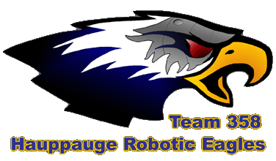
Scouter’s Name:___________________________
Team #:______ Match #:________
Extra Comments:

Autonomous
# High Successful Shots:________________
# Middle Successful Shots:______________
# Low Successful Shots:_________________ (use slashes when counting, e.g. | | | | )
# Missed Shots:___________________________

Tipped Bridge? [Yes] / [No]

Teleoperated
# High Successful Shots:______
# Middle Successful Shots:____
# Low Successful Shots:______
# Missed Shots:_____

Defensive Ability:
# Balls cleared from opponents side:____
[pushed] or [was pushed] by opponent robots
# times pinned, caught, or chased away:____

Bridge
Operating bridge manipulator: [No] / [quick-easy] / [slow-sure] / [iffy] / [stinger]
Robots Balanced: [no attempt] / [fail] / [1] / [2] / [3]

Fouls/Penalities:
[None] or
# Technical:_____
Yellow card: [Yes] / [No]
Red card: [Yes] / [No]
Explain:

Primary alliance role: [defense] / [shooter] / [ball carrier]
Robot dead at all during match?: [Yes / [No]

